Trigonometry SOH CAH TOA GREEN

Question 1 – Calculate the missing sides on the triangles below.

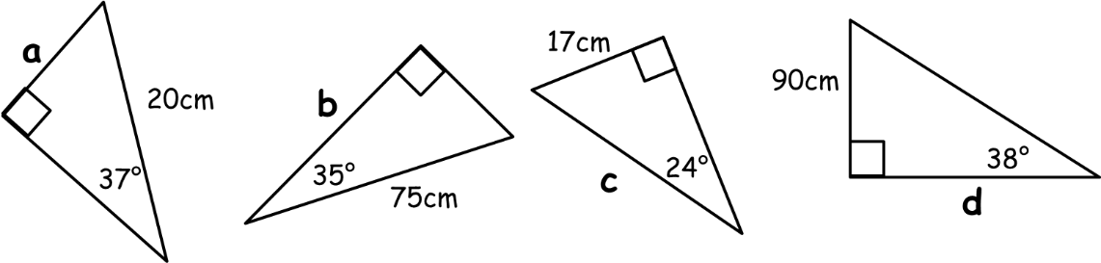

Question 2 - Calculate the missing angles on the triangles below.

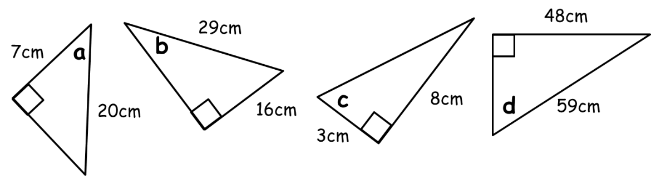

Question 3
A ladder of length 3.5m rests against a vertical wall and makes an angle of 40º with the floor. How far up the wall does the ladder reach?

Question 4
Find the angle X in the triangle below.

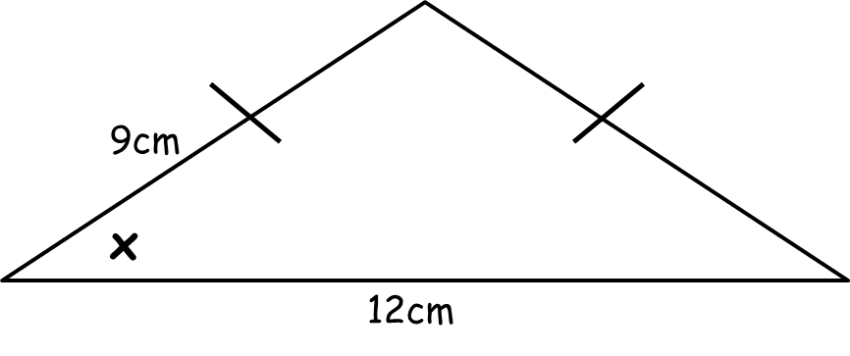

Question 5
A rope 10m long from the top of a vertical pole to a point on the ground makes an angle of 23º with the pole. How high is the pole?

Trigonometry SOH CAH TOA AMBER

$\sin{θ}=\frac{O}{H}$ $\cos{θ}=\frac{A}{H}$ $\tan{θ}=\frac{O}{A}$

Question 1 – Calculate the missing sides on the triangles below.

Question 2 - Calculate the missing angles on the triangles below.
You’ll need to use sin⁻¹, cos⁻¹ and tan⁻¹ to answer these ones!

Question 3
A ladder of length 3.5m rests against a vertical wall and makes an angle of 40º with the floor. How far up the wall does the ladder reach? (Hint: if it’s tricky, draw a piccy!)

Question 4
Find the angle X in the isosceles triangle below.

Question 5
A rope 10m long from the top of a vertical pole to a point on the ground makes an angle of 23º with the pole. How high is the pole? (Hint: if it’s tricky, draw a piccy!)

Trigonometry SOH CAH TOA RED

$\sin{θ}=\frac{O}{H}$ $\cos{θ}=\frac{A}{H}$ $\tan{θ}=\frac{O}{A}$

Question 1 – Calculate the missing sides on the triangles below.
Start by labelling the sides with O, A and H, then decide which trig ratio to use.

Question 2 - Calculate the missing angles on the triangles below.
You’ll need to use sin⁻¹, cos⁻¹ and tan⁻¹ to answer these ones!

Question 3
A ladder of length 3.5m rests against a vertical wall and makes an angle of 40º with the floor. How far up the wall does the ladder reach? (Hint: if it’s tricky, draw a piccy!)

Question 4
Find the angle X in the isosceles triangle below.

Question 5
A rope 10m long from the top of a vertical pole to a point on the ground makes an angle of 23º with the pole. How high is the pole? (Hint: if it’s tricky, draw a piccy!)

