**Angles in parallel lines exam questions**

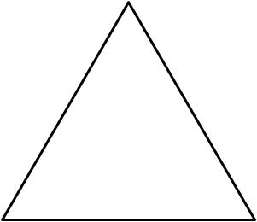Angles in a **triangle** equal 180°

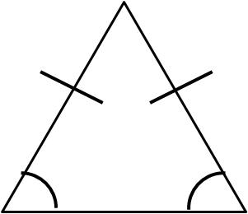

Base angles in an **isosceles triangle** are equal

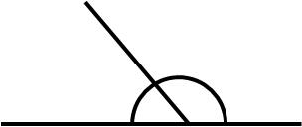

Angles on a **straight line** equal 180°

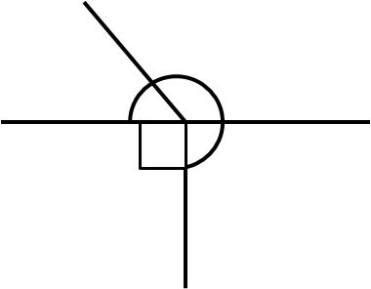 Angles **around a point** equal 360°

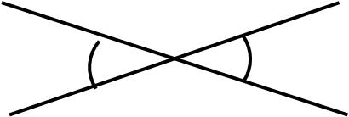` **Vertically opposite** angles are equal

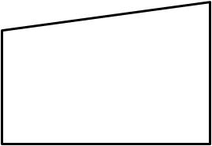 Angles in a **quadrilateral** equal 360°

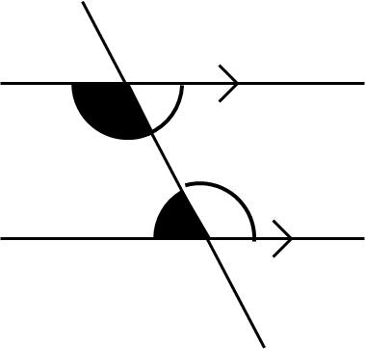C-shape **co-interior** angles add up to 180°

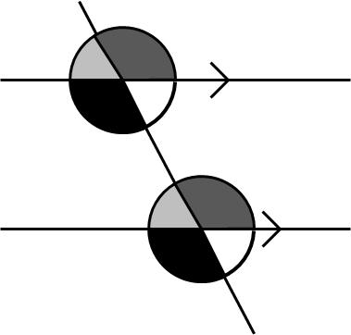 F-shaped **corresponding** angles are equal

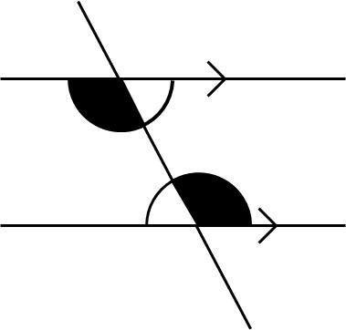Z-shaped a**lternate** angles are equal

**1.**   


*BEG* and *CFG* are straight lines. *ABC* is parallel to *DEF.* Angle *ABE* = 48°. Angle *BCF* = 30°.

(a) (i) Write down the size of the angle marked *x.*

*x* = ...................°

(ii) Give a reason for your answer.

...........................................................................................................................

(2)

(b) (i) Write down the size of the angle marked *y*.

*y* = ...................°

(ii) Give a reason for your answer.

...........................................................................................................................

(2)

(Total 4 marks)

**2.**



*BA* is parallel to *EGD*. *BGC* is parallel to *EF*. Angle *ABC* = 63°.

(a) (i) Find the size of angle *x*.

..................................

(ii) Give a reason for your answer.

...........................................................................................................................

...........................................................................................................................

(2)

(b) Work out the size of angle *y*.

..................................

(1)

(Total 3 marks)

**3.**

 

*AB* is parallel to *CD*.

(i) Write down the value of *y*.

.......................

(ii) Give a reason for your answer.

.....................................................................................................................................

(Total 2 marks)

**4.**



*AB* is parallel to *CD*.

Explain why angle *x* is 72º.

...........................................................................................................................................

...........................................................................................................................................

(Total 2 marks)

**5.**

Diagram **NOT** accurately drawn

*BEG* and *CFG* are straight lines. *ABC* is parallel to *DEF*. Angle *ABE* = 56°. *EF* = *EG*

(a) (i) Write down the size of the angle marked *x*

*x* = ………..…..°

(ii) Give a reason for your answer.

..........................................................................................................................

..........................................................................................................................

(2)

(a) (i) Write down the size of the angle marked *y*

*y* = ………..…..°

(ii) Give a reason for your answer.

..........................................................................................................................

..........................................................................................................................

(2)

(Total 5 marks)

**6.**



Diagram **NOT** accurately drawn

*ABC* is parallel to *DEFG*.  
*BE* = *EF*.  
Angle *ABE* = 38°.

(a) (i) Find the value of *x*.

*x* = .............................

(ii) Give a reason for your answer.

..........................................................................................................................

(2)

(b) Work out the value of *y*.

*y* = .............................

(2)

(Total 4 marks)

**7.** Diagram **NOT**accurately drawn



*ABCD* and *AFE* are straight lines. *BF* is parallel to *CE.* Angle *CBF =* 103°. *AB = AF.*

(a) (i) Find the size of angle *x.*

......................................°

(ii) Give a reason for your answer.

...........................................................................................................................

...........................................................................................................................

(2)

(b) Find the size of angle *y.*

......................................°

(2)

(Total 4 marks)

**8.**



Diagram **NOT** accurately drawn

*ABC* and *DEFG* are straight lines. *AC* is parallel to *DG. BE* = *BF.* Angle *ABE* = 62°.

(a) (i) Find the value of *x.*

*x* = .....................................

(ii) Give a reason for your answer.

...........................................................................................................................

(2)

(b) Work out the value of *y.*

*y* = .....................................

(2)

(Total 4 marks)

**9.**



Diagram **NOT** accurately drawn

*ABCD* is a straight line. *PQ* is parallel to *RS.*

(a) (i) Write down the size of the angle marked *x*.

...................................°

(ii) Give a reason for your answer.

...........................................................................................................................

...........................................................................................................................

(2)

(b) (i) Write down the size of the angle marked *y*.

................................... °

(ii) Give a reason for your answer.

...........................................................................................................................

...........................................................................................................................

(2)

(Total 4 marks)