Volume and Surface Area (F)

Pre-Intervention Assessment

Name: _______________________________

Class: _______________________________

Date: _______________________________

Question | Objective | RAG
1 | Calculate volume and surface area of cubes and cuboids
2 | Calculate volume and surface area of prisms, including cylinders

1. The diagram shows a box for winter grit.
The box is in the shape of a cuboid.
The box is empty.
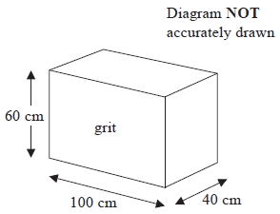
Jon wants to fill the box with grit.
A bag of grit costs £2.50
There are 8000 cm³ of grit in a bag.
Jon has £70 to spend on the grit.
Does Jon have enough money to buy all the grit he needs to fill the box completely?

2. Here is a solid prism.

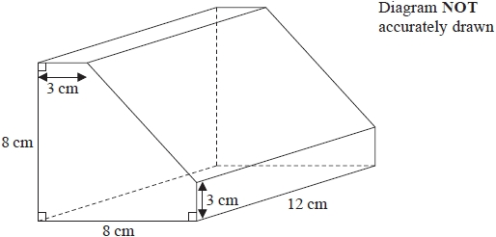

Work out the volume of the prism.
You must show all your working.

[Glue here]

