Real Life Tables GREEN

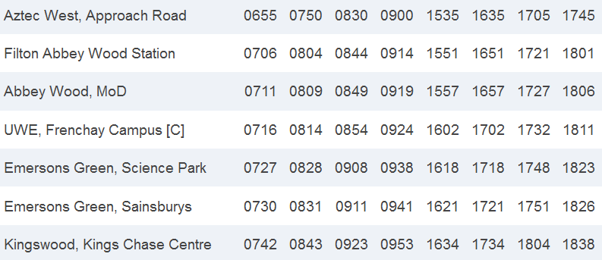

1) What is the first bus from Abbeywood, MoD?
___________________________
2) If I get on that bus what time will I arrive at Emersons Green, Science Park?
___________________________
3) How long did that Journey take me?

___________________________
4) If I want to arrive at Kingswood, Kings Chase Centre at 1634, what is the latest bus I can get from Aztec West?
___________________________
5) If I catch the 0914 from Filton Abbey Wood Station, what time will I arrive at UWE, Frenchay Campus?
___________________________
6) I have a class at UWE Frenchay Campus that begins 1000. What is the latest bus I can catch from Aztec West that will get me to University for the class?
___________________________

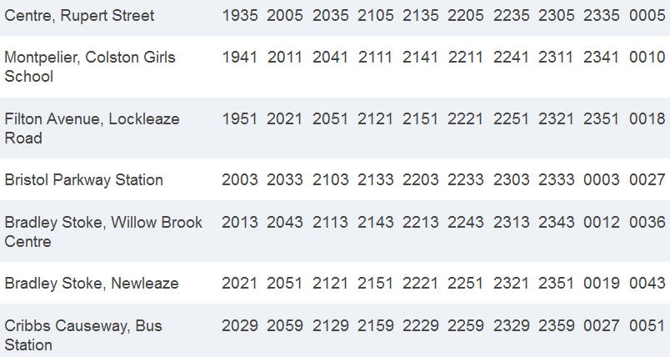

7) What is the first bus from Bristol Parkway Station?
___________________________
8) If I get on that bus what time will I arrive at Cribbs Causeway?
___________________________
9) How long did that Journey take me?

___________________________
10) If I want to arrive at Bradley Stoke, Newleaze at 2051, what is the latest bus I can get from Centre, Rupert St?
___________________________
11) If I catch the 2205 from Centre, Rupert St, what time will I arrive at Bradley Stoke, Willow Brook Centre?
___________________________
12) I work at Cribbs Causeway and begin work at 2100. I need to be at work half an hour early. What is the latest bus I can catch from Centre, Rupert St so I can start work on time?

___________________________
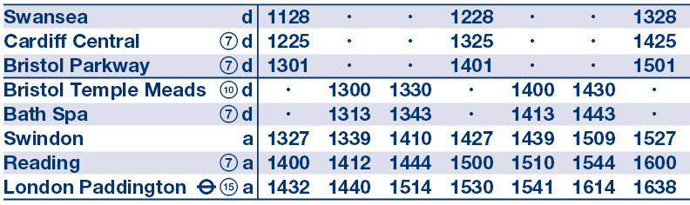

13) What is the first train from Swansea?
___________________________
14) If I get on that train what time will I arrive at Reading?
___________________________
15) How long did that Journey take me?

___________________________
16) If I miss that Train from Swansea, how long is the wait for the next train?
___________________________
17) If I want to arrive at London Paddington at 1541, what is the latest train I can get from Bristol Temple Meads?
___________________________
18) If I catch the 1325 from Cardiff, what time will I arrive at Swindon?
___________________________
19) I begin work in London at 1500. It takes me 15 minutes to walk from London Paddington to work. What is the latest train from Swindon I can take to get me to work on time?

___________________________

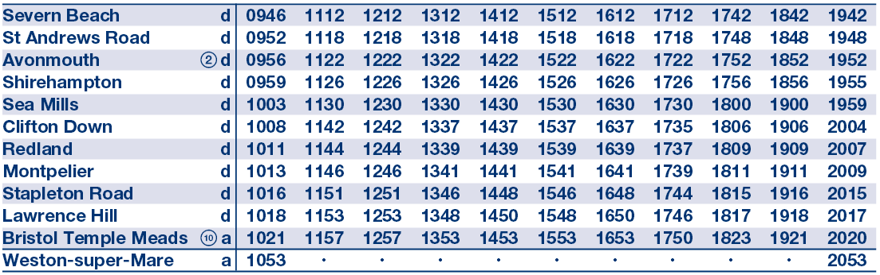

20) What is the first train from St Andrews Road?
___________________________
21) If I get on that train what time will I arrive at Stapleton Road?
___________________________
22) How long did that Journey take me?

___________________________
23) If I want to arrive at Bristol Temple Meads at 1453, what is the latest train I can get from Clifton Down?
___________________________
24) If I catch the 1326 from Shirehampton, what time will I arrive at Lawrence Hill?
___________________________
25) I begin work at Redland 1400. It takes me 45 minutes to get lunch and walk to work from the train station. What is the latest train I can get from Avonmouth so I arrive at work on time?

___________________________

Real Life Tables AMBER

1) What is the first bus from Abbeywood, MoD?
___________________________
2) If I get on that bus what time will I arrive at Emersons Green, Science Park?
___________________________
3) How long did that Journey take me?
Work out the difference between the departure time and time of arrival.

___________________________
4) If I want to arrive at Kingswood, Kings Chase Centre at 1634, what is the latest bus I can get from Aztec West?
___________________________
5) If I catch the 0914 from Filton Abbey Wood Station, what time will I arrive at UWE, Frenchay Campus?
___________________________
6) I have a class at UWE Frenchay Campus that begins 1000. What is the latest bus I can catch from Aztec West that will get me to University for the class?
___________________________

7) What is the first bus from Bristol Parkway Station?
___________________________
8) If I get on that bus what time will I arrive at Cribbs Causeway?
___________________________
9) How long did that Journey take me?
Work out the difference between the departure time and time of arrival.

___________________________
10) If I want to arrive at Bradley Stoke, Newleaze at 2051, what is the latest bus I can get from Centre, Rupert St?
___________________________
11) If I catch the 2205 from Centre, Rupert St, what time will I arrive at Bradley Stoke, Willow Brook Centre?
___________________________
12) I work at Cribbs Causeway and begin work at 2100. I need to be at work half an hour early. What is the latest bus I can catch from Centre, Rupert St so I can start work on time?

___________________________

13) What is the first train from Swansea?
___________________________
14) If I get on that train what time will I arrive at Reading?
___________________________
15) How long did that Journey take me?

___________________________
16) If I miss that Train from Swansea, how long is the wait for the next train?
___________________________
17) If I want to arrive at London Paddington at 1541, what is the latest train I can get from Bristol Temple Meads?
___________________________
18) If I catch the 1325 from Cardiff, what time will I arrive at Swindon?
___________________________
19) I begin work in London at 1500. It takes me 15 minutes to walk from London Paddington to work. What is the latest train from Swindon I can take to get me to work on time?

___________________________

20) What is the first train from St Andrews Road?
___________________________
21) If I get on that train what time will I arrive at Stapleton Road?
___________________________
22) How long did that Journey take me?

___________________________
23) If I want to arrive at Bristol Temple Meads at 1453, what is the latest train I can get from Clifton Down?
___________________________
24) If I catch the 1326 from Shirehampton, what time will I arrive at Lawrence Hill?
___________________________
25) I begin work at Redland 1400. It takes me 45 minutes to get lunch and walk to work from the train station. What is the latest train I can get from Avonmouth so I arrive at work on time?

___________________________

Real Life Tables RED

1) What is the first bus from Abbeywood, MoD?
___________________________
2) If I get on that bus what time will I arrive at Emersons Green, Science Park?
___________________________
3) How long did that Journey take me?
Work out the difference between the departure time and time of arrival.
0711 0727
______ mins
___________________________
4) If I want to arrive at Kingswood, Kings Chase Centre at 1634, what is the latest bus I can get from Aztec West?
___________________________
5) If I catch the 0914 from Filton Abbey Wood Station, what time will I arrive at UWE, Frenchay Campus?
___________________________
6) I have a class at UWE Frenchay Campus that begins 1000. What is the latest bus I can catch from Aztec West that will get me to University for the class?
___________________________
What is the last bus to arrive before 1000 at UWE Frenchay Campus?

7) What is the first bus from Bristol Parkway Station?
___________________________
8) If I get on that bus what time will I arrive at Cribbs Causeway?
___________________________
9) How long did that Journey take me?
Work out the difference between the departure time and time of arrival.

___________________________
10) If I want to arrive at Bradley Stoke, Newleaze at 2051, what is the latest bus I can get from Centre, Rupert St?
___________________________
11) If I catch the 2205 from Centre, Rupert St, what time will I arrive at Bradley Stoke, Willow Brook Centre?
___________________________
12) I work at Cribbs Causeway and begin work at 2100. I need to be at work half an hour early. What is the latest bus I can catch from Centre, Rupert St so I can start work on time?

___________________________

13) What is the first train from Swansea?
___________________________
14) If I get on that train what time will I arrive at Reading?
___________________________
15) How long did that Journey take me?
Work out the difference between the departure time and time of arrival.

___________________________
4) If I miss that Train from Swansea, how long is the wait for the next train?
___________________________
5) If I want to arrive at London Paddington at 1541, what is the latest train I can get from Bristol Temple Meads?
___________________________
6) If I catch the 1325 from Cardiff, what time will I arrive at Swindon?
___________________________
7) I begin work in London at 1500. It takes me 15 minutes to walk from London Paddington to work. What is the latest train from Swindon I can take to get me to work on time?

___________________________

1) What is the first train from St Andrews Road?
___________________________
2) If I get on that train what time will I arrive at Stapleton Road?
___________________________
3) How long did that Journey take me?

___________________________
4) If I want to arrive at Bristol Temple Meads at 1453, what is the latest train I can get from Clifton Down?
___________________________
5) If I catch the 1326 from Shirehampton, what time will I arrive at Lawrence Hill?
___________________________
6) I begin work at Redland 1400. It takes me 45 minutes to get lunch and walk to work from the train station. What is the latest train I can get from Avonmouth so I arrive at work on time?

___________________________

