Sine Rule GREEN

Use the sine rule to find side x in each of the following triangles
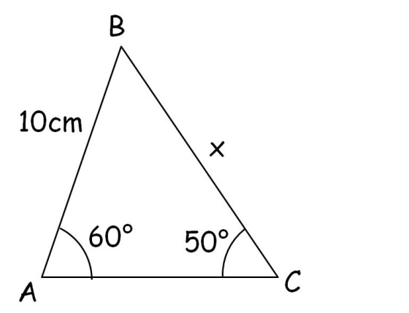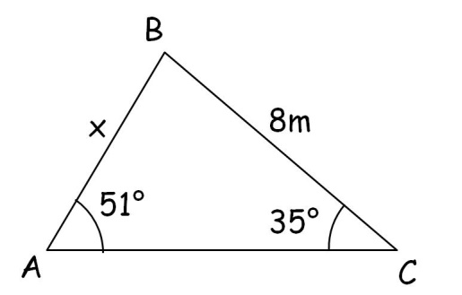

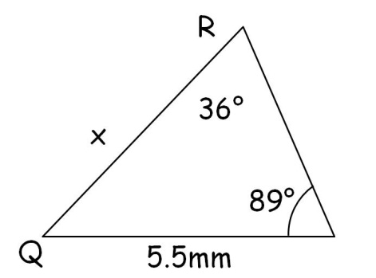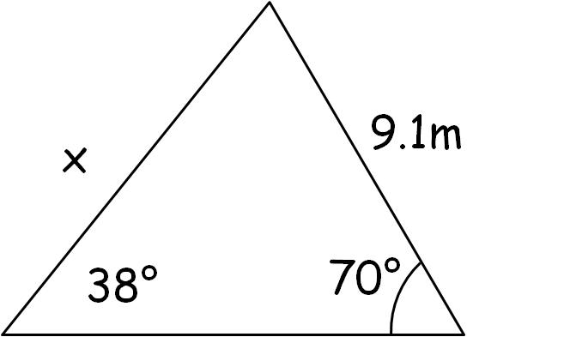

Use the sine rule to find angle X in each of the following triangles
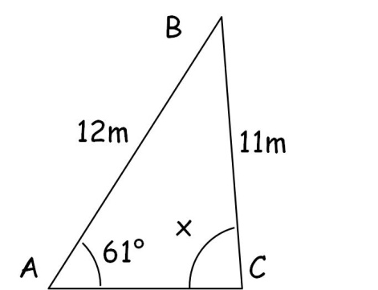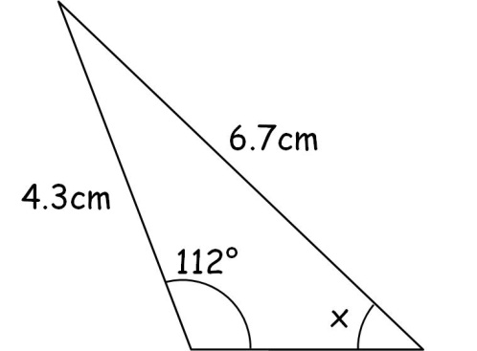

Sine Rule AMBER

_a = b = c_
sinA sinB sinC

Use the sine rule to find side x in each of the following triangles

Use the sine rule to find angle X in each of the following triangles

sinA = sinB = sinC
a b c

Sine Rule RED

_a = b = c_
sinA sinB sinC

Use the sine rule to find side x in each of the following triangles

x_ = 10_
sin60 sin50

x = 10 sin60 =
sin50

Use the sine rule to find angle X in each of the following triangles

sinA = sinB = sinC
a b c

sinX = sin61
12 11

sinX = 12 sin61
11

X =

