Calculating Percentage Change

For each product, work out what percentage it has been reduced by in the sale.

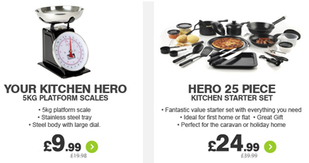

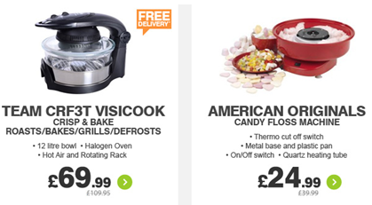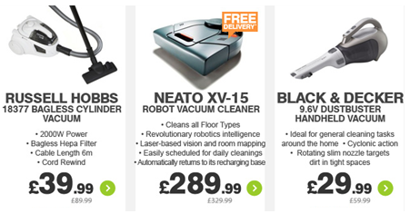

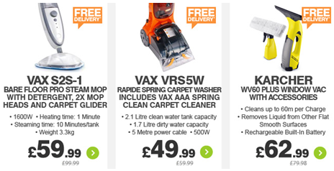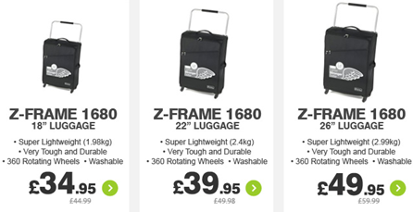

Answers Salter 1000 50% reduction
Hero Scales 50%
Hero Starter Kit 37.5%
Visicook 36.3%
A.O. candy floss 37.5%
Russel Hobbs Vac 55.6%
Robot Vacuum 40%
B&D Vacuum 50%
VAX S2S1 40%
VAX VRS5W 16.7%
Karcher 21.2%
18” luggage 22.3%
22” luggage 20%
26” luggage 16.7%
Philips system 12.5%
TOMTOM 20%
Garmin 13%

