**Area and Perimeter (F)**

Intervention Booklet

Name: _______________________________

Class: _______________________________

**Useful websites:**

**www.mathswatchvle.com**

*(Video explanations and questions)*

Username: STH…@twgash

Password: stmaths

**www.methodmaths.com**

*(Past papers online that get instantly marked)*

Centre ID: wga

Username: firstname

Password: lastname

**www.hegartymaths.com**

*(Online tutorials and quizzes)*

Login: first name and last name are case sensitive

**www.bbc.co.uk/schools/gcsebitesize/maths**

**Area and Perimeter of Rectangles and Triangles**

**Things to remember:**

* Area of a rectangle = base x height
* Area of a triangle = ½ x base x height
* The perimeter is the distance around the outside of shape

**Questions:**

**1.** On the centimetre grid, draw a rectangle with an area of 12 cm2.

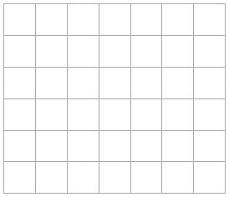

**(Total for Question is 2 marks)**

**2.** On the grid of centimetre squares, draw a rectangle with a perimeter of 10 cm.



**(Total for Question is 2 marks)**

**3.** Here is a rectangle. Work out the area of this rectangle.

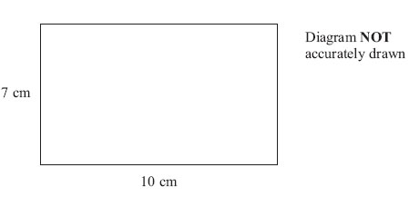

…........................................................ cm2

**(Total for Question is 2 marks)**

**4.** The shaded shape is drawn on a grid of centimetre squares.

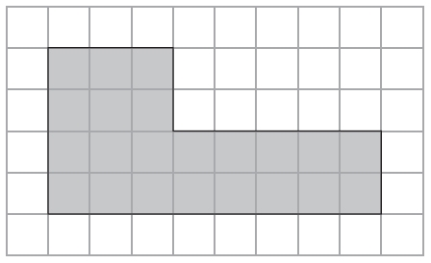

(a) Find the perimeter of the shaded shape.

…........................................................ cm

**(1)**

(b) Find the area of the shaded shape.

…........................................................ cm2

**(1)**

**(Total for Question is 2 marks)**

**5.** The shaded shape is drawn on a grid of centimetre squares.

(a) Find the perimeter of the shaded shape.

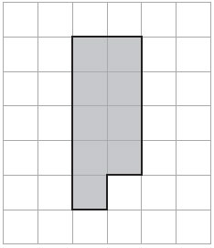

…........................................................ cm

**(2)**

(b) On the grid below, draw a square with the same area as the shaded shape.

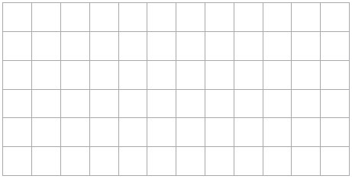

**(1)**

**(Total for Question is 3 marks)**

**6.** Dilys buys a new house.

She wants to have a lawn in the back garden.  
The lawn is going to be in the shape of a rectangle.

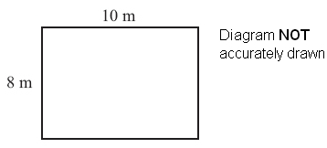

The lawn will have a length of 10 m. The lawn will have a width of 8 m.

Dilys wants to buy edging strip for her lawn.  
The length of the edging strip needs to be equal to the perimeter of her lawn.  
Edging strip costs £1.50 per metre. What is the total cost of the edging strip?

£…........................................................

**(Total for Question is 4 marks)**

**7.** The diagram shows a garden with 4 flower beds.   
The garden is a rectangle, 23 m by 17 m.

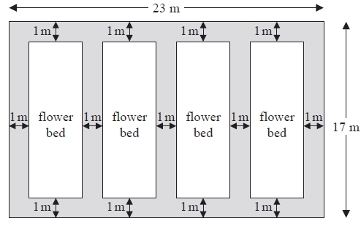

Diagram NOT accurately drawn  
Each flower bed is a rectangle with the same length and the same width.

Work out the length and the width of a flower bed.

length =...........................................................m

width =...........................................................m  
**(Total for Question is 3 marks)**

**8.** The diagram shows a rectangle and a square.

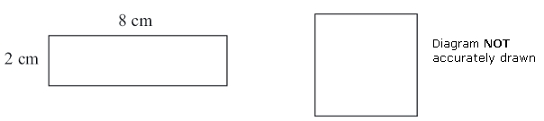

The perimeter of the rectangle is the same as the perimeter of the square.

Work out the length of one side of the square.

…........................................................ cm

**(Total for Question is 4 marks)**

**5.**

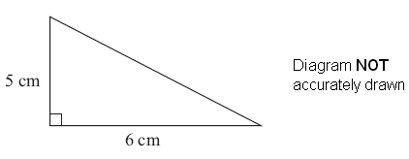

Work out the area of this triangle.

      ..............................................................................................................................................

**(Total for Question is 3 marks)**

**Area Problems**

**Things to remember:**

* Area of a rectangle = base x height
* Area of a triangle = ½ x base x height
* Area of a parallelogram = base x height
* Area of a trapezium = ½ (a + b) h, where a and b are the parallel sides and h is the height
* The perimeter is the distance around the edge of the shape

**Questions:**

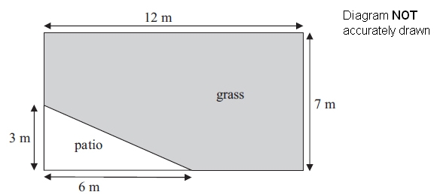**1.** Mrs Kunal's garden is in the shape of a rectangle.  
Part of the garden is a patio in the shape of a triangle.  
The rest of the garden is grass.

Mrs Kunal wants to spread fertiliser over all her grass.

One box of fertiliser is enough for 32 m2 of grass.

How many boxes of fertiliser will she need?  
You must show your working.

…………………………………………………

**(Total for Question is 4 marks)**

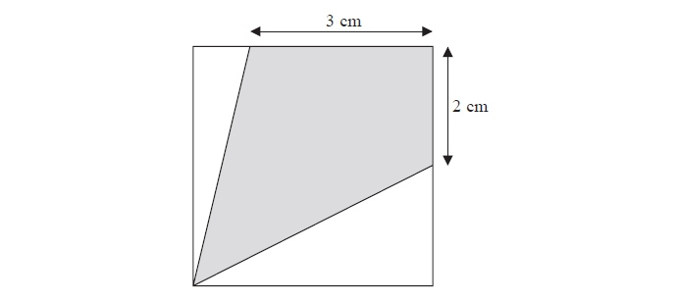**2**. The diagram shows a square with perimeter 16 cm.

Work out the **proportion** of the area inside the square that is shaded.

…………………………………………………

**(Total for question = 5 marks)**

**3**.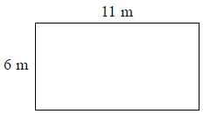 A tin of varnish costs £15

A rectangular floor has dimensions 6 m by 11 m.   
The floor is going to be covered in varnish.

Helen assumes that each tin of this varnish covers an area of 12 m2.

(a) Using Helen's assumption, work out the cost of buying the varnish for this floor.

£ …………………………………………………

**(4)**

Helen finds that each tin of varnish covers less than 12 m2.

(b)   Explain how this might affect the number of tins she needs to buy.

………………………………………………………………………………

………………………………………………………………………………

………………………………………………………………………………

**(1)**

**(Total for question = 5 marks)**

**4**. The diagram shows a wall in Neil's house.

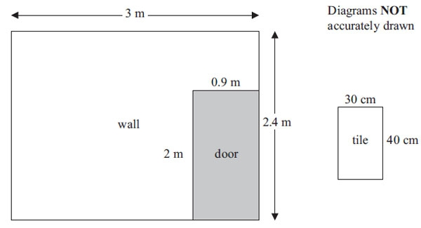

Neil is going to cover the wall completely with tiles.  
 Each tile has a width of 30 cm and a height of 40 cm.

The tiles are sold in packs.  
 There are 6 tiles in each pack.  
 Each pack costs £15

Work out the least amount of money Neil needs to pay for the tiles.  
 You must show all your working.

      …………………………………………………

**(Total for Question is 4 marks)**

**5**. A picture is made from tiles.

The diagram shows the picture in the shape of a rectangle, 120 cm by 100 cm.  
It also shows a tile in the shape of a rectangle, 15 cm by 20 cm.

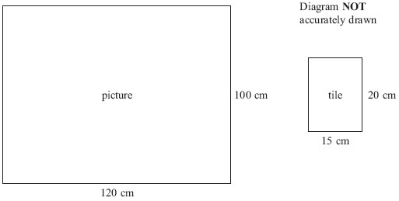

(a) Work out the number of these tiles needed to make the picture.

      …………………………………………………

**(3)**

The total cost of the tiles is £52 plus VAT.  
The rate of VAT is 20%.

(b) Work out 20% of £52

      …………………………………………………

**(2)**

**(Total for Question is 5 marks)**

**6**. Andy is going to cover a wall with tiles.

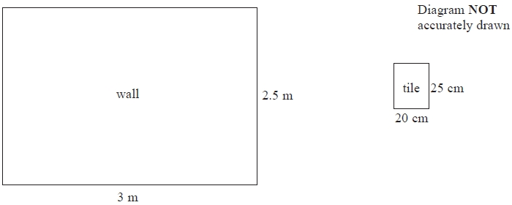

The wall is in the shape of a rectangle.   
The wall is 3 m wide and 2.5 m high.   
The tiles are rectangles 20 cm wide and 25 cm high.

The tiles are sold in boxes.   
There are 20 tiles in each box.   
Each box of tiles costs £8.50

Work out the total cost of the boxes of tiles Andy needs to buy.   
You must show all your working.

£ …………………………………………………

**(Total for question = 5 marks)**

**7**. The diagram shows the floor of a village hall.

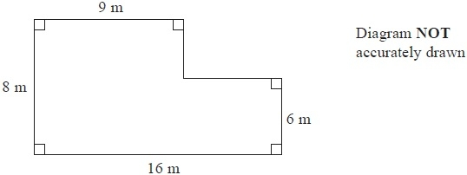

The caretaker needs to polish the floor.

One tin of polish normally costs £19

One tin of polish covers 12 m2 of floor.

There is a discount of 30% off the cost of the polish.

The caretaker has £130

Has the caretaker got enough money to buy the polish for the floor?

You must show all your working.

**(Total for Question is 5 marks)**

**8**. Here is a diagram of Jim's garden.

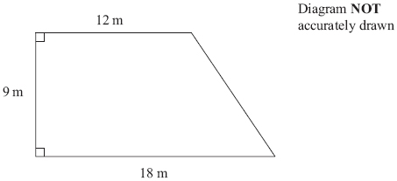

Jim wants to cover his garden with grass seed to make a lawn.

Grass seed is sold in bags.  
There is enough grass seed in each bag to cover 20 m2 of garden.

Each bag of grass seed costs £4.99

Work out the least cost of putting grass seed on Jim's garden.

£…………………………………………………

**(Total for Question is 4 marks)**

**9**. A piece of card is in the shape of a trapezium.

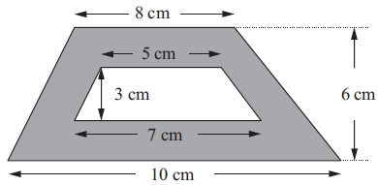

Diagram NOT accurately drawn

A hole is cut in the card.   
The hole is in the shape of a trapezium.

Work out the area of the shaded region.

…………………………………………………cm2

**(Total for Question is 3 marks)**

**Circles**

**Things to remember:**

* πr² sounds like area to me, when I need the circumference I’ll just use πD.
* Read the question carefully and check if you are being asked to find circumference or area and whether they have given you the radius or the diameter.
* Remember the diameter is twice the radius.

**Questions:**

**1.** The diameter of a wheel on Harry’s bicycle is 0.65 m.

Calculate the circumference of the wheel.  
Give your answer correct to 2 decimal places.

Diagram NOT accurately drawn

................................. m

**(Total 2 marks)**

**2.** Diagram NOT accurately drawn

The radius of this circle is 8 cm.

Work out the circumference of the circle.  
Give your answer correct to 2 decimal places.

.............................. cm

**(Total 2 marks)**

**3.**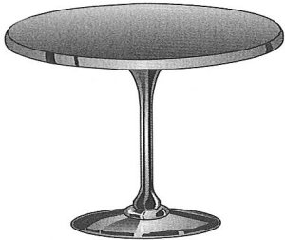 The top of a table is a circle.  
The radius of the top of the table is 50 cm.

(a) Work out the area of the top of the table.

………………………cm²

**(2)**

The base of the table is a circle.  
The diameter of the base of the table is 40 cm.

(b) Work out the circumference of the base of the table.

………………………cm

**(2)**

**(Total 4 marks)**

**4.** The diagram shows two small circles inside a large circle.  
The large circle has a radius of 8 cm.

Each of the two small circles has a diameter of 4 cm.

1. Write down the radius of each of the small circles.

............................. cm

**(1)**

(b) Work out the area of the region shown shaded in the diagram.  
Give your answer correct to one decimal place.

...................................... cm²

**(4)**

**(Total 5 marks)**