Statistical Inquiry (F)

Intervention Booklet

Name: _______________________________

Class: _______________________________

Useful websites:

www.mathswatchvle.com
(Video explanations and questions)
Centre ID: twgash
Username: firstname
Password: lastname

www.methodmaths.com
(Past papers online that get instantly marked)
Centre ID: wga
Username: firstname
Password: lastname

www.hegartymaths.com
(Online tutorials and quizzes)
Login: first name and last name are backwards and case sensitive

www.bbc.co.uk/schools/gcsebitesize/maths

Averages

Things to remember:
- Mode is most – the number that occurs the most frequently.
- Median is middle – put the numbers in order then identify the middle number.
- Mean is mean to work out – add all the numbers together and divide by the quantity in the list.
- Range is the difference from the biggest to the smallest.

Questions:
1. Chloe made a list of her homework marks.
4 5 5 5 4 3 2 1 4 5
(a) Write down the mode of her homework marks.
…………………….
(1)
(b) Work out her mean homework mark.

…………………….
(2)
(Total 3 marks)
2. Peter rolled a 6-sided dice ten times.
Here are his scores.
3 2 4 6 3 3 4 2 5 4
(a) Work out the median of his scores.

.................................
(2)
(b) Work out the mean of his scores.

.................................
(2)
(c) Work out the range of his scores.

.................................
(1)
(Total 5 marks)

3. Mr Smith kept a record of the number of absences for each student in his class for one term.
Here are his results.
0 0 0 8 4 5 5 3 2 1
(a) Write down the mode.
………………...
(1)
(b) Work out the mean.

………………...
(2)
(Total 3 marks)

4. Here are ten numbers.
7 6 8 4 5 9 7 3 6 7
(a) Work out the range.
.....................................
(2)
(b) Work out the mean.

.....................................
(2)
(Total 4 marks)

5. Here are the test marks of 6 girls and 4 boys.
Girls: 5 3 10 2 7 3
Boys: 2 5 9 3
(a) Write down the mode of the 10 marks.
……………………………
(1)
(b) Work out the median mark of the boys.

……………………
(2)
(c) Work out the range of the girls’ marks.

……………………
(1)
(d) Work out the mean mark of all 10 students.

……………………
(2)
(Total 6 marks)

6. Here are 10 numbers.
3 2 5 4 2 4 6 2 1 2
Find the mode of these numbers.
……………….
(Total 1 mark)

7. Jalin wrote down the ages, in years, of seven of his relatives.
45, 38, 43, 43, 39, 40, 39
(a) Find the median age.
.......................................
(1)
(b) Work out the range of the ages.

.......................................
(1)
(c) Work out the mean age.

.......................................
(2)
(Total 4 marks)
8. Mrs Smith asked each student in her class to record the numbers of times they used their mobile phone last Saturday.
Here are the results for the boys.
Boys 8 10 8 9 7 9 8 13 14
(a) Work out the median.

...........................................................
(2)
Here are the results for the girls.
Girls 6 8 9 9 10 14 14
*(b) Compare the numbers of times the boys used their mobile phones with the numbers of times the girls used their mobile phones.

(4)
(Total for question = 6 marks)

9. There are 18 packets of sweets and 12 boxes of sweets in a carton.
The mean number of sweets in all the 30 packets and boxes is 14
The mean number of sweets in the 18 packets is 10
Work out the mean number of sweets in the boxes.

...........................................................
(Total for question = 3 marks)

10. 25 students in class A did a science exam.
30 students in class B did the same science exam.
The mean mark for the 25 students in class A is 67.8
The mean mark for all the 55 students is 72.0
Work out the mean mark for the students in class B.

...........................................................
(Total for Question is 3 marks)

11. There are 10 boys and 20 girls in Mrs Brook's class.
Mrs Brook gave all the class a test.
The mean mark for all the class is 60
The mean mark for the girls is 56
Work out the mean mark for the boys.

...........................................................
(Total for Question is 3 marks)

12. Here are four number cards.
One of the cards is turned over so you cannot see the number on it.
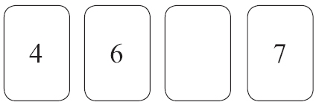
The mean of the four numbers is 6
Work out the number you cannot see.

...........................................................
(Total for Question 10 is 3 marks)

*13. There are two trays of plants in a greenhouse.
The first tray of plants was given fertiliser.
The second tray of plants was not given fertiliser.
On Monday the heights of the plants were measured in centimetres.
The boxes show some information about the heights of the plants.
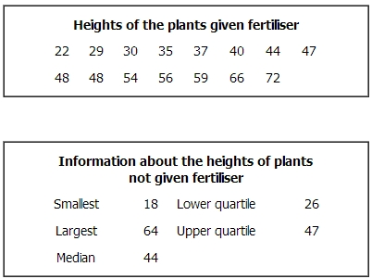
Compare the distribution of the heights of the plants given fertiliser to the distribution of the heights of the plants not given fertiliser.

(Total for Question is 4 marks)

14. 23 girls have a mean height of 153 cm.
17 boys have a mean height of 165 cm.
Work out the mean height of all 40 children.

........................................................... cm
(Total for Question is 3 marks)

15. Hertford Juniors is a basketball team.
At the end of 10 games, their mean score is 35 points per game.
At the end of 11 games, their mean score has gone down to 33 points per game.
How many points did the team score in the 11th game?
...........................................................
(Total for Question is 3 marks)

16. Mr Brown gives his class a test.
The 10 girls in the class get a mean mark of 70%
The 15 boys in the class get a mean mark of 80%

Nick says that because the mean of 70 and 80 is 75 then the mean mark for the whole
class in the test is 75%
Nick is not correct.
Is the correct mean mark less than or greater than 75%?
You must justify your answer.
.............................................................................................................................................

.............................................................................................................................................

.............................................................................................................................................
(Total for question = 2 marks)

17. Walkden Reds is a basketball team.
At the end of 11 games, their mean score was 33 points per game.
At the end of 10 games, their mean score was 2 points higher.

Jordan says,
"Walkden Reds must have scored 13 points in their 11th game."

Is Jordan right?
You must show how you get your answer.
...........................................................
(Total for question is 3 marks)
Sampling

Things to remember:
- Random sampling is where every member of the population has an equal chance of being chosen, which makes it fair.
- With systematic sampling you are unlikely to get a biased sample.
- Stratified sampling is the best way to reflect the population accurately.
- Stratified sample = $\frac{total in group}{total in population} x sample size$

Questions:
1. In Holborn School there are
460 students in Key Stage 3
320 students in Key Stage 4
165 students in Key Stage 5
Nimer is carrying out a survey.
He needs a sample of 100 students stratified by Key Stage.
Work out the number of students from Key Stage 3 there should be in the sample.

...........................................................
(Total for Question is 2 marks)

2. Henri is carrying out a survey of the people aged 65 and over in his village.
The table shows information about these people.
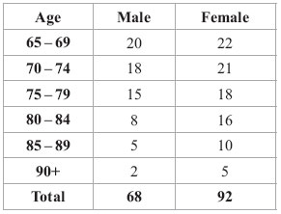
Henri is going to take a sample of 30 people stratified by age.
How many people aged 75 – 79 should be in the sample?

...........................................................
(Total for Question is 3 marks)

3. 156 students went to London.
Each student visited one of the British Museum or the National Gallery or the Stock Exchange.
The table gives information about these students.
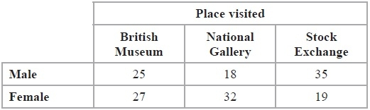
Kate takes a sample of 30 of these students.
The sample is stratified by place visited and by gender.
Work out the number of male students who visited the Stock Exchange in the sample.
...........................................................
(Total for Question is 2 marks)

4. There are 1200 students at a school. Kate is helping to organise a party. She is going to order pizza. Kate takes a sample of 60 of the students at the school. She asks each student to tell her one type of pizza they want. The table shows information about her results.
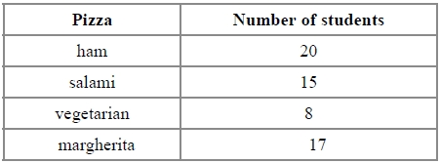
Work out how much ham pizza Kate should order.
Write down any assumption you make and explain how this could affect your answer.
.............................................................................................................................................

.............................................................................................................................................
(Total for question = 3 marks)
5. (a) Max wants to take a random sample of students from his year group.
(i) Explain what is meant by a random sample.

...........................................................................................................................

...........................................................................................................................

...........................................................................................................................

(ii) Describe a method Max could use to take his random sample.

...........................................................................................................................

...........................................................................................................................

...........................................................................................................................
(2)
(b) The table below shows the numbers of students in 5 year groups at a school.

Year | Number of students
9 | 239
10 | 257
11 | 248
12 | 190
13 | 206
Lisa takes a stratified sample of 100 students by year group.
Work out the number of students from Year 9 she has in her sample.

...........................................................
(2)
(Total for Question is 4 marks)

Averages from Tables

Things to remember:
- The mode is the one with the highest frequency.
- To calculate the median, find where the middle value is located by using $\frac{n+1}{2}$.
- The mean is given by $\frac{Σfx}{Σf}$, ie. the total frequency x midpoint divided by the total frequency.
- Always look back at the data to check your answer looks realistic.

Questions:
1. Zach has 10 CDs. The table gives some information about the number of tracks on each CD.
Number of tracks | Frequency
11 | 1
12 | 3
13 | 0
14 | 2
15 | 4

(a) Write down the mode.
...........................................................
(1)
(b) Work out the mean.

...........................................................
(3)
(Total 4 marks)

2. 30 adults took part in a survey. They were each asked how much money they spent on lottery tickets last week. The table shows the results of the survey.
Money (£) | Frequency
0 | 5
2 | 16
4 | 6
20 | 2
30 | 1

Work out the mean amount of money the 30 adults spent on lottery tickets.

£ ...........................................................
(Total 3 marks)

3. Josh asked 30 adults how many cups of coffee they each drank yesterday.
The table shows his results.

Number of cups | Frequency
0 | 5
1 | 9
2 | 7
3 | 4
4 | 3
5 | 2

Work out the mean.

...........................................................
(Total 3 marks)

4. Majid carried out a survey of the number of school dinners 32 students had in one week.
The table shows this information.

Number of school dinners | Frequency
0 | 0
1 | 8
2 | 12
3 | 6
4 | 4
5 | 2

Calculate the mean.

...........................................................
(Total 3 marks)

5. Fred did a survey on the areas of pictures in a newspaper.
The table gives information about the areas.
Area (A cm2) | Frequency
0 < A ≤ 10 | 38
10 < A ≤ 25 | 36
25 < A ≤ 40 | 30
40 < A ≤ 60 | 46

Work out an estimate for the mean area of a picture.

........................................................... cm²
(Total 4 marks)

6. The table gives some information about the time taken by a group of 100 students to complete an IQ test.
Time (t seconds) | Frequency
60 < t < 70 | 12
70 < t < 80 | 22
80 < t < 90 | 23
90 < t < 100 | 24
100 < t < 110 | 19

(a) Write down the modal class interval.
...........................................................
(1)
(b) Calculate an estimate for the mean time taken by the students.

........................................................... seconds
(4)
(Total 5 marks)

7. The table gives some information about the time taken by a group of 100 students to complete an IQ test.
Time (t seconds) | Frequency
60 < t ≤ 70 | 12
70 < t ≤ 80 | 22
80 < t ≤ 90 | 23
90 < t ≤ 100 | 24
100 < t ≤ 110 | 19

Calculate an estimate for the mean time taken by the students.

........................................................... seconds
(Total 4 marks)

