Equation of a Line from a Graph GREEN 1

Calculate the equations of the graph below, writing your answers in the form y = mx + c

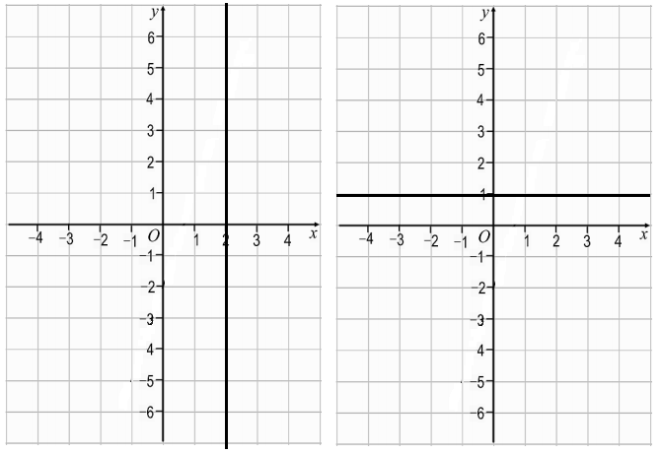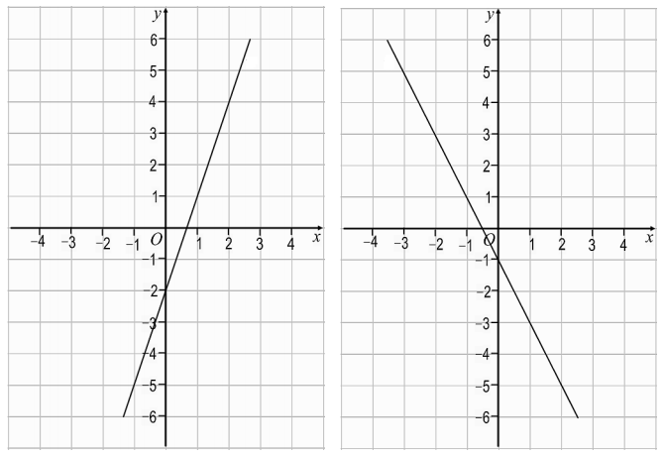

Equation of a Line from a Graph GREEN 2

Calculate the equations of the graph below, writing your answers in the form y = mx + c
Look carefully at the scale on the axes!

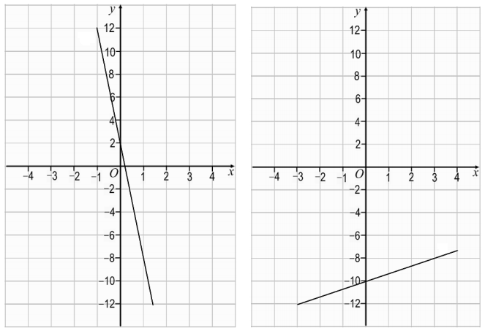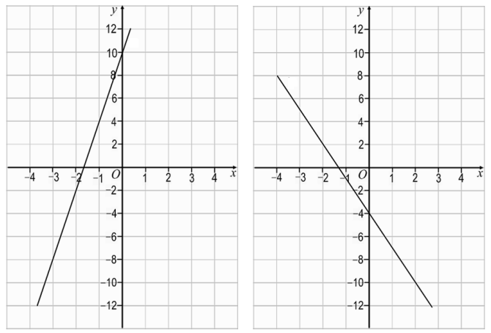

Equation of a Line from a Graph AMBER 1

Calculate the equations of the graph below, writing your answers in the form y = mx + c

Negative gradient
Positive gradient

Equation of a Line from a Graph AMBER 2

Calculate the equations of the graph below, writing your answers in the form y = mx + c
Look carefully at the scale on the axes!

Negative gradient

Equation of a Line from a Graph RED 1

Calculate the equations of the graph below, writing your answers in the form y = mx + c

Negative gradient
Positive gradient

x = _____ y = _____
y = mx + c y = mx + c
Rise = _____ = _____ Rise = _____ = _____
Run Run
y = _____x __ _____

Equation of a Line from a Graph RED 2

Calculate the equations of the graph below, writing your answers in the form y = mx + c
Look carefully at the scale on the axes!

Negative gradient

