Fractions, Decimals and Percentages (F)

Intervention Booklet

Name: _______________________________

Class: _______________________________

Useful websites:

www.mathswatchvle.com
(Video explanations and questions)
Username: STH…@twgash
Password: stmaths

www.methodmaths.com
(Past papers online that get instantly marked)
Centre ID: wga
Username: firstname
Password: lastname

www.hegartymaths.com
(Online tutorials and quizzes)
Login: first name and last name are case sensitive

www.bbc.co.uk/schools/gcsebitesize/maths
Simplifying Fractions and Fractions of Amounts
- Divide both the numerator (top) and denominator (bottom) of the fraction by the same factor until in its simplest form.
- To find a fraction of an amount, divide the amount by the denominator, then multiply by the numerator.

Questions:
1. Sam has £480
He spends ¼ of the £480
Work out how much money Sam has left.

£ ...........................................................
(Total for Question is 3 marks)

*2. The normal price of a denim shirt at a shop is £9.60
On Special Offer Day, there is off the normal price.
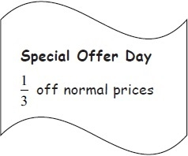
Billy has £13
Has he enough money to buy two denim shirts on Special Offer Day?
You must show all your working.
(Total for Question is 4 marks)

3. Here is a shape. Shade ³⁄₄ of this shape.

(Total for Question is 1 mark)

4. (a) Write down the fraction of this shape that is shaded.
...........................................................
(1)
(b) Shade of this shape.
(1)
Here are some fractions.
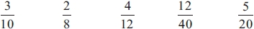
Two of these fractions are equivalent to
(d) Which two fractions?

........................................................... and ...........................................................
(2)
(Total for question = 5 marks)

*5. Here are two fractions.
²⁄₃ ⁷⁄₈
Which of these fractions has a value closer to ³⁄₄?
You must show clearly how you get your answer.

(Total for Question is 3 marks)

6. Why does 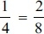?
…………………………………………………………………………………………………..

…………………………………………………………………………………………………..
(Total for Question is 2 marks)

7. (a) What fraction of this shape is shaded?
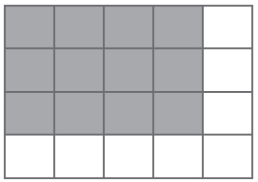

Write your fraction in its simplest form.
...........................................................
(2)
(b) Shade ³⁄₈ of this shape.
(1)
(Total for Question is 3 marks)

8. Write 35 out of 65 as a fraction.
Give your fraction in its simplest form.
...........................................................
(Total for question = 2 marks)
Fractions, Decimals and Percentages

Things to remember:
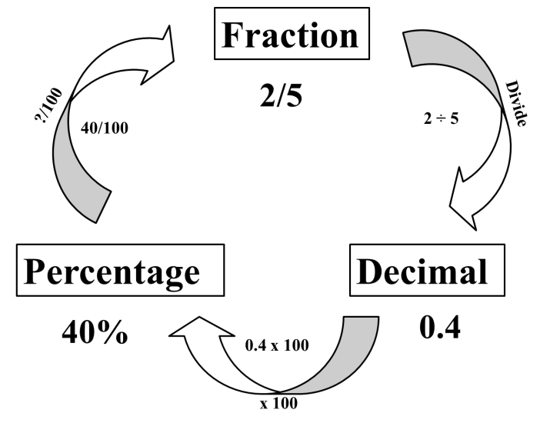

Questions:
1. (a) Write 0.1 as a fraction.
...........................................................
(1)
(b) Write ¼ a decimal.
...........................................................
(1)
(Total for Question is 2 marks)
2. (a) Write as a decimal.
...........................................................
(1)
(b) Write 0.3 as a fraction.
...........................................................
(1)
(Total for Question is 2 marks)
3. (a) Write as a decimal.
...........................................................
(1)
(b) Write 0.15 as a fraction.
...........................................................
(1)
(c) Write 17 out of 40 as a fraction.
...........................................................
(1)
(Total for question = 3 marks)

4. (a) Write ⁷⁄₁₀ as a decimal.
...........................................................

(1)
(b) Write 0.45 as a percentage.
...........................................................

(1)
(c) Write 30% as a fraction.
Give your fraction in its simplest form.
...........................................................
(2)
(Total for Question is 4 marks)

5. (a) Write 0.7 as a fraction.
...........................................................
(1)
(b) Write 0.3 as a percentage.
...........................................................
(1)
(c) Write ⁸⁄₁₂ in its simplest form.

...........................................................
(1)
(Total for Question is 3 marks)

6. Write these numbers in order of size. Start with the smallest number.

…………………………………………………………………………………………………..
(Total for question = 2 marks)

7. Write these numbers in order of size. Start with the smallest number.
…………………………………………………………………………………………………..
(Total for question = 2 marks)

8. Celina and Zoe both sing in a band.
One evening the band plays for 80 minutes.
Celina sings for 65% of the 80 minutes.
Zoe sings for of the 80 minutes.
Celina sings for more minutes than Zoe sings.
Work out for how many more minutes.
You must show all your working.
........................................................... minutes
(Total for question = 4 marks)

Percentages of Amounts, Increasing and Decreasing

Things to remember:
- “Per cent” means “out of 100”.
- Increase means the value will go up, decrease means the value will go down.

Questions:
1. David is going to buy a cooker.
The cooker has a price of £320
David pays a deposit of 15% of the price of the cooker.
How much money does David pay as a deposit?
£ ...........................................................
(Total for Question is 2 marks)

2. Work out 65% of 300
...........................................................
(Total for question = 2 marks)

*3. Barak is going to buy 550 nails from one of these companies.
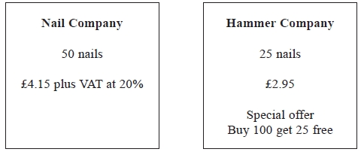
He wants to buy the nails at the cheaper cost.
Where should he buy the nails, from the Nail Company or the Hammer Company?

(Total for question = 5 marks)

4. Greg sells car insurance and home insurance.
The table shows the cost of these insurances.
Insurance | car insurance | home insurance
Cost | £200 | £350
Each month Greg earns
£530 basic pay
5% of the cost of all the car insurance he sells
and 10% of the cost of all the home insurance he sells
In May Greg sold
6 car insurances
and 4 home insurances
Work out the total amount of money Greg earned in May.

£ ...........................................................
(Total for Question is 5 marks)

5. Mr Watkins needs to buy some oil for his central heating.
Mr Watkins can put up to 1500 litres of oil in his oil tank.
There are already 850 litres of oil in the tank.
Mr Watkins is going to fill the tank with oil.
The price of oil is 67.2p per litre.
Mr Watkins gets 5% off the price of the oil.
How much does Mr Watkins pay for the oil he needs to buy?

£ ...........................................................
(Total for Question is 5 marks)

*6. Jim's pay is £180 each week.
Jim asks his boss for an increase of £20 a week.
Jim's boss offers him a 10% increase.
Is the offer from Jim's boss more than Jim asked for?
You must show your working.

(Total for Question is 3 marks)

*7. Gordon owns a shop.
Here are the prices of three items in Gordon's shop and in a Supermarket.
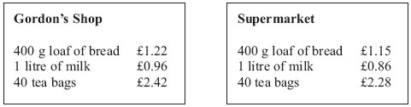
Gordon reduces his prices by 5%.
Will the total cost of these three items be cheaper in Gordon's shop than in the Supermarket?

(Total for Question is 3 marks)

8. Mr Brown and his 2 children are going to London by train.
An adult ticket costs £24
A child ticket costs £12
Mr Brown has a Family Railcard.
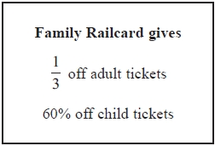
Work out the total cost of the tickets when Mr Brown uses his Family Railcard.
£...........................................................
(Total for Question is 4 marks)

Calculating with Fractions

Things to remember:
- If you have a mixed number, start by converting it to an improper fraction.
- Multiply fractions is easy – just multiply the numerators and multiply the denominators.
- To divide fractions, flip the second fraction upside-down and multiply instead.
- If you need to add or subtract fractions, you will need to start by finding equivalent fractions with a common denominator.
- Make sure you leave your answer in its simplest form.
- To convert a recurring decimal to a fraction you will need to multiply by 10^{n}, where n is the number of recurring digits. Then subtract the original number from the new one. Rearrange to find the fraction.

Questions:
1. (a) Work out $1\frac{3}{4}+3\frac{1}{2}$

...........................................................
(2)
(b) Work out $\frac{3}{7}$ × £28
£...........................................................
(2)
(Total for question = 4 marks)

2. Work out $3\frac{4}{5}+\frac{3}{7}$
Give your answer as a mixed number in its simplest form.
...........................................................
(Total for question = 3 marks)

3. The diagram shows three identical shapes A, B and C.
$\frac{3}{5}$ of shape A is shaded. $\frac{7}{8}$ of shape C is shaded.
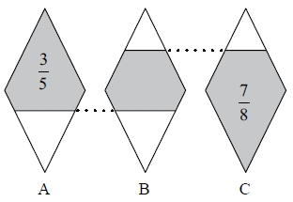
What fraction of shape B is shaded?

(Total for question = 3 marks)

4. Express the recurring decimal as a fraction.
Give your answer in its simplest form.

...........................................................
(Total for Question is 3 marks)

5. Work out $3\frac{1}{3} x 4\frac{2}{5}$
Give your answer as a mixed number in its simplest form.
...........................................................
(Total for question = 3 marks)

6. Work out ³⁄₈ + ¹⁄₃

...........................................................
(Total for Question is 2 marks)

7. Express the recurring decimal as a fraction.

...........................................................
(Total for Question is 3 marks)

8. Express the recurring decimal as a fraction in its simplest form.

...........................................................
(Total for Question is 3 marks)

9. Work out 3¹⁄₃ ÷ 4¾

...........................................................
(Total for Question is 2 marks)

10. On a farm, $4\frac{1}{2}$ out of every 15 acres of the land are used to grow crops.
Wheat is grown on $\frac{5}{8}$ of the land used to grow crops.
What percentage of the total area of the land on the farm is used to grow wheat?

(Total for question = 3 marks)

Percentages – compound interest

Things to remember:
Number of years
- ${New amount=original amount x multiplier}^{n}$

Questions:
1. Henry invests £4500 at a compound interest rate of 5% per annum.
At the end of n complete years the investment has grown to £5469.78.
Find the value of n.

...........................................................
(Total 2 marks)

2. Bill buys a new machine.
The value of the machine depreciates by 20% each year.
(a) Bill says ‘after 5 years the machine will have no value’.
Bill is wrong. Explain why.

.......................................................................................................................................

.......................................................................................................................................

.......................................................................................................................................
(1)
Bill wants to work out the value of the machine after 2 years.
(b) By what single decimal number should Bill multiply the value of the machine when new?

...........................................................
(2)
(Total 3 marks)

3. Gwen bought a new car. Each year, the value of her car depreciated by 9%.
Calculate the number of years after which the value of her car was 47% of its value when new.

...........................................................
(Total 3 marks)
4. The value of a car depreciates by 35% each year.
At the end of 2007 the value of the car was £5460
Work out the value of the car at the end of 2006

£ ...........................................................
(Total 3 marks)

5. Toby invested £4500 for 2 years in a savings account.
He was paid 4% per annum compound interest.
(a) How much did Toby have in his savings account after 2 years?

£ ...........................................................
(3)
Jaspir invested £2400 for n years in a savings account.
He was paid 7.5% per annum compound interest.
At the end of the n years he had £3445.51 in the savings account.
- Work out the value of n.

...........................................................
(2)
(Total 5 marks)

6. Mario invests £2000 for 3 years at 5% per annum compound interest.
Calculate the value of the investment at the end of 3 years.

£ ...........................................................
(Total 3 marks)

7. Toby invested £4500 for 2 years in a savings account.
He was paid 4% per annum compound interest.
How much did Toby have in his savings account after 2 years?

£ ...........................................................
(Total 3 marks)

