Simplifying Surds GREEN

Write the following in simplest surd form:

1. $\sqrt{18}$ 2. $\sqrt{56}$

3. $\sqrt{96}$ 4. $\sqrt{60}$

Write these as a single surd then evaluate:

5. $\sqrt{27}×\sqrt{2}$

6. $\sqrt{6}×\sqrt{8}×\sqrt{3}$

7. $\frac{\sqrt{320}}{\sqrt{5}}$

8. $\frac{\sqrt{30}×\sqrt{12}}{\sqrt{2}×\sqrt{5}}$

Expand and simplify:

9. $(5+\sqrt{3})(6+\sqrt{3})$

10. $(7+\sqrt{5})(7-\sqrt{5})$

11. $(7-\sqrt{2})(4-3\sqrt{2})$

12. $(6+3\sqrt{3})(6-3\sqrt{3})$

Simplifying Surds AMBER

Write the following in simplest surd form:

1. $\sqrt{18}$ 2. $\sqrt{56}$
$=\sqrt{9}×\sqrt{2}$
$=$

3. $\sqrt{96}$ 4. $\sqrt{60}$

Write these as a single surd then evaluate:

5. $\sqrt{27}×\sqrt{2}$
$=\sqrt{9}×\sqrt{3}×\sqrt{2}$
$=$

6. $\sqrt{6}×\sqrt{8}×\sqrt{3}$

7. $\frac{\sqrt{320}}{\sqrt{5}}$

8. $\frac{\sqrt{30}×\sqrt{12}}{\sqrt{2}×\sqrt{5}}$

Expand and simplify:

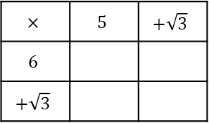
9. $(5+\sqrt{3})(6+\sqrt{3})$

10. $(7+\sqrt{5})(7-\sqrt{5})$

11. $(7-\sqrt{2})(4-3\sqrt{2})$

12. $(6+3\sqrt{3})(6-3\sqrt{3})$

Simplifying Surds RED

Write the following in simplest surd form:

1. $\sqrt{18}$ 2. $\sqrt{56}$
$=\sqrt{9}×\sqrt{2}$ $=\sqrt{4}×\sqrt{}$
$=$ $=$

3. $\sqrt{96}$ 4. $\sqrt{60}$
$=\sqrt{16}×\sqrt{}$
$=$

Write these as a single surd then evaluate:

5. $\sqrt{27}×\sqrt{2}$
$=\sqrt{9}×\sqrt{3}×\sqrt{2}$
$=$

6. $\sqrt{6}×\sqrt{8}×\sqrt{3}$

7. $\frac{\sqrt{320}}{\sqrt{5}}=\frac{\sqrt{64}×\sqrt{5}}{\sqrt{5}}$
$=$

8. $\frac{\sqrt{30}×\sqrt{12}}{\sqrt{2}×\sqrt{5}}$

Expand and simplify:

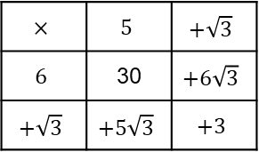
9. $(5+\sqrt{3})(6+\sqrt{3})$

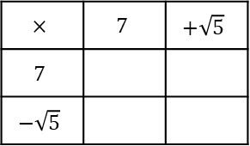
10. $(7+\sqrt{5})(7-\sqrt{5})$

11. $(7-\sqrt{2})(4-3\sqrt{2})$

12. $(6+3\sqrt{3})(6-3\sqrt{3})$

