Multiplication GREEN

Match up the questions and answers. Show all your working in your book!

120 x 46 | 3565
37 x 7 | 1300
132 x 14 | 259
713 x 5 | 32184
536 x 8 | 1239
413 x 3 | 1848
224 x 27 | 9108
361 x 6 | 6048
25 x 52 | 5520
41 x 82 | 4288
894 x 36 | 3362
23 x 396 | 2166

Multiplication AMBER

Match up the questions and answers. Show all your working in your book!

57 x 3 | 280
35 x 8 | 150
25 x 21 | 168
22 x 27 | 186
24 x 7 | 1066
25 x 6 | 6208
41 x 12 | 23576
31 x 26 | 525
71 x 54 | 492
41 x 26 | 594
56 x 421 | 171
32 x 194 | 3834

Multiplication RED

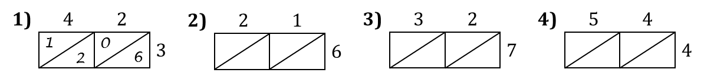

42 x 3 = 21 x 6 = 32 x 7 = 54 x 4 =
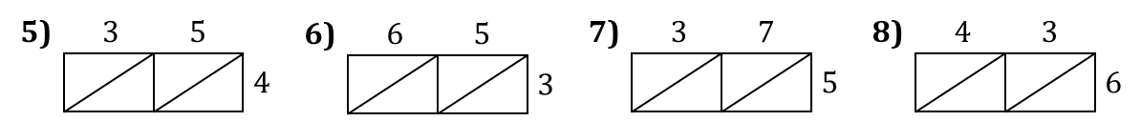

35 x 4 = 65 x 3 = 37 x 5 = 43 x 6 =
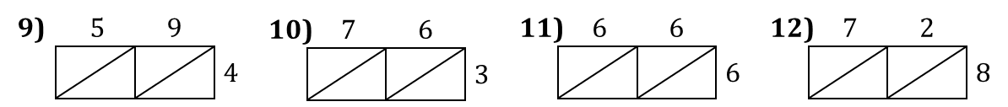

59 x 4 = 76 x 3 = 66 x 6 = 58 x 6 =

