3D SOH CAH TOA GREEN

1. The diagram represents a prism.
$AEFD$ is a rectangle. $ABCD$ is a square.
$EB$ and $FC$ are perpendicular to plane $ABCD$.
$AB=60$ cm. $AD=60$ cm. Angle $ABE=90°$. Angle $BAE=30°$.
Calculate the size of the angle that the line $DE$ makes with the plane
$ABCD$.
Give your answer correct to 1 decimal place.
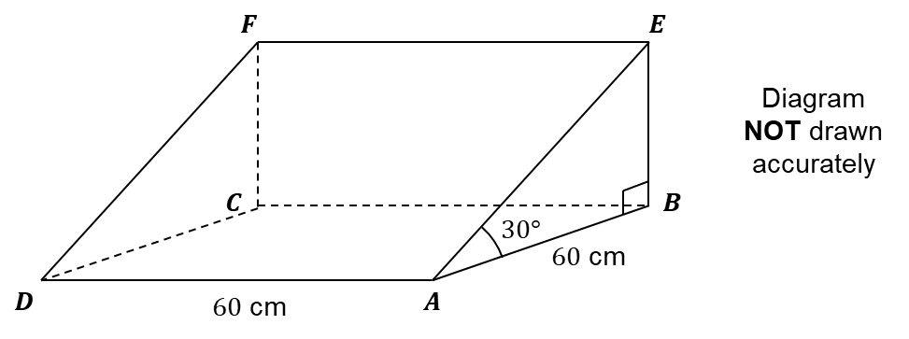

____________________°
(Total 4 marks)
2. The diagram represents a cuboid $ABCDEFGH$.
$AB=5$ cm. $BC=7$ cm. $AE=3$ cm.

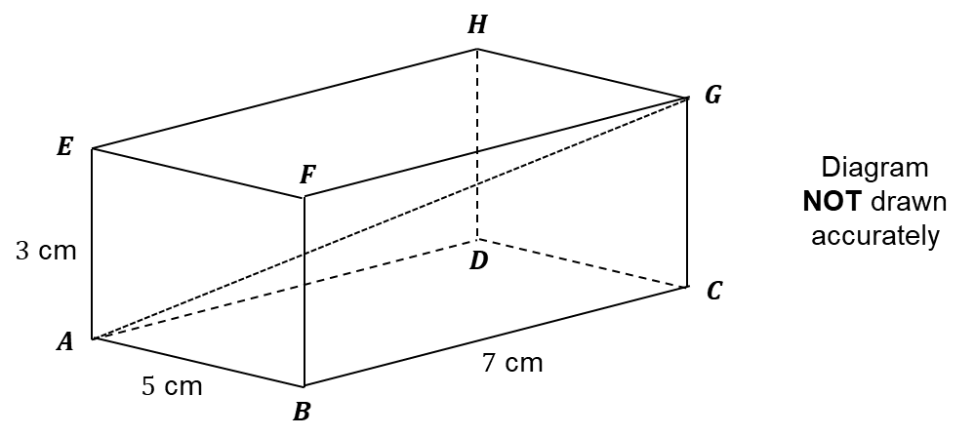

(a) Calculate the length of $AG$.
Give your answer correct to 3 significant figures.

____________________ cm
(2)
(b) Calculate the size of the angle between $AG$ and the face $ABCD$.
Give your answer correct to 1 decimal place.

____________________°
(2)
(Total 4 marks)

3D SOH CAH TOA AMBER

1. The diagram represents a prism.
$AEFD$ is a rectangle. $ABCD$ is a square.
$EB$ and $FC$ are perpendicular to plane $ABCD$.
$AB=60$ cm. $AD=60$ cm. Angle $ABE=90°$. Angle $BAE=30°$.
Calculate the size of the angle that the line $DE$ makes with the plane
$ABCD$.
Give your answer correct to 1 decimal place.

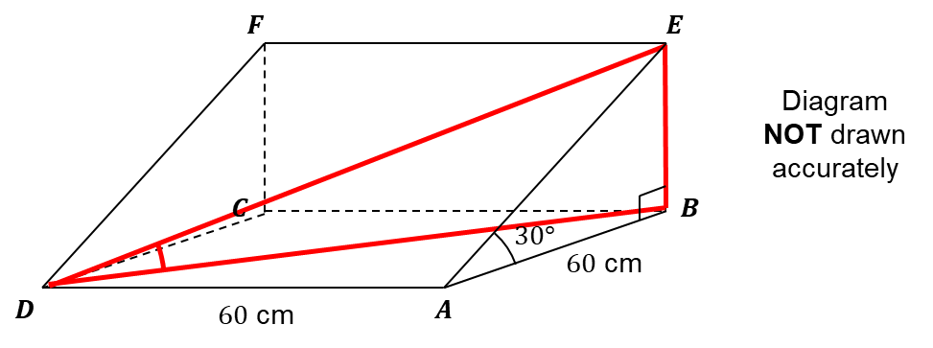

____________________°
(Total 4 marks)
2. The diagram represents a cuboid $ABCDEFGH$.
$AB=5$ cm. $BC=7$ cm. $AE=3$ cm.

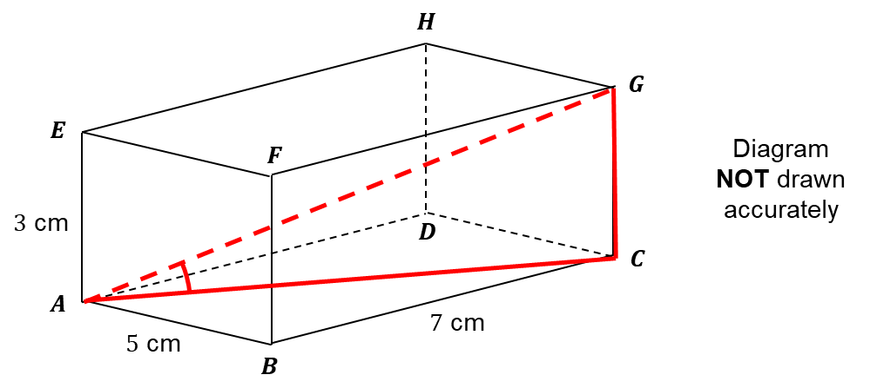

(a) Calculate the length of $AG$.
Give your answer correct to 3 significant figures.

____________________ cm
(2)
(b) Calculate the size of the angle between $AG$ and the face $ABCD$.
Give your answer correct to 1 decimal place.

____________________°
(2)
(Total 4 marks)

3D SOH CAH TOA RED

1. The diagram represents a prism.
$AEFD$ is a rectangle. $ABCD$ is a square.
$EB$ and $FC$ are perpendicular to plane $ABCD$.
$AB=60$ cm. $AD=60$ cm. Angle $ABE=90°$. Angle $BAE=30°$.
Calculate the size of the angle that the line $DE$ makes with the plane
$ABCD$.
Give your answer correct to 1 decimal place.

Start by using Pythagoras’ Theorem with triangle $ABD$ to calculate length $BD$.
Then use SOH CAH TOA with triangle $ABE$ to calculate the height of the prism.
THEN use SOH CAH TOA with triangle $BDE$ to calculate the angle shown on the diagram.

____________________°
(Total 4 marks)
2. The diagram represents a cuboid $ABCDEFGH$.
$AB=5$ cm. $BC=7$ cm. $AE=3$ cm.

Start by using Pythagoras’ Theorem with triangle $ABC$ to calculate length $AC$.
Then use Pythagoras’ Theorem with triangle $ACG$ to calculate length $AG$.
(a) Calculate the length of $AG$.
Give your answer correct to 3 significant figures.

____________________ cm
(2)
(b) Calculate the size of the angle between $AG$ and the face $ABCD$.
Give your answer correct to 1 decimal place.
Use SOH CAH TOA with triangle $ACG$ to calculate the angle shown on the diagram (you know lengths $AG$ and $CG$ already).

____________________°
(2)
(Total 4 marks)

