Equation of a Line from Two Coordinates GREEN

1(a) Calculate the gradient of the line which passes through (1, 6) and (3, 10).

(b) Give the equation of the line

2(a) Calculate the gradient of the line which passes through (1, 3) and (2, 8).

(b) Give the equation of the line

3(a) Calculate the gradient of the line which passes through (3, -2) and (5, 6).

(b) Give the equation of the line

4(a) Calculate the gradient of the line which passes through (-1, -6) and (1, 4).

(b) Give the equation of the line

5(a) Calculate the gradient of the line which passes through (2, 2) and (5, -4).

(b) Give the equation of the line

6(a) Calculate the gradient of the line which passes through (2, 1) and (10, -3).

(b) Give the equation of the line

Equation of a Line from Two Coordinates AMBER

1(a) Calculate the gradient of the line which passes through (1, 6) and (3, 10).
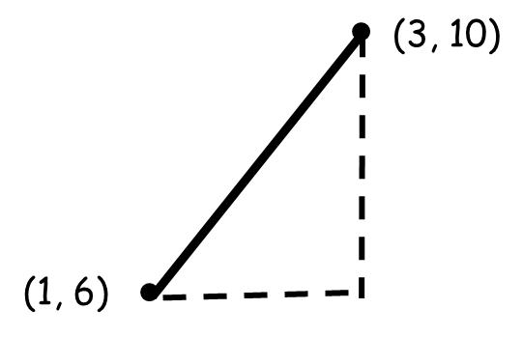

(b) Give the equation of the line
Hint: Substitute (1, 6) and the gradient into y = mx + c

y = x + c

2(a) Calculate the gradient of the line which passes through (1, 3) and (2, 8).
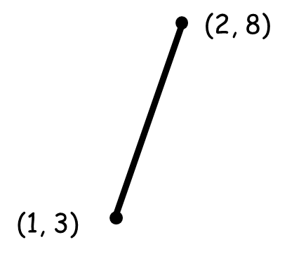

(b) Give the equation of the line

y = x + c

3(a) Calculate the gradient of the line which passes through (3, -2) and (5, 6).

(b) Give the equation of the line

4(a) Calculate the gradient of the line which passes through (-1, -6) and (1, 4).

(b) Give the equation of the line

5(a) Calculate the gradient of the line which passes through (2, 2) and (5, -4).

(b) Give the equation of the line

6(a) Calculate the gradient of the line which passes through (2, 1) and (10, -3).

(b) Give the equation of the line

Equation of a Line from Two Coordinates RED

1(a) Calculate the gradient of the line which passes through (1, 6) and (3, 10).
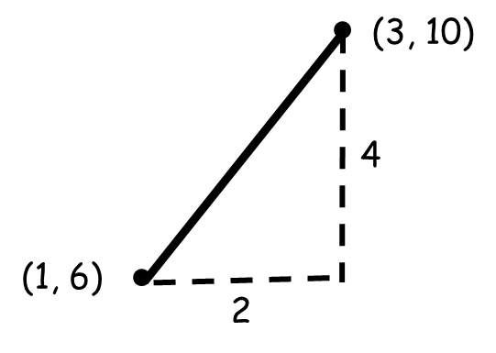
rise = 4 = 2 Graph goes upwards so gradient is positive.
run 2
m = 2

(b) Give the equation of the line
Hint: Substitute (1, 6) and the gradient into y = mx + c
2
y = x + c 6 = 2(1) + c
6 = 2 + c
4 = c
y = 2x + 4

2(a) Calculate the gradient of the line which passes through (1, 3) and (2, 8).
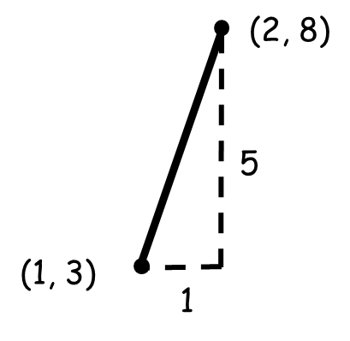
rise =
run

(b) Give the equation of the line
Hint: Substitute (1, 3) and the gradient into y = mx + c

y = x + c

3(a) Calculate the gradient of the line which passes through (3, -2) and (5, 6).

(b) Give the equation of the line

4(a) Calculate the gradient of the line which passes through (-1, -6) and (1, 4).

(b) Give the equation of the line

5(a) Calculate the gradient of the line which passes through (2, 2) and (5, -4).

(b) Give the equation of the line

6(a) Calculate the gradient of the line which passes through (2, 1) and (10, -3).

(b) Give the equation of the line

