Secure a job! | Secure a job! | Secure a job!
Secure a job! | Secure a job! | Secure a job!
Teacher  Salary: £29 005  Hours per week: 48 (average) | Plumber  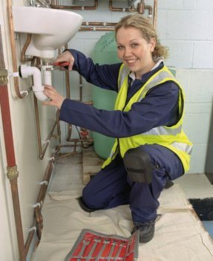  Wage: £11.33 per hour  Hours per week: 40 | Research Scientist  Salary: £30 345  Hours per week: 40
Nurse  Salary: £23 478  Hours per week: 37.5 | Sales Assistant  Wage: £6.91 per hour  Hours per week: 40 | Factory Worker  Wage: £7.74 per hour  Hours per week: 45
Elite Credit Union | Spotlight Holdings Inc. | Goodlife Bank Group
Felicity Banks Inc. | Cloud Nine Banks | Goldleaf Corporation
For the first 5 years:  3.2%  6th year onwards:  4.8%  Per annum  (compound interest) | For the first 5 years:  3.6%  6th year onwards:  4.7%  Per annum  (compound interest) | For the first 5 years:  3.9%  6th year onwards:  4%  Per annum  (compound interest)
For the first 5 years:  3.1%  6th year onwards:  4.9%  Per annum  (compound interest) | For the first 5 years:  3%  6th year onwards:  5.1%  Per annum  (compound interest) | For the first 5 years:  3.5%  6th year onwards:  4.5%  Per annum  (compound interest)
Book a holiday! | Book a holiday! | Book a holiday!
Book a holiday! | Book a holiday! | Book a holiday!
Paris, France  1 week  £803 per person | New York, USA  1 week  £1 284 per person | Skegness, UK  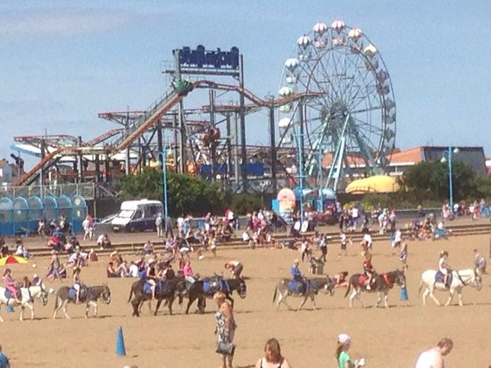  1 week  £602 per person
Lanzarote, Spain  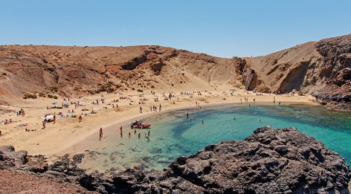  1 week  £882 per person | Agra, India  1 week  £1 007 per person | Hua Hin, Thailand  1 week  £731 per person
Buy a car! | Buy a car! | Buy a car!
Buy a car! | Buy a car! | Buy a car!
Nissan Micra (2004)  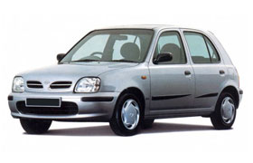  £500  Has a DAB stereo, Bluetooth connection, AUX and USB connection for phone | Land Rover Discovery (2001)  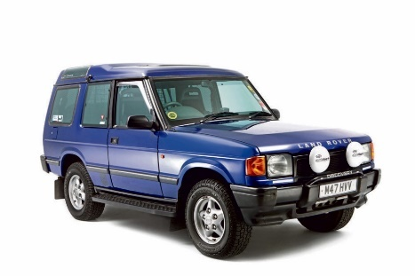  £2 495  It drives very well and has a decent MOT | Audi Q3 (2012)  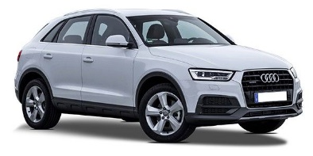  £11 490  18 Inch Alloy Wheels, Heated Seats, Satellite Navigation, Automatic, Bluetooth Interface
Skoda Octavia (2007)  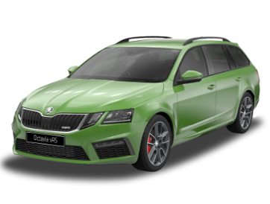  £4 449  Superb colour, cruise control, climate control, lovely car | Citroen Cactus (2015)  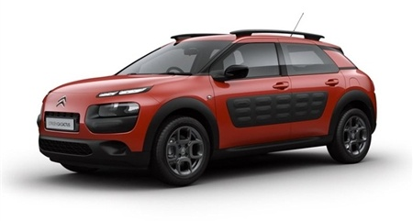  £7 950  This top specification includes Sat Nav, Parking Camera and a touchscreen system | Ford Mondeo (2006)  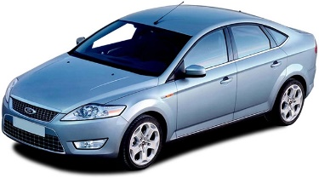  £1 290  Has had just two owners from new and it has been maintained to a very high standard

