Reverse Percentages GREEN

1) A camera costs £180 in a 10% sale. What was the pre-sale price?

2) After fuel prices rose by 15%, a family’s annual heating bill was £1654. What would the bill have been without the price increase?

3) The cost of a holiday, including VAT at 20% is £540. What is the pre-VAT price?

4) The world’s tiger population has decreased by 95% since 1910 and is now believed to be as low as 3200. If these figures are correct, what was the tiger population in 1910?

5) The sale price of a television is £420 after a 15% reduction. What was the price before the sale?

6) After a 6.5% pay rise an engineer’s salary is £36,700. What was the salary before the increase?

7) Due to falling orders a company reduces its workforce by 12% to 792. What was the original number of employees?

8) An engine modification improved the fuel consumption of a car by 27% to 17.2 km per litre. What was the fuel consumption before the modification?

9) After a long-haul flight, the total weight of a Boeing 747 had decreased by 27% to 305,000kg. What weight of fuel was the aircraft carrying at take-off?

10) An insurance company offers a no-claims discount of 55% for drivers who have not had an accident for four years. If the discounted premium for such a driver is £334, how much did the driver save?

Reverse Percentages AMBER

1) A camera costs £180 in a 10% sale. What was the pre-sale price?

2) After fuel prices rose by 15%, a family’s annual heating bill was £1654. What would the bill have been without the price increase?

3) The cost of a holiday, including VAT at 20% is £540. What is the pre-VAT price?

4) The world’s tiger population has decreased by 95% since 1910 and is now believed to be as low as 3200. If these figures are correct, what was the tiger population in 1910?

5) The sale price of a television is £420 after a 15% reduction. What was the price before the sale?

6) After a 6.5% pay rise an engineer’s salary is £36,700. What was the salary before the increase?

7) Due to falling orders a company reduces its workforce by 12% to 792. What was the original number of employees?

8) An engine modification improved the fuel consumption of a car by 27% to 17.2 km per litre. What was the fuel consumption before the modification?

9) After a long-haul flight, the total weight of a Boeing 747 had decreased by 27% to 305,000kg. What weight of fuel was the aircraft carrying at take-off?

10) An insurance company offers a no-claims discount of 55% for drivers who have not had an accident for four years. If the discounted premium for such a driver is £334, how much did the driver save?

Reverse Percentages RED

1) A camera costs £180 in a 10% sale. What was the pre-sale price?

2) After fuel prices rose by 15%, a family’s annual heating bill was £1654. What would the bill have been without the price increase?
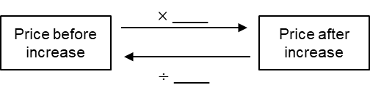

3) The cost of a holiday, including VAT at 20% is £540. What is the pre-VAT price?
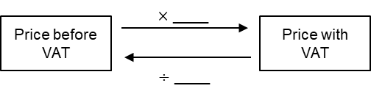

4) The world’s tiger population has decreased by 95% since 1910 and is now believed to be as low as 3200. If these figures are correct, what was the tiger population in 1910?

5) The sale price of a television is £420 after a 15% reduction. What was the price before the sale?

6) After a 6.5% pay rise an engineer’s salary is £36,700. What was the salary before the increase?

7) Due to falling orders a company reduces its workforce by 12% to 792. What was the original number of employees?

8) An engine modification improved the fuel consumption of a car by 27% to 17.2 km per litre. What was the fuel consumption before the modification?

9) After a long-haul flight, the total weight of a Boeing 747 had decreased by 27% to 305,000kg. What weight of fuel was the aircraft carrying at take-off?

10) An insurance company offers a no-claims discount of 55% for drivers who have not had an accident for four years. If the discounted premium for such a driver is £334, how much did the driver save?

