Similar Area and Volume GREEN

For each pair of similar solids, find the scale factor of the solid on the left to the solid on the right. Then find the ratios of the surface areas and the ratio of the volumes.

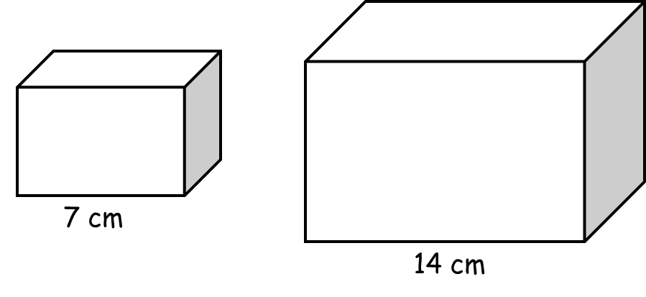
1) Linear scale factor: ________

Area scale factor: ________

Volume scale factor: ________

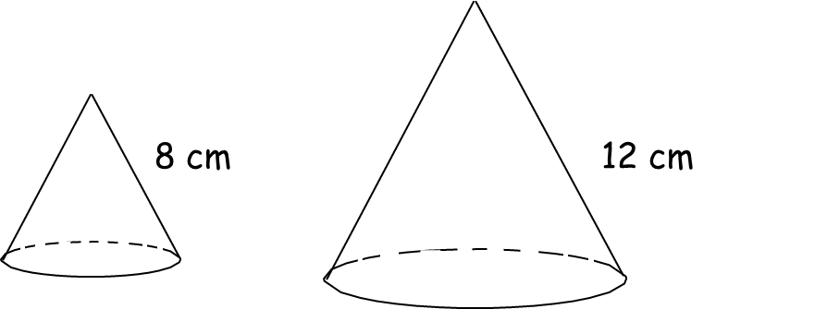
2) Linear scale factor: ________

Area scale factor: ________

Volume scale factor: ________

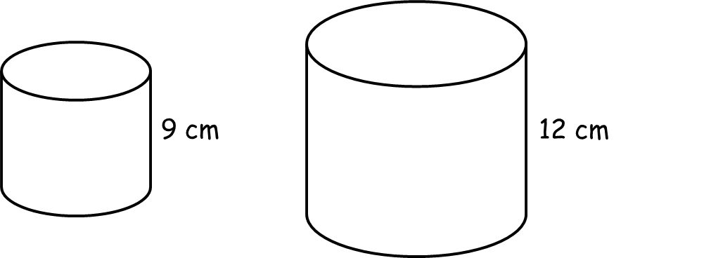
3) Linear scale factor: ________

Area scale factor: ________

Volume scale factor: ________

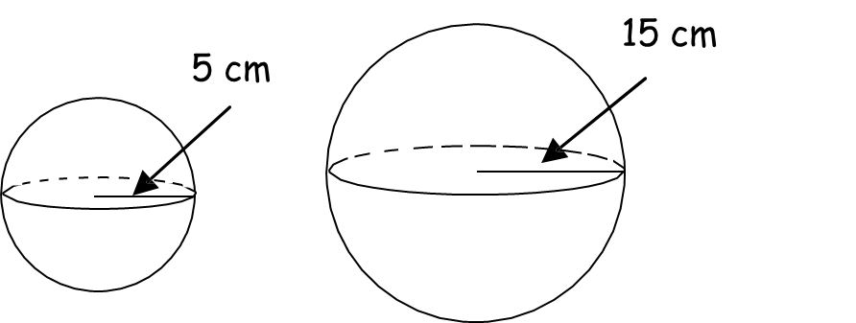
4) Linear scale factor: ________

Area scale factor: ________

Volume scale factor: ________

5) Look at the two cylinders shown below. The ratio of corresponding diameters is equal to the ratio of the corresponding heights.
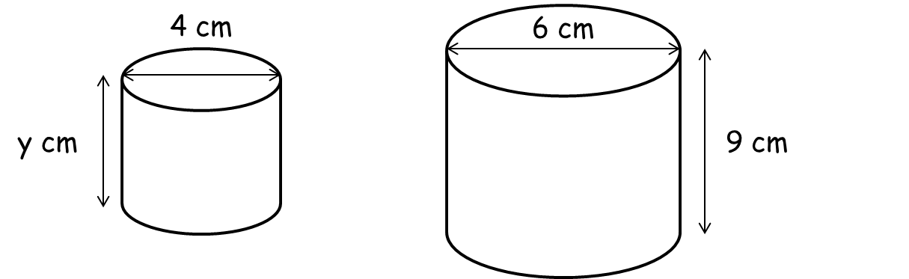

a) What is the height of the small cylinder? ________ cm

b) What is the volume scale factor? ________

6) The ratio of the volumes of two tetrahedrons is 1000:1. The smaller tetrahedron has a side length of 8 cm. What is the side length of the larger tetrahedron?

________ cm

7) Suppose that all pizzas have the same thickness and the cost and number of servings both depend only on the surface area. A pizza 10 inches in diameter costs £8.99 and serves 2 people.

- How much should a 14-inch pizza cost?

£ ________

- How many people would the 14-inch pizza serve?

________

8) A trophy that is 20 cm tall weighs 2 kg. A trophy of similar shape is 25 cm tall. How much does the larger trophy weigh? Assume that the weight is proportional to the volume in any solid.

________ kg

Similar Area and Volume AMBER

For each pair of similar solids, find the scale factor of the solid on the left to the solid on the right. Then find the ratios of the surface areas and the ratio of the volumes.

1) Linear scale factor: ________

Area scale factor: ________
(area SF = linear SF²)
Volume scale factor: ________
(volume SF = linear SF³)

2) Linear scale factor: ________

Area scale factor: ________
(area SF = linear SF²)
Volume scale factor: ________
(volume SF = linear SF³)

3) Linear scale factor: ________

Area scale factor: ________
(area SF = linear SF²)
Volume scale factor: ________
(volume SF = linear SF³)

4) Linear scale factor: ________

Area scale factor: ________
(area SF = linear SF²)
Volume scale factor: ________
(volume SF = linear SF³)

5) Look at the two cylinders shown below. The ratio of corresponding diameters is equal to the ratio of the corresponding heights.

a) What is the height of the small cylinder? ________ cm

b) What is the volume scale factor? ________

6) The ratio of the volumes of two tetrahedrons is 1000:1. The smaller tetrahedron has a side length of 8 cm. What is the side length of the larger tetrahedron?
Draw it!

________ cm

7) Suppose that all pizzas have the same thickness and the cost and number of servings both depend only on the surface area. A pizza 10 inches in diameter costs £8.99 and serves 2 people.
Linear SF = ____ , Area SF = ____

- How much should a 14-inch pizza cost?

£ ________

- How many people would the 14-inch pizza serve?

________

8) A trophy that is 20 cm tall weighs 2 kg. A trophy of similar shape is 25 cm tall. How much does the larger trophy weigh? Assume that the weight is proportional to the volume in any solid.
Linear SF = ____ , Volume SF = ____

________ kg

Similar Area and Volume RED

For each pair of similar solids, find the scale factor of the solid on the left to the solid on the right. Then find the ratios of the surface areas and the ratio of the volumes.

1) Linear scale factor: ________

Area scale factor: ________
(area SF = linear SF²)
Volume scale factor: ________
(volume SF = linear SF³)
Linear SF = 14 ÷ 7 = ____

2) Linear scale factor: ________

Area scale factor: ________
(area SF = linear SF²)
Volume scale factor: ________
(volume SF = linear SF³)

Linear SF = 12 ÷ 8 = ____

3) Linear scale factor: ________

Area scale factor: ________
(area SF = linear SF²)
Volume scale factor: ________
(volume SF = linear SF³)
Linear SF = 12 ÷ 9 = ____

4) Linear scale factor: ________

Area scale factor: ________
(area SF = linear SF²)
Volume scale factor: ________
(volume SF = linear SF³)
Linear SF = 15 ÷ 5 = ____

5) Look at the two cylinders shown below. The ratio of corresponding diameters is equal to the ratio of the corresponding heights.

a) What is the height of the small cylinder? ________ cm

b) What is the volume scale factor? ________

6) The ratio of the volumes of two tetrahedrons is 1000:1. The smaller tetrahedron has a side length of 8 cm. What is the side length of the larger tetrahedron?
Draw it!

________ cm

7) Suppose that all pizzas have the same thickness and the cost and number of servings both depend only on the surface area. A pizza 10 inches in diameter costs £8.99 and serves 2 people.
Linear SF = ____ , Area SF = ____

- How much should a 14-inch pizza cost?

£ ________

- How many people would the 14-inch pizza serve?

________

8) A trophy that is 20 cm tall weighs 2 kg. A trophy of similar shape is 25 cm tall. How much does the larger trophy weigh? Assume that the weight is proportional to the volume in any solid.
Linear SF = ____ , Volume SF = ____

________ kg

