Adding and Subtracting Fractions GREEN

When the denominators are not the same to start with, you need to use equivalent fractions to make them the same. Calculate the new denominators by finding the lowest common multiple of the original denominators. Don’t forget to multiply the numerators, too!

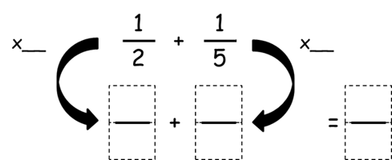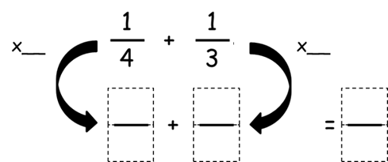

Adding and Subtracting Fractions AMBER

When the denominators are not the same to start with, you need to use equivalent fractions to make them the same. Calculate the new denominators by finding the lowest common multiple of the original denominators. Don’t forget to multiply the numerators, too!

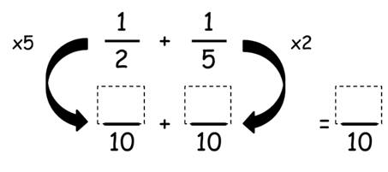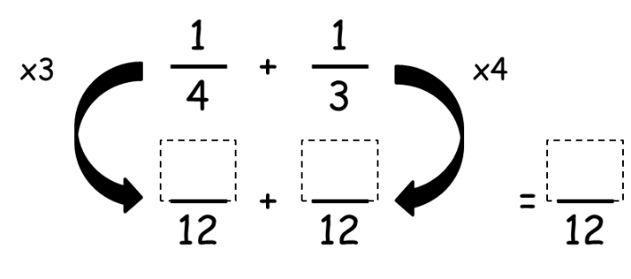

Adding and Subtracting Fractions RED

When the denominators are not the same to start with, you need to use equivalent fractions to make them the same. Calculate the new denominators by finding the lowest common multiple of the original denominators. Don’t forget to multiply the numerators, too!

