Problem Solving with Data Handling

Name: _____________________________________
Class: _____________________________________

Time: 1 hour 20 mins
Total marks available: 70 | Total marks achieved: _____

Q1.
* 14 students did a history test.
Here are the results.
Girls | 3 | 8 | 2 | 4 | 3 | 4 | 4 | 6
Boys | 3 | 6 | 3 | 3 | 1 | 4
Adele says,
"The range of the girls' marks is 1 more than the range of the boys' marks."
Is Adele right?
You must show your working.

(Total for Question is 3 marks)

Q2.
Heidi asks all the children in her class to tell her the sport they like best.
The pictogram shows how many children like swimming best, like netball best and like football best.
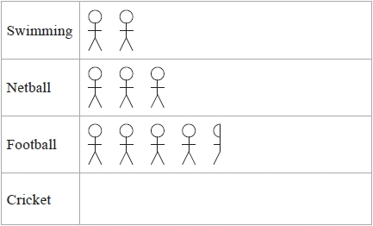
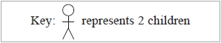
8 children like cricket best.
(a) Use this information to complete the pictogram.
(1)
(b) Work out the total number of children in Heidi's class.
...........................................................
(2)

(Total for question = 3 marks)

Q3.
Liz asks 20 people to name the flavour of chocolate they like best.
Here are her results.
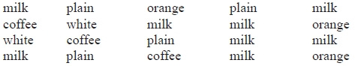
(a) Complete the frequency table.
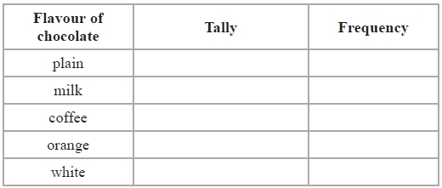
(2)
(b) On the grid, draw a suitable chart or diagram to show Liz's results.
(3)
(Total for Question is 5 marks)
Q4.
Milk is sold in pint bottles, in 1 pint bottles and in 2 pint bottles.
One weekend a shop sold 100 bottles of milk.
46 of the bottles were sold on Sunday.
15 of the bottles sold on Sunday were 2 pint bottles.
31 of the bottles sold on Saturday were pint bottles.
22 of the bottles sold were 2 pint bottles.
30 of the bottles sold were 1 pint bottles.
How many 1 pint bottles were sold on Sunday?
...........................................................

(Total for question = 4 marks)

Q5.
The table shows information about some students' favourite sports.
 | Football | Squash | Swimming | Tennis | Badminton
Boys | 10 | 5 | 6 | 4 | 3
Girls | 3 | 9 | 8 | 5 | 7
On the grid, draw a suitable diagram or chart for this information.
(Total for Question is 4 marks)

Q6.
There are 25 students in a class.
12 of the students are girls.
Here are the heights, in cm, of the 12 girls.
 | 160 | 173 | 148 | 154 | 152 | 164 | 179 | 164 | 162 | 174 | 168 | 170
(a) Show this information in an ordered stem and leaf diagram.

(3)
There are 13 boys in the class.
Here are the heights, in cm, of the 13 boys.
 | 157 | 159 | 162 | 166 | 168 | 169 | 170 | 173 | 174 | 176 | 176 | 181 | 184
* (b) Compare the heights of the boys with the heights of the girls.

(3)
(Total for Question is 6 marks)

Q7.
People can buy three types of plane tickets.
They can buy
an Economy ticket
a Premium ticket
or a Business ticket
200 people buy plane tickets.
92 males buy tickets
30 of the males buy Business tickets
62 females buy Economy tickets
A total of 44 people buy Business tickets.
A total of 60 people buy Premium tickets.
How many males buy Premium tickets?
You must show all your working.
...........................................................

(Total for question = 4 marks)

Q8.
A group of Year 10 students was asked to choose a new subject to study.
The table shows information about the choices.
Subject | Number of students
construction | 40
hairdressing | 56
tourism | 24
(a) Draw an accurate pie chart to show this information.

(3)

A group of Year 11 students was also asked to choose a new subject to study.
This pie chart shows information about their choices.
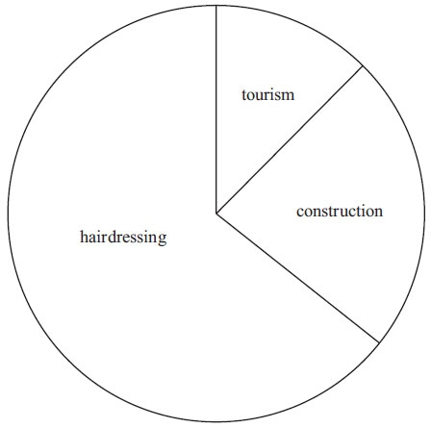

Danny says
"The pie charts show that hairdressing was chosen by more Year 11 students than by Year 10 students."
(b) Is Danny correct? . . . . . . . . . . . . . . . . . . . . . .
You must explain your answer.
..............................................................................................................................................

..............................................................................................................................................

..............................................................................................................................................

..............................................................................................................................................
(1)
(Total for Question is 4 marks)

Q9.
Jenny works in a shop that sells belts.
The table shows information about the waist sizes of 50 customers who bought belts from the shop in May.
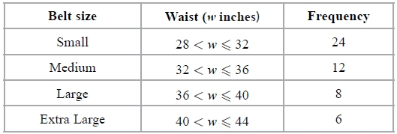
(a) Calculate an estimate for the mean waist size.
........................................................... inches
(3)
Belts are made in sizes Small, Medium, Large and Extra Large.
Jenny needs to order more belts in June.
The modal size of belts sold is Small.
Jenny is going to order ¾ of the belts in size Small.
The manager of the shop tells Jenny she should not order so many Small belts.
(b) Who is correct, Jenny or the manager?
You must give a reason for your answer.
.............................................................................................................................................
.............................................................................................................................................
(2)
(Total for question is 5 marks)
Q10.
Here is the number of goals scored by a football team in each of its first 10 games.
3 1 4 2 0 1 1 1 3 2
(a) Write down the mode.
...........................................................
(1)
(b) Work out the mean number of goals for the first 10 games.
...........................................................
(2)
In the 11th game the team scored 4 goals.
In the 12th game the team scored 2 goals.
*(c) Will the mean number of goals for the 12 games be greater than or less than the mean number of goals for the first 10 games?
You must explain your answer.
(2)
(Total for Question is 5 marks)

Q11.
Here are the heights, in metres, that 10 men jumped in a high jump competition.
2.19 | 2.23 | 2.23 | 2.23 | 2.26 | 2.28 | 2.29 | 2.29 | 2.31 | 2.33
(a) For these heights, find
(i) the mode,

. . . . . . . . . . . . . . . . . m
(ii) the mean,

. . . . . . . . . . . . . . . . . m
(iii) the range.

. . . . . . . . . . . . . . . . . m
(4)
In a high jump competition for women, the heights, in metres, that 10 women jumped were recorded.
For these heights
the mean was 1.95 m
the range was 0.18 m
(b) Compare the heights that the men jumped with the heights that the women jumped.
..............................................................................................................................................

..............................................................................................................................................

..............................................................................................................................................

..............................................................................................................................................
(2)
(Total for Question is 6 marks)

Q12.
Caroline and Marc are in a darts team.
The pie charts show information about the number of games Caroline and Marc each won last year.
They also show information about the number of games Caroline and Marc each lost last year.
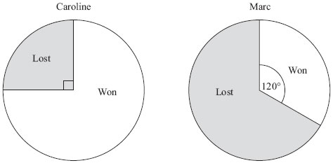
Caroline played 52 games.
Marc played 150 games.
Marc won more games than Caroline.
How many more?

..............................................................................................................................................
(Total for Question is 3 marks)

Q13.
Katie measured the length and the width of each of 10 pine cones from the same tree.
She used her results to draw this scatter graph.
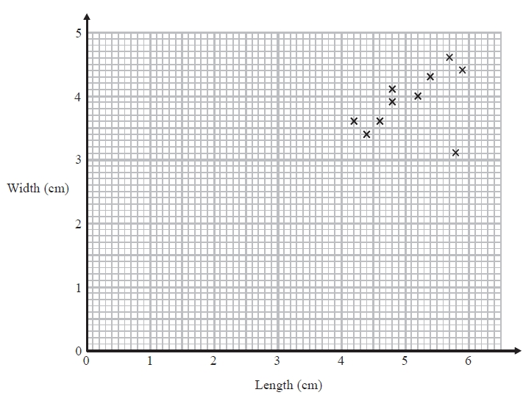
(a) Describe one improvement Katie can make to her scatter graph.
.............................................................................................................................................
.............................................................................................................................................
(1)
The point representing the results for one of the pine cones is an outlier.
(b) Explain how the results for this pine cone differ from the results for the other pine
cones.
.............................................................................................................................................
.............................................................................................................................................
(1)

(Total for question = 2 marks)

Q14.
There are 1200 students at a school.
Kate is helping to organise a party.
She is going to order pizza.
Kate takes a sample of 60 of the students at the school.
She asks each student to tell her one type of pizza they want.
The table shows information about her results.
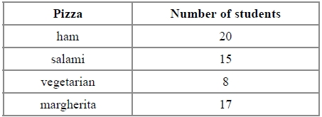
Work out how much ham pizza Kate should order.
Write down any assumption you make and explain how this could affect your answer.
.............................................................................................................................................
.............................................................................................................................................

(Total for question = 3 marks)

Q15.
Michael carried out a survey of the time, in minutes, it takes the 20 people in his office to get to work. This table gives some information about his results.
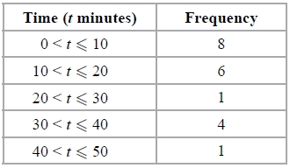
Michael used this information to work out the mean of the times taken.
He got an answer of 68 minutes.
(a) Explain why it is impossible for the mean time to be 68 minutes.
(1)
The 20 people in the survey had:
a mean age of 45 years
a median age of 41 years
Michael decides to include his age so that he works out the mean age and median age of 21 people.
Michael is 42 years old.
Here are two statements about the ages of the 21 people.
Statement 1: The mean age of the 21 people is less than 45 years.
Statement 2: The median age of the 21 people is more than 41 years.
(b) (i) Is statement 1 correct?
You must give a reason to support your answer.
(ii) Is statement 2 correct?
You must give a reason to support your answer.
(2)
(Total for question = 3 marks)
Q16.
Imran carried out a survey on the wearing of cycle helmets by the men and the women living in his village.
He used the information he collected to draw two pie charts.
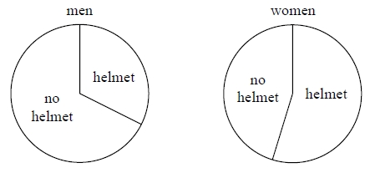
Mary looks at the two pie charts.
She says:
"The pie charts show that more women wear helmets than men."
(a) Is Mary right?
You must explain your answer.
(1)
Imran chose to draw pie charts to display the results of his survey.
(b) Are pie charts the best way to show this information?
You must explain your answer.
(1)

(Total for question = 2 marks)

Q17.
The manager of a clothes shop recorded the size of each dress sold one morning.
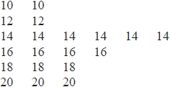
The sizes of dresses are always even numbers.
The mean size of the dresses sold that morning is 15.3
The manager says,

"The mean size of the dresses is not a very useful average."

(i) Explain why the manager is right.
.............................................................................................................................................
.............................................................................................................................................
(ii) Which is the more useful average for the manager to know, the median or the mode?
You must give a reason for your answer.
.............................................................................................................................................
.............................................................................................................................................
.............................................................................................................................................

(Total for question is 2 marks)

Q18.
The pie charts show some information about the numbers of medals won by Germany and by the Russian Federation in the 2010 Winter Olympics.
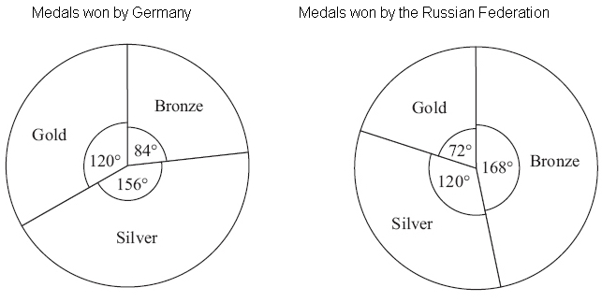
Germany won 7 bronze medals.
(a) How many gold medals did Germany win?

..............................................................................................................................................
(2)
(b) Graham says,
'The pie charts show that Germany won more gold medals than the Russian Federation'.
Is Graham right? ...................
You must explain your answer.
..............................................................................................................................................

..............................................................................................................................................
(1)
(Total for Question is 3 marks)

Q19.
Ed has 4 cards.
There is a number on each card.
The mean of the 4 numbers on Ed's cards is 10
Work out the number on the 4th card.

. . . . . . . . . . . . . . . . . . . . . .
(Total for Question is 3 marks)

