**Probability (H)**

Intervention Booklet

Name: _______________________________

Class: _______________________________

**Useful websites:**

**www.mathswatchvle.com**

*(Video explanations and questions)*

Username: STH…@twgash

Password: stmaths

**www.methodmaths.com**

*(Past papers online that get instantly marked)*

Centre ID: wga

Username: firstname

Password: lastname

**www.hegartymaths.com**

*(Online tutorials and quizzes)*

Login: first name and last name are case sensitive

**www.bbc.co.uk/schools/gcsebitesize/maths**

**Set Theory**

**Things to remember:**

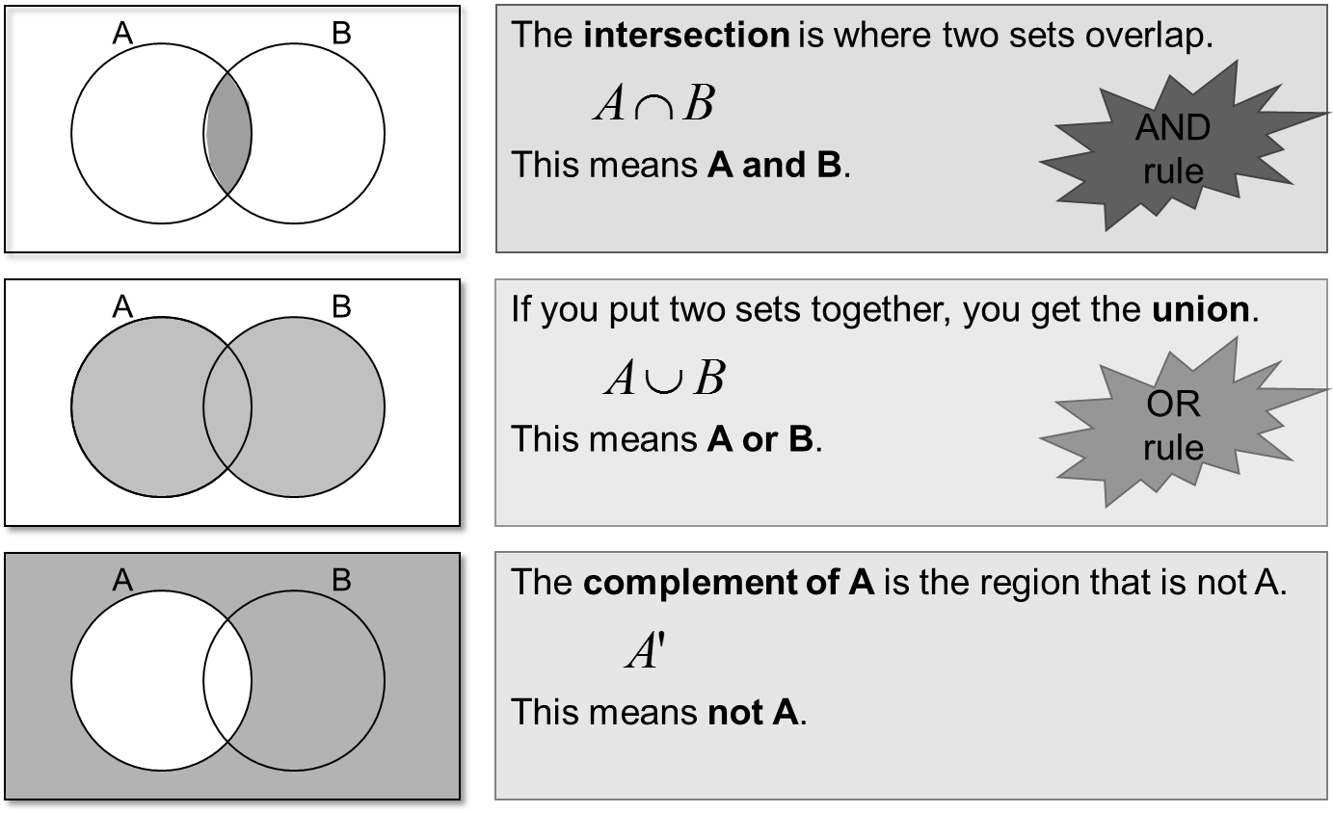

**Questions:**

**1.**

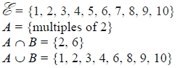

Draw a Venn diagram for this information.

**(Total for question is 4 marks)**

**2.** Sami asked 50 people which drinks they liked from tea, coffee and milk.

All 50 people like at least one of the drinks   
19 people like all three drinks.   
16 people like tea and coffee but do not like milk.   
21 people like coffee and milk.   
24 people like tea and milk.   
40 people like coffee.   
1 person likes only milk.

Sami selects at random one of the 50 people.

(a)   Work out the probability that this person likes tea.

...........................................................

**(4)**

(b)   Given that the person selected at random from the 50 people likes tea, find the probability that this person also likes exactly one other drink.

...........................................................

**(2)**

**(Total for question = 6 marks)**

**Probability Trees**

**Things to remember:**

* The branches must sum to 1;
* Read the question carefully to decide if it is with replacement or without replacement;
* AND means x and OR means +.

**Questions:**

**1.** Amy has 10 CDs in a CD holder.  
Amy’s favourite group is Edex.  
She has 6 Edex CDs in the CD holder.

Amy takes one of these CDs at random.  
She writes down whether or not it is an Edex CD.  
She puts the CD back in the holder.  
Amy again takes one of these CDs at random.

(a) Complete the probability tree diagram.



**(2)**

Amy had 30 CDs.  
The mean playing time of these 30 CDs was 42 minutes.

Amy sold 5 of her CDs.  
The mean playing time of the 25 CDs left was 42.8 minutes.

(b) Calculate the mean playing time of the 5 CDs that Amy sold.

........................................................... minutes

**(3)**

**(Total 5 marks)**

**2.** Amy is going to play one game of snooker and one game of billiards.

The probability that she will win the game of snooker is

The probability that she will win the game of billiards is

Complete the probability tree diagram.

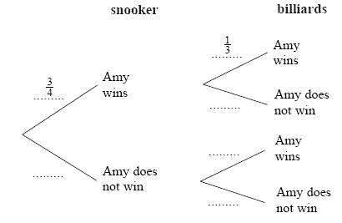

**(Total 2 marks)**

**3.** Loren has two bags.  
The first bag contains 3 red counters and 2 blue counters.  
The second bag contains 2 red counters and 5 blue counters.

Loren takes one counter at random from each bag.

Complete the probability tree diagram.



**(Total 2 marks)**

**4.** Julie has 100 music CDs. 58 of the CDs are classical. 22 of the CDs are folk. The rest of the CDs are jazz. On Saturday, Julie chooses one CD at random from the 100 CDs. On Sunday, Julie chooses one CD at random from the 100 CDs.

(a) Complete the probability tree diagram.

**(2)**



(b) Calculate the probability that Julie will choose a jazz CD on **both** Saturday and  
Sunday.

...........................................................

**(2)**

(c) Calculate the probability that Julie will choose at least one jazz CD on Saturday and  
Sunday.

...........................................................

**(3)**

**(Total 7 marks)**

**Conditional Probability**

**Things to remember:**

* The branches of probability trees must sum to 1.
* AND means x and OR means +.
* The second event is dependent on the first in all of these questions – read the question carefully to decide how the probability of the second event will differ from the first.

**Questions**

**1**. The probability that it will rain on a day in June is 0.2

When it rains the probability that my tennis match is cancelled is 0.7

When it does not rain, the probability that my tennis match is not cancelled is 0.95

(a)   Complete the probability tree diagram for this information.

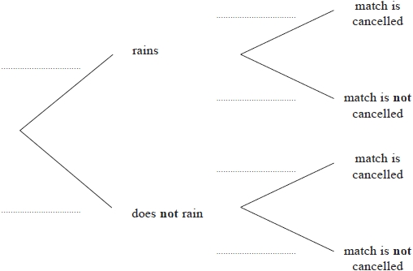

**(3)**

(b)   Work out the probability that, on a day in June, it does not rain and my tennis match is cancelled.

...........................................................

**(2)**

**(Total for question = 5 marks)**

**2**. There are 8 counters in a box.   
The letter A is on 6 of the counters.   
The letter B is on the other 2 counters.

Sally takes at random a counter from the box.   
She keeps the counter.   
Then Tina takes at random a counter from the box.

(a)   Complete the probability tree diagram.

Sally                 Tina

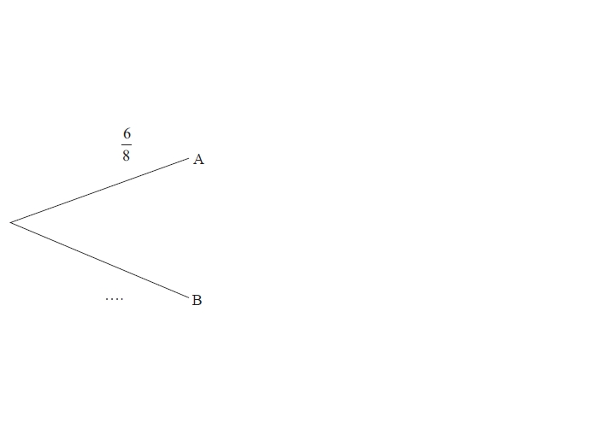

**(3)**

(b)   Work out the probability that both Sally and Tina take a counter with the letter A on it.

...........................................................

**(2)**

(c)  Work out the probability that at least one counter with the letter A on it is taken.

...........................................................

**(3)**

**(Total for question = 8 marks)**

**3**. Here are 9 cards.   
Each card has a shape on it.

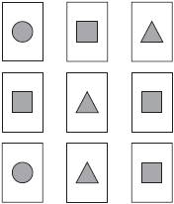

In a game the cards are turned over so that the shapes are hidden.   
The cards are then mixed up.

Katie turns over at random two of the cards.

Work out the probability that these two cards have different shapes on them.   
You must show all your working.

...........................................................

**(Total for question = 4 marks)**

**4**. Nomusa has 30 sweets.

She has

18 fruit sweets   
7 aniseed sweets   
5 mint sweets

Nomusa is going to take at random two sweets.

Work out the probability that the two sweets will not be the same type of sweet.   
You must show all your working.

...........................................................

**(Total for question = 4 marks)**

**5**. There are 11 counters in a bag.

4 of the counters are blue.   
7 of the counters are green.

Maria takes at random a counter from the bag.   
She keeps the counter.   
She then takes at random another counter from the bag.

Work out the probability that Maria takes one counter of each colour.   
You must show your working.

...........................................................

**(Total for question = 4 marks)**

**Probability with Algebra**

**Things to remember:**

* Think about what you already know about probability – all this still applies!
* Start by writing out the expression or equation, simplify it afterwards if you can.

**Questions**

**1**. Mary plays a game of throwing a ball at a target.

The table shows information about the probability of each possible score.

|  |  |  |  |  |  |  |
| --- | --- | --- | --- | --- | --- | --- |
| Score | 0 | 1 | 2 | 3 | 4 | 6 |
| Probability | 0.09 | *x* | 3*x* | 0.16 | 0.21 | 0.30 |

Mary is 3 times as likely to score 2 points than to score 1 point.

(a) Work out the value of *x*.

      ...........................................................

**(3)**

Mary plays the game twice.

(b) Work out the probability of Mary scoring a total of 8

      ...........................................................

**(3)**

**(Total for Question is 6 marks)**

**2**. There are only red counters, yellow counters, blue counters and green counters in a bag.   
Olu takes at random a counter from the bag.

The table shows each of the probabilities.

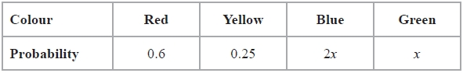

The probability that Olu will take a blue counter is twice the probability that he will take a green counter.

(a)   Work out the value of *x*.

...........................................................

**(3)**

Olu takes a counter from the bag.   
He writes down the colour of the counter.   
He puts the counter back in the bag.

Olu does this 50 times.

(b)   Work out an estimate for the number of times that Olu takes a red counter from the bag.

...........................................................

**(2)**

**(Total for question = 5 marks)**

**3**. The probability that Rebecca will win any game of snooker is *p*.  
She plays two games of snooker.

(a) Complete, in terms of *p*, the probability tree diagram.

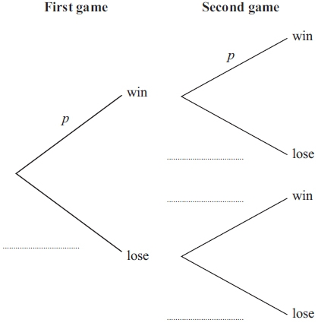

**(2)**

(b) Write down an expression, in terms of *p*, for the probability that Rebecca will win both games.

      ...........................................................

**(1)**

(c) Write down an expression, in terms of *p*, for the probability that Rebecca will win exactly one of the games.

      ...........................................................

**(2)**

**(Total for Question is 5 marks)**

**4.** There are *y* black socks and 5 white socks in a drawer.

Joshua takes at random two socks from the drawer.

The probability that Joshua takes one white sock and one black sock is 

(a)   Show that 3*y*2 – 28*y* + 60 = 0

**(4)**

(b)  Find the probability that Joshua takes two black socks.

...........................................................

**(3)**

**(Total for question = 7 marks)**

**5**. There are *n* sweets in a bag.   
6 of the sweets are orange.   
The rest of the sweets are yellow.

Hannah takes at random a sweet from the bag.   
She eats the sweet.

Hannah then takes at random another sweet from the bag.   
She eats the sweet.

The probability that Hannah eats two orange sweets is 

(a)   Show that *n*2 − *n* − 90 = 0

**(3)**

(b)   Solve *n*2 − *n* − 90 = 0 to find the value of *n*.

...........................................................

**(3)**

**(Total for question = 6 marks)**