Trapezium Rule GREEN

1. Here is a speed-time graph for a train.

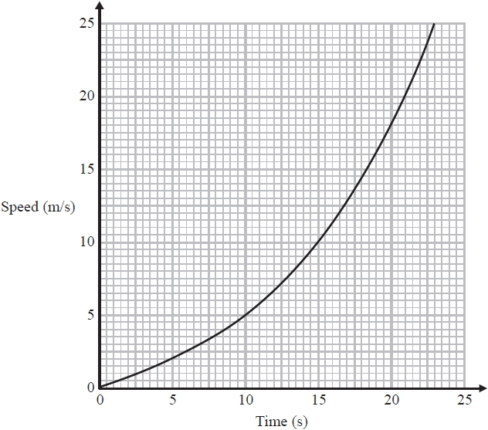

a) Work out an estimate for the distance the train travelled in the first 20 seconds. Use 4 strips of equal width.

b) Is your answer to (a) an underestimate or an overestimate of the actual distance the train travelled? Give a reason for your answer.

2. A car moves from rest. The graph gives information about the speed, $v$ metres per second, of the car $t$ seconds after it starts to move.

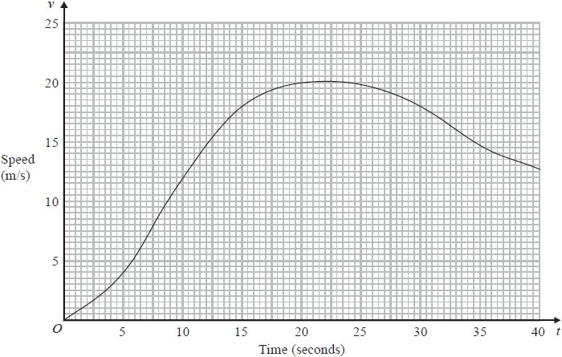

a) i) Calculate an estimate of the gradient of the graph at
$t=15$

ii) Describe what your answer to part (i) represents.

b) Work out an estimate for the distance the car travels in the first 20 seconds of its journey. Use 4 strips of equal width.

3. Here is a speed-time graph for a car.

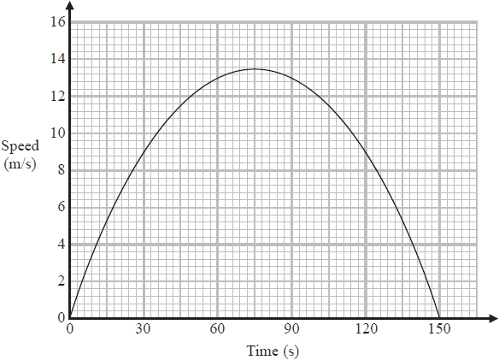

a) Work out an estimate for the distance the car travelled in the first 30 seconds.

b) Is your answer to part (a) an underestimate or an overestimate of the actual distance the car travelled in the first 30 seconds? Give a reason for your answer.

Julian used the graph to answer this question.

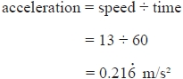
Here is Julian's working. Julian's method does not give a good estimate of the acceleration at time 60 seconds.

c) Explain why.
4. The graph shows the speed of a car, in metres per second, during the first 20 seconds of a journey.

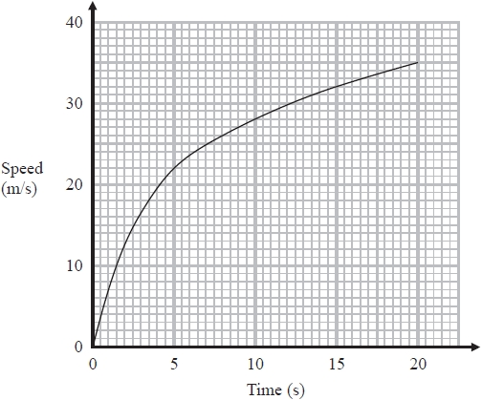

a) Work out an estimate for the distance the car travelled in the first 20 seconds. Use 4 strips of equal width.

b) Is your answer to part (a) an underestimate or an overestimate of the actual distance the car travelled in the first 20 seconds? Give a reason for your answer.

Trapezium Rule AMBER

1. Here is a speed-time graph for a train.

a) Work out an estimate for the distance the train travelled in the first 20 seconds. Use 4 strips of equal width.

b) Is your answer to (a) an underestimate or an overestimate of the actual distance the train travelled? Give a reason for your answer.

2. A car moves from rest. The graph gives information about the speed, $v$ metres per second, of the car $t$ seconds after it starts to move.

a) i) Calculate an estimate of the gradient of the graph at
$t=15$

ii) Describe what your answer to part (i) represents.

b) Work out an estimate for the distance the car travels in the first 20 seconds of its journey. Use 4 strips of equal width.

3. Here is a speed-time graph for a car.

a) Work out an estimate for the distance the car travelled in the first 30 seconds.

b) Is your answer to part (a) an underestimate or an overestimate of the actual distance the car travelled in the first 30 seconds? Give a reason for your answer.

Julian used the graph to answer this question.

Here is Julian's working. Julian's method does not give a good estimate of the acceleration at time 60 seconds.

c) Explain why.

4. The graph shows the speed of a car, in metres per second, during the first 20 seconds of a journey.

a) Work out an estimate for the distance the car travelled in the first 20 seconds. Use 4 strips of equal width.

b) Is your answer to part (a) an underestimate or an overestimate of the actual distance the car travelled in the first 20 seconds? Give a reason for your answer.

Trapezium Rule RED

1. Here is a speed-time graph for a train.

a) Work out an estimate for the distance the train travelled in the first 20 seconds. Use 4 strips of equal width.
Hint: Calculate the area under the graph!

b) Is your answer to (a) an underestimate or an overestimate of the actual distance the train travelled? Give a reason for your answer.
Is your area bigger or smaller than the actual area under the graph?

2. A car moves from rest. The graph gives information about the speed, $v$ metres per second, of the car $t$ seconds after it starts to move.

a) i) Calculate an estimate of the gradient of the graph at
$t=15$
$\frac{\text{rise}}{\text{run}}\text{=}$

ii) Describe what your answer to part (i) represents.
Rate of change in context…

b) Work out an estimate for the distance the car travels in the first 20 seconds of its journey. Use 4 strips of equal width.

3. Here is a speed-time graph for a car.

a) Work out an estimate for the distance the car travelled in the first 30 seconds.

b) Is your answer to part (a) an underestimate or an overestimate of the actual distance the car travelled in the first 30 seconds? Give a reason for your answer.

Julian used the graph to answer this question.

Here is Julian's working. Julian's method does not give a good estimate of the acceleration at time 60 seconds.

c) Explain why.

4. The graph shows the speed of a car, in metres per second, during the first 20 seconds of a journey.

a) Work out an estimate for the distance the car travelled in the first 20 seconds. Use 4 strips of equal width.

b) Is your answer to part (a) an underestimate or an overestimate of the actual distance the car travelled in the first 20 seconds? Give a reason for your answer.

