Using Scales GREEN

Draw an arrow at the correct measurement on each scale.

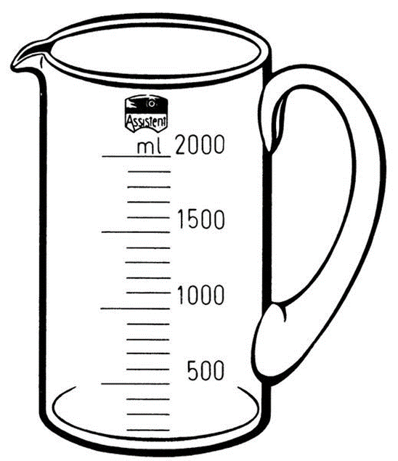  1000 ml | 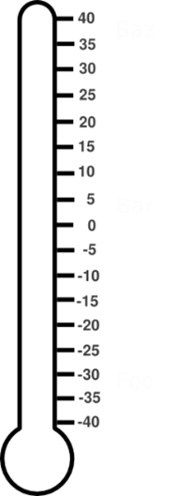  -25°C | 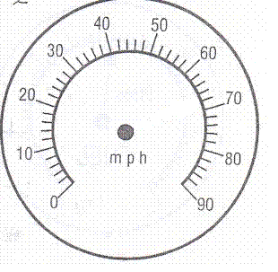  35 mph
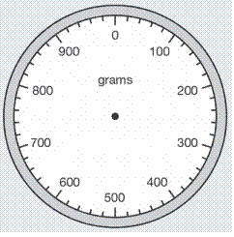  640 grams | 68 mph | 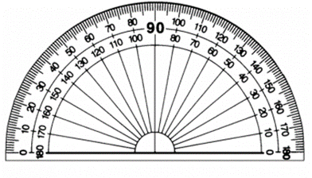  110°
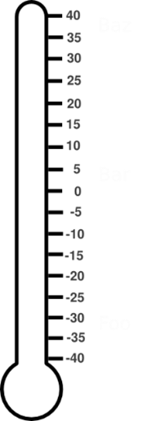  18 °C | 700 ml | 310 grams

Using Scales AMBER

Draw an arrow at the correct measurement on each scale. Think about which numbers the arrow will be between.

1000 ml | -25°C | 35 mph
640 grams | 68 mph | 110°
18 °C | 700 ml | 310 grams

Using Scales RED

Draw an arrow at the correct measurement on each scale. Use the circle to help identify roughly where to draw your arrow!

1000 ml | -25°C | 35 mph
640 grams | 68 mph | 110°
18 °C | 700 ml | 310 grams

