Interpreting Pie Charts GREEN

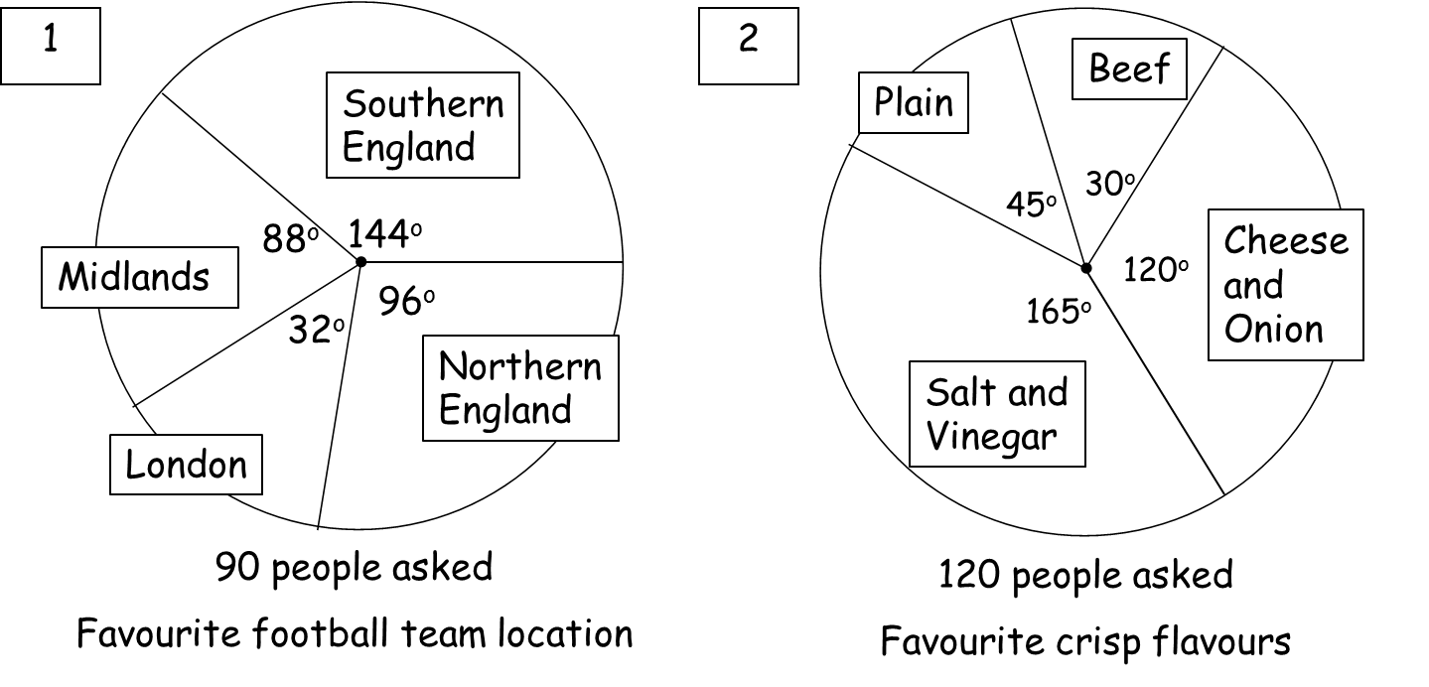

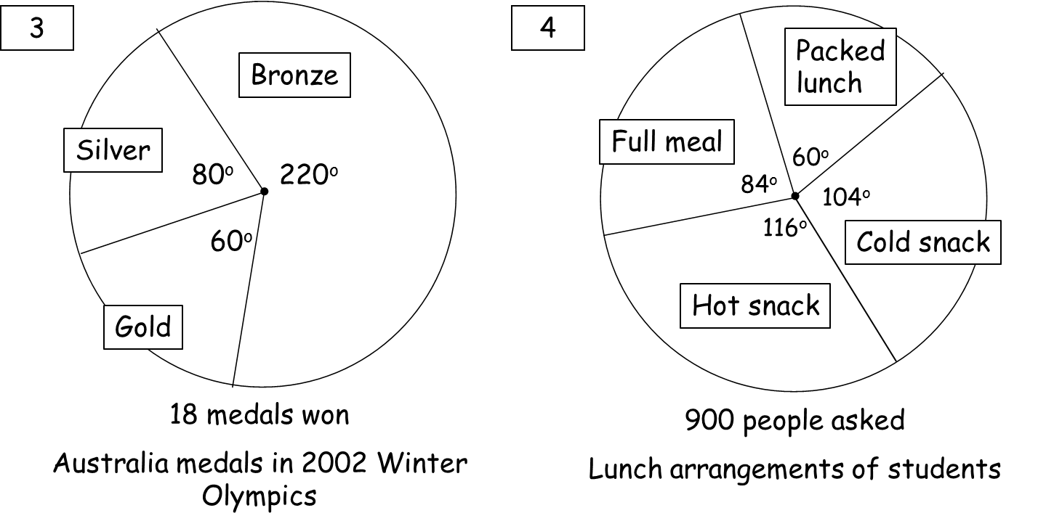

Interpreting Pie Charts AMBER

Location | Frequency | Angle |  | Flavour | Frequency | Angle
Total |  |  |  | Total

Medals | Frequency | Angle |  | Lunch | Frequency | Angle
Total |  |  |  | Total

Interpreting Pie Charts AMBER

Location | Frequency | Angle |  | Flavour | Frequency | Angle
Sth England |  | 144°
Nth England |  | 96°
London |  | 32°
Midlands |  | 88°
Total | 90 | 360° |  | Total | 120 | 360°

Medals | Frequency | Angle |  | Lunch | Frequency | Angle
Total | 18 | 360° |  | Total | 900 | 360°

