Mathematics Assessment

Bands 5-7 Problem Solving – Test 1
Calculators allowed on questions with this symbol:

Name: ______________________________

Class: ______________________________

Teacher: ______________________________

Remember:
- The test is 1 hour long.
- You will need: pen, pencil, rubber and a ruler.
- Try to answer all questions.
- Write all your answers and working in the spaces provided in this test paper – do not use any rough paper. Marks may be awarded for working.
- Check your work carefully.
- Don’t spend too long on one question. Leave it and try the next one.

Formulae Sheet
Perimeter, area, surface area and volume formulae
Sphere | Cone
Volume = $\frac{4}{3}$ πr³  Surface Area = 4πr² | Volume = $\frac{1}{3}$ πr²h  Curved Surface Area = πrl

1. | A 20 Euro note is a rectangle 133 mm long and 72 mm wide. A 500 Euro Note is a rectangle 165 mm long and 82 mm wide. Show that the two rectangles are not mathematically similar.  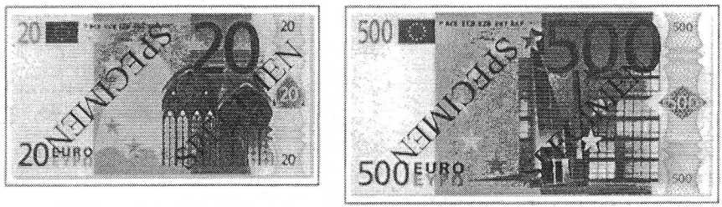  Not drawn accurately. | / 3
2. | A water molecule has a mass of 3 x 10⁻²⁹ kg. A bottle contains 1.7 x 10²⁸ molecules of water. Calculate the mass of the water in the bottle.  _____________ kg | / 3
3. | A scientist wishes to find out how many fish are in a lake. He catches 40 fish and marks them with a small tag. Two weeks later he returns to the lake and catches another 40 fish. Five of the fish he catches are tagged. Estimate how many fish are in the lake.  _____________ | / 3
4. | Two rectangles have the same area. Calculate the value of x.  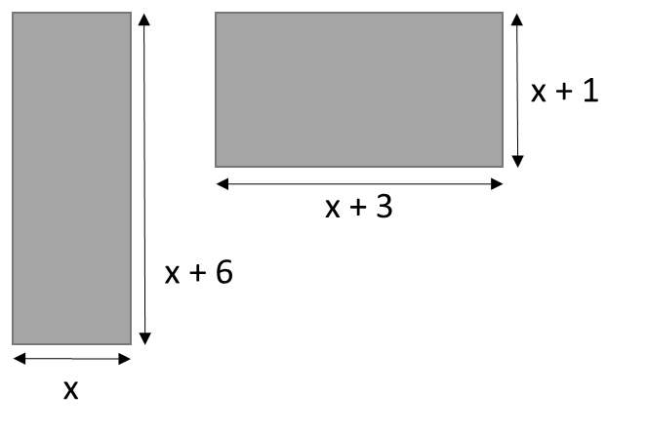  x = _____________ | / 4
5. | A tree can be planted between 10 m and 4 m from corner C. It must be planted at least 14 m from the house. Accurately shade the region where the tree could be planted.  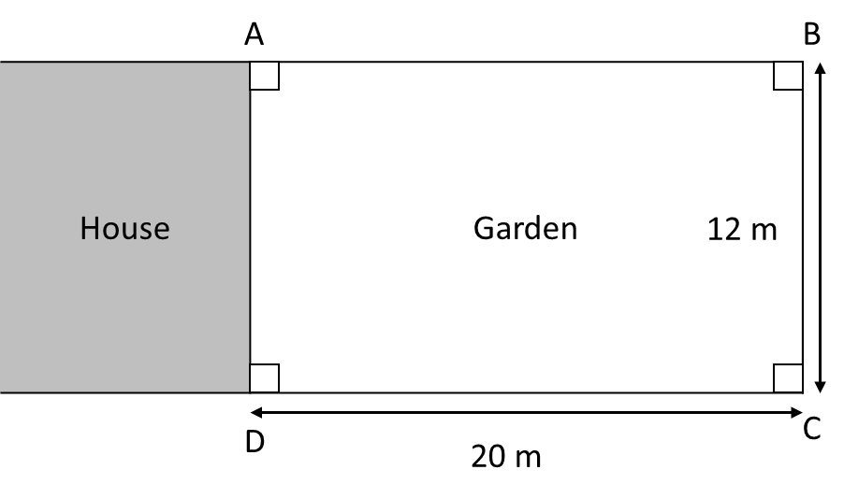  Scale: 1 cm to 2 m | / 4
6. | An internet auction has two identical cars for sale. Both cars are priced at £10 000. The price of each car is to be reduced each week until they are sold. The first car is reduced by 10% each week. The second car is reduced by £800 each week. Assuming that no one buys the cars, after how many weeks will the second car be cheaper than the first? You must show your working. | / 4

7. | The table shows the distances jumped by two athletes training for a long jump event. At the long jump event, both athletes must compete against the current champion who jumped 8.31 m. By considering averages, explain who has the better chance of beating him. You must explain your answer.  Distance (d m) Ben’s frequency Jamie’s frequency  6.5 ≤ d < 7.0 3 8  7.0 ≤ d < 7.5 7 18  7.5 ≤ d < 8.0 25 21  8.0 ≤ d < 8.5 1 3  8.5 ≤ d < 9.0 0 1 | / 7

8. | A rectangle is made using four straight lines on centimetre square paper. Three of these lines are shown on the grid. The point (-4, 0) lies on the missing side. Work out the equation of the missing side.  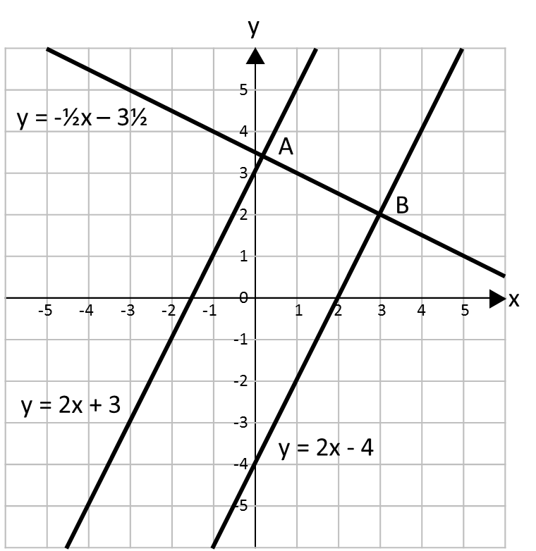  ___________________________ | / 4

9. | The diagram below shows a hexagon. All the measurements are in centimetres. The area of this shape is 102 cm². Work out the length of the longest side of the shape.  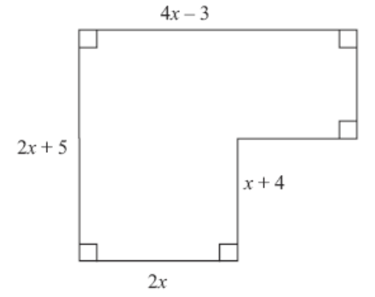  ________________ cm | / 6

10 | Calculate the length of the side of the largest square that fits inside a 12 cm diameter circle. Give your answer correct to 2 decimal places.  ___________________ cm | / 5
11. | Use vectors to show that P(1, 3), Q(4, 6) and R(10, 12) are collinear. | / 6

