Inverse Functions GREEN
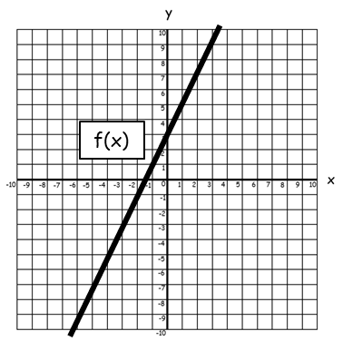
1. Given that $f(x)=2x+3$,
a) Sketch the graph of $f^{-1}(x)$
b) Determine the equation of $f^{-1}(x)$.

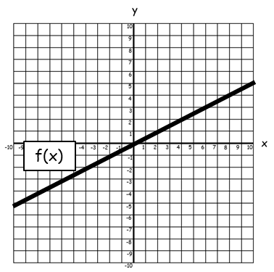
2. Given that $f(x)=\frac{x}{2}$,
a) Sketch the graph of $f^{-1}(x)$
b) Determine the equation of $f^{-1}(x)$.

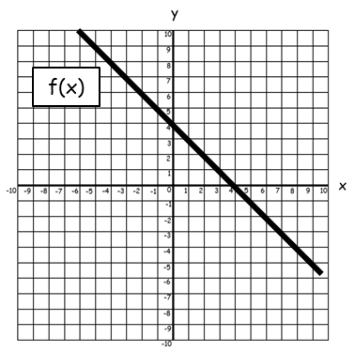
3. Given that $f(x)=4-x$,
a) Sketch the graph of $f^{-1}(x)$.
b) Determine the equation of $f^{-1}(x)$.

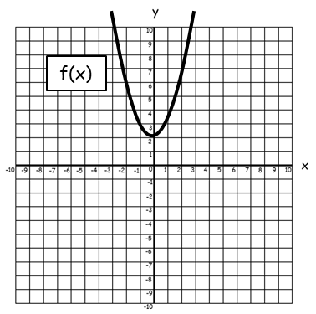
4. Given that $f(x)=x²+2$,
a) Sketch the graph of $f^{-1}(x)$.
b) Determine the equation of $f^{-1}(x)$.

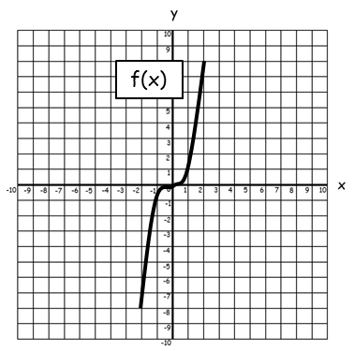

5. Given that $f(x)=x³$,
a) Sketch the graph of $f^{-1}(x)$.
b) Determine the equation of $f^{-1}(x)$.

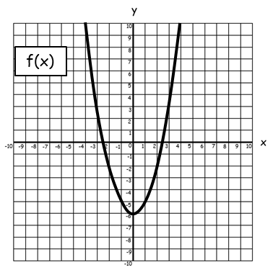
6. Given that $f(x)=x²-6$,
a) Sketch the graph of $f^{-1}(x)$.
b) Determine the equation of $f^{-1}(x)$.

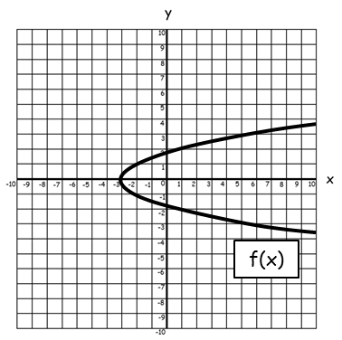
7. Given that $f(x)=\sqrt{x-3}$,
a) Sketch the graph of $f^{-1}(x)$.
b) Determine the equation of $f^{-1}(x)$.

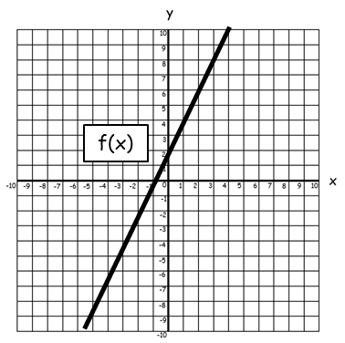
8. Given that $f\left(x\right)=2x+\frac{5}{3}$,
a) Sketch the graph of $f^{-1}(x)$.
b) Determine the equation of $f^{-1}(x)$.

Inverse Functions AMBER
1. Given that $f(x)=2x+3$,
a) Sketch the graph of $f^{-1}(x)$.
b) Determine the equation of $f^{-1}(x)$.
Hint: Let $f(x)=y$ and rearrange to make $x$ the subject.

$y=2x+3$

2. Given that $f(x)=\frac{x}{2}$,
a) Sketch the graph of $f^{-1}(x)$.
b) Determine the equation of $f^{-1}(x)$.
Hint: Let $f(x)=y$ and rearrange to make $x$ the subject.

3. Given that $f(x)=4-x$,
a) Sketch the graph of $f^{-1}(x)$.
b) Determine the equation of $f^{-1}(x)$.
Hint: Let $f(x)=y$ and rearrange to make $x$ the subject.

4. Given that $f(x)=x²+2$,
a) Sketch the graph of $f^{-1}(x)$.
b) Determine the equation of $f^{-1}(x)$.

5. Given that $f(x)=x³$,
a) Sketch the graph of $f^{-1}(x)$.
b) Determine the equation of $f^{-1}(x)$.

6. Given that $f(x)=x²-6$,
a) Sketch the graph of $f^{-1}(x)$.
b) Determine the equation of $f^{-1}(x)$.

7. Given that $f(x)=\sqrt{x-3}$,
a) Sketch the graph of $f^{-1}(x)$.
b) Determine the equation of $f^{-1}(x)$.

8. Given that $f\left(x\right)=2x+\frac{5}{3}$,
a) Sketch the graph of $f^{-1}(x)$.
b) Determine the equation of $f^{-1}(x)$.

Inverse Functions RED
1. Given that $f(x)=2x+3$,
a) Sketch the graph of $f^{-1}(x)$.
b) Determine the equation of $f^{-1}(x)$.
Hint: Let $f(x)=y$ and rearrange to make $x$ the subject.

$y=2x+3$
$y–3=2x$
$=x$

Therefore $f^{-1}\left(x\right)=$
Reflect the graph in $y=x$

2. Given that $f(x)=\frac{x}{2}$,
a) Sketch the graph of $f^{-1}(x)$.
b) Determine the equation of $f^{-1}(x)$.
Hint: Let $f(x)=y$ and rearrange to make $x$ the subject.

$y=\frac{x}{2}$

3. Given that $f(x)=4-x$,
a) Sketch the graph of $f^{-1}(x)$.
b) Determine the equation of $f^{-1}(x)$.
Hint: Let $f(x)=y$ and rearrange to make $x$ the subject.

4. Given that $f(x)=x²+2$,
a) Sketch the graph of $f^{-1}(x)$.
b) Determine the equation of $f^{-1}(x)$.

5. Given that $f(x)=x³$,
a) Sketch the graph of $f^{-1}(x)$.
b) Determine the equation of $f^{-1}(x)$.

6. Given that $f(x)=x²-6$,
a) Sketch the graph of $f^{-1}(x)$.
b) Determine the equation of $f^{-1}(x)$.

7. Given that $f(x)=\sqrt{x-3}$,
a) Sketch the graph of $f^{-1}(x)$.
b) Determine the equation of $f^{-1}(x)$.

8. Given that $f\left(x\right)=2x+\frac{5}{3}$,
a) Sketch the graph of $f^{-1}(x)$.
b) Determine the equation of $f^{-1}(x)$.

