Statistical Inquiry (F)

Pre-Intervention Assessment

Name: _______________________________

Class: _______________________________

Date: _______________________________

Question | Objective | RAG
1 | Calculate averages from a set of data
2 | Understand and apply types of sampling
3 | Calculate averages from a table

1. Chloe made a list of her homework marks.
4 5 5 5 4 3 2 1 4 5
(a) Write down the mode of her homework marks.

…………………….
(b) Work out her mean homework mark.

…………………….

2. The table shows information about 1065 students.
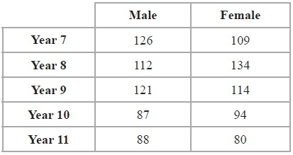
Elena takes a stratified sample of 120 students by year group and by gender.
Work out the number of Year 8 female students in her sample.

...........................................................

3. Fred did a survey on the areas of pictures in a newspaper.
The table gives information about the areas.

Area (A cm²) | Frequency
0 < A ≤ 10 | 38
10 < A ≤ 25 | 36
25 < A ≤ 40 | 30
40 < A ≤ 60 | 46

Work out an estimate for the mean area of a picture.

........................................................... cm²

[Glue here]

