End of Unit Test Name: ____________________________
Volume and Surface Area - FOUNDATION

1. Work out the volume of the cuboid. State the units of your answer.

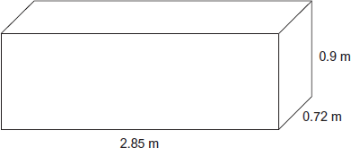

………………………………………………………………………………………………………...

………………………………………………………………………………………………………...

………………………………………………………………………………………………………...

………………………………………………………………………………………………………...

Answer ......................................................................
(Total 3 marks)

2. Here is the net of a cuboid. The net shows the area of each face. Not drawn accurately
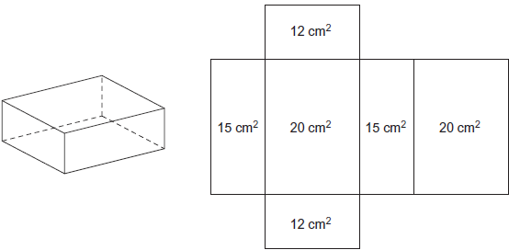
Work out the volume of the cuboid.

………………………………………………………………………………………………………...

………………………………………………………………………………………………………...

………………………………………………………………………………………………………...

………………………………………………………………………………………………………...

Answer ............................................................... cm³
(Total 3 marks)

3. The total surface area of a cube is 384 cm². Work out the volume of the cube.

………………………………………………………………………………………………………...

………………………………………………………………………………………………………...

………………………………………………………………………………………………………...

………………………………………………………………………………………………………...

………………………………………………………………………………………………………...

………………………………………………………………………………………………………...

Answer ...................................................................... cm³
(Total 4 marks)

4. Calculate the volume of the prism. State the units of your answer.

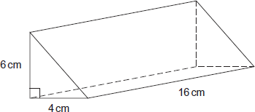

………………………………………………………………………………………………………...

………………………………………………………………………………………………………...

………………………………………………………………………………………………………...

………………………………………………………………………………………………………...

………………………………………………………………………………………………………...

Answer ......................................................................
(Total 4 marks)

5. The radius, r, of the cylinder is 10 cm. The height, h, is 4 cm. The volume, V, of a cylinder is V = πr²h. Work out the volume of the cylinder. Use π = 3.1

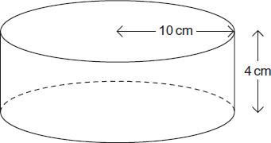

………………………………………………………………………………………………………...

………………………………………………………………………………………………………...

………………………………………………………………………………………………………...

………………………………………………………………………………………………………...

………………………………………………………………………………………………………...

………………………………………………………………………………………………………...

………………………………………………………………………………………………………...

Answer ...................................................................... cm³
(Total 3 marks)
6. A tank contains 0.6m³ of water. The water is used to fill pots. Each pot can hold 1200 cm³
of water. How many pots can be filled?

………………………………………………………………………………………………………...

………………………………………………………………………………………………………...

………………………………………………………………………………………………………...

………………………………………………………………………………………………………...

………………………………………………………………………………………………………...

Answer ......................................................................
(Total 3 marks)
(Total for test = 20 marks)

