End of Unit Test Name: ____________________________
Fractions, Decimals and Percentages - FOUNDATION

1. (a) Write 30% as a fraction.

…………………………………………………………………………………………………

…………………………………………………………………………………………………

Answer ......................................................................
(1)
(b) Write 80% as a decimal.

…………………………………………………………………………………………………

…………………………………………………………………………………………………

Answer ......................................................................
(1)
(c) Circle the two values that are equivalent to $\frac{2}{3}$

$\frac{66}{100}$ $0.\dot{6}$ 60% $\frac{66}{99}$ 0.6
(2)
(Total 4 marks)

2. Which of $\frac{2}{5}$ or $\frac{5}{8}$ is closer in value to $\frac{1}{2}$ ? You must show your working.

…………………………………………………………………………………………………………

…………………………………………………………………………………………………………

…………………………………………………………………………………………………………

…………………………………………………………………………………………………………

Answer ...................................................................................
(Total 3 marks)
3. A gym has 275 members. 40% are bronze members. 28% are silver members. The rest are
gold members. Work out the number of gold members.

…………………………………………………………………………………………………………

…………………………………………………………………………………………………………

…………………………………………………………………………………………………………

…………………………………………………………………………………………………………

…………………………………………………………………………………………………………

Answer ............................................
(Total 3 marks)
4. Put these in order starting with the smallest value.

$\frac{13}{4}$ $3 \frac{1}{2}$ 3.15 $\sqrt{9}$

You must show your working.

…………………………………………………………………………………………………………

…………………………………………………………………………………………………………

…………………………………………………………………………………………………………

Smallest ....................................................................

....................................................................

....................................................................

Largest ....................................................................
(Total 3 marks)
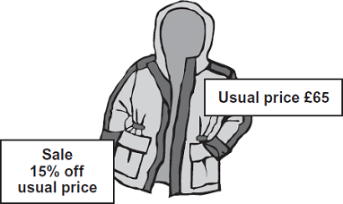
5. Work out the sale price.

…………………………………………………………

…………………………………………………………

…………………………………………………………

…………………………………………………………

…………………………………………………………

Answer £ ......................................................................
(Total 3 marks)
6. 120 men and 80 women were asked if they drive to work. Altogether $\frac{1}{4}$ of the people said
yes. $\frac{1}{3}$ of the men said yes. What fraction of the women said yes?

…………………………………………………………………………………………………………

…………………………………………………………………………………………………………

…………………………………………………………………………………………………………

…………………………………………………………………………………………………………

…………………………………………………………………………………………………………

…………………………………………………………………………………………………………

Answer ............................................
(Total 4 marks)
(Total for test = 20 marks)

