End of Unit Test Name: ____________________________
Lines, Angles and Shapes - HIGHER

1. These two triangles are congruent. Not drawn accurately

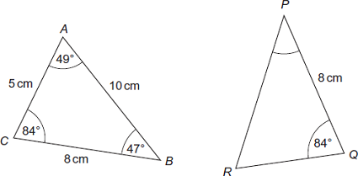
(a) What is the size of angle P? Circle your answer.

47° 49° 84° none of these
(1)
(b) What is the length of PR? Circle your answer.

5 cm 8 cm 10 cm none of these
(1)
(Total 2 marks)
2. ABCD and AEFG are identical squares. CD = EF = 10 cm. Angle BAG = 45°. Not drawn accurately.

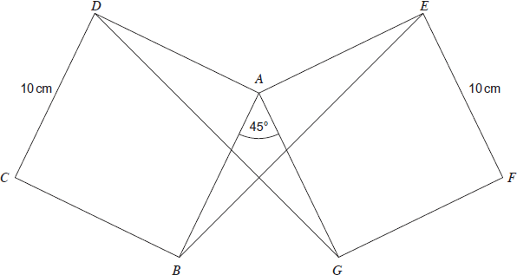

Prove that triangles AGD and ABE are congruent.

…………………………………………………………………………………………………………

…………………………………………………………………………………………………………

…………………………………………………………………………………………………………

…………………………………………………………………………………………………………

…………………………………………………………………………………………………………
(Total 4 marks)

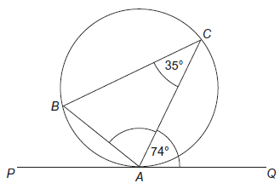
3. A, B and C are points on a circle. PAQ is a tangent to the circle. Not drawn accurately. Work out the size of angle CAB.

………………………………………………………

………………………………………………………

………………………………………………………

………………………………………………………

…………………………………………………………………………………………………………

…………………………………………………………………………………………………………

Answer ..................................................................... degrees
(Total 3 marks)
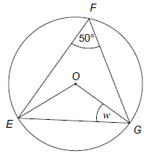
4. (a) E, F and G are points on a circle, centre O. Not drawn
accurately. Work out the size of angle w.

……………………………………………………………

……………………………………………………………

……………………………………………………………

……………………………………………………………

……………………………………………………………

…………………………………………………………………………………………………

Answer ..................................................................... degrees
(2)
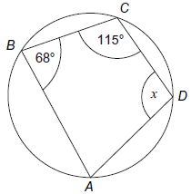
(b) A, B, C and D are points on the circumference of the circle. Not drawn accurately. Work out the size of angle x. Give a reason for your answer.

……………………………………………………………

……………………………………………………………

……………………………………………………………

……………………………………………………………

Answer ..................................................................... degrees

Reason ………………………………………………………………………………………

…………………………………………………………………………………………………
(2)

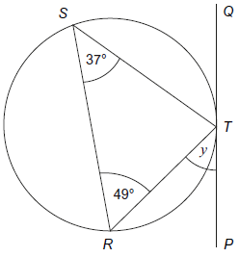
(c) PTQ is a tangent to the circle. R, S and T are points on the circle. Not drawn accurately. Write down the size of angle y. Give a reason for your answer.

……………………………………………………………

……………………………………………………………

……………………………………………………………

……………………………………………………………

Answer ………………………………………degrees

Reason ………………………………………………………………………………………

…………………………………………………………………………………………………
(2)
(Total 6 marks)
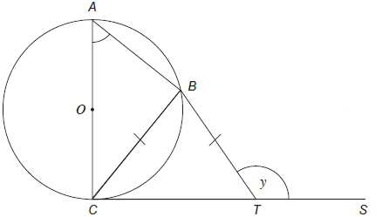
5. AC is a diameter of a circle, centre O. CTS is a tangent to the circle. B is a point on the circumference of the circle such that BC = BT. Angle BTS = y. Not drawn accurately

(a) Prove that angle CAB = 180° – y. Give reasons for any angles you write down or calculate.

…………………………………………………………………………………………………

…………………………………………………………………………………………………

…………………………………………………………………………………………………

…………………………………………………………………………………………………

…………………………………………………………………………………………………

(3)
(b) You are given that angle ACB = 20°. Work out the value of y. You must show your working which may be on the diagram.

…………………………………………………………………………………………………

…………………………………………………………………………………………………

Answer .................................................................... degrees
(2)
(Total 5 marks)

(Total for test = 20 marks)

