Pixi’s Place
Menu

Caution: ingredients stated may not be the correct amount for the number of people you are cooking for!

Starters

Tomato Soup
To make tomato soup for 4 people I need:
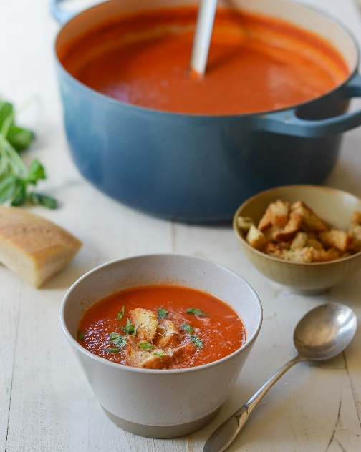
6 tomatoes
1 potato
1 onion
2 tablespoons of olive oil
2 pints of vegetable stock
1 carrot
4 slices of bread

Prawn Cocktail
To make prawn cocktail for 4 people I need:
400g of prawns
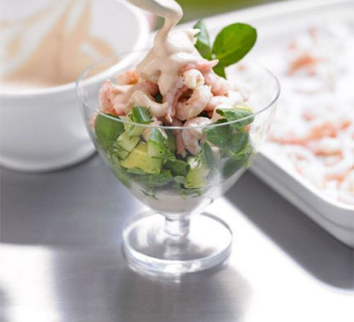
4 teaspoons of mayonnaise
4 teaspoons of tomato sauce
4 lettuce leaves

Main Courses

Spaghetti Bolognese
To make spaghetti bolognese for 2 people I need:
1 teaspoon of olive oil
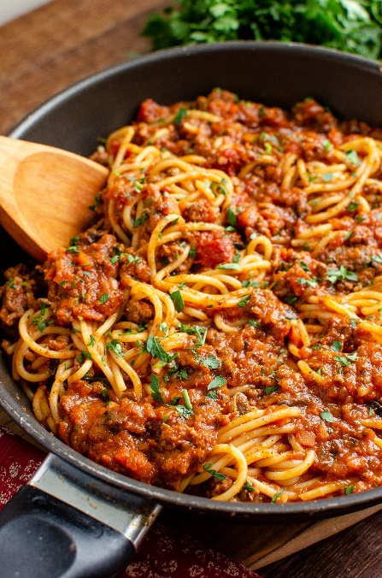
1 large onion
2 gloves of garlic
250g of minced beef
200g chopped tomatoes
3 mushrooms
200g spaghetti

Roast dinner
To make a roast dinner for 2 people I need:
6 roast potatoes
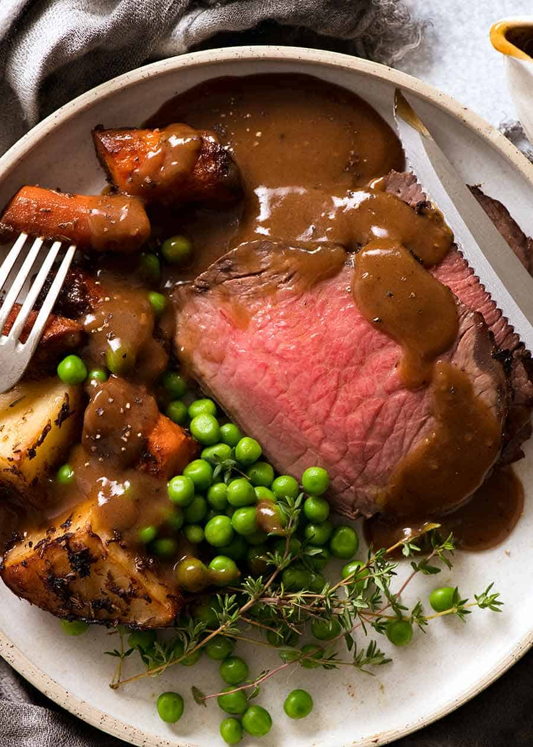
2 carrots
1 can of peas
4 slices of beef
2 Yorkshire puddings

Desserts

Sponge cake
To make sponge cake for 8 people I need:
220g of butter
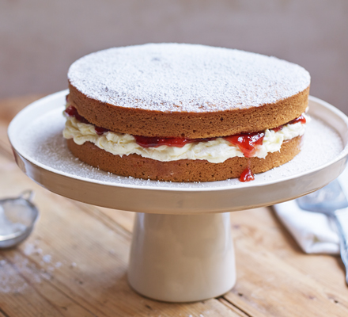
220g of sugar
4 medium eggs
2 teaspoons of vanilla essence
220g of flour
200g of jam

Fruit salad
To make a fruit salad for 10 people I need:
Half a watermelon
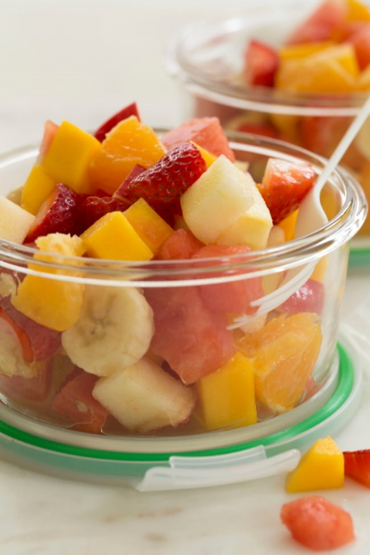
1 bunch of grapes
2 bananas
3 oranges
4 apples
400g strawberries

