Data – Interpreting Results (F)

Post-Intervention Assessment

Name: _______________________________

Class: _______________________________

Date: _______________________________

Question | Objective | RAG
1 | Draw and interpret tally charts, bar graphs and pictograms
2 | Calculate averages from a set of data
3 | Draw and interpret pie charts
4 | Draw and interpret scatter graphs
5 | Calculate averages from a table

1. Daniel carried out a survey of his friends’ favourite flavour of crisps.
Here are his results.
Plain Chicken Bovril Salt & Vinegar Plain
Salt & Vinegar Plain Chicken Plain Bovril
Plain Chicken Bovril Salt & Vinegar Bovril
Bovril Plain Plain Salt & Vinegar Plain
(a) Complete the table to show Daniel’s results.
Flavour of crisps | Tally | Frequency
Plain
Chicken
Bovril
Salt & Vinegar
(3)
(b) Write down the number of Daniel’s friends whose favourite flavour was Salt & Vinegar.
……………………..
(1)
(c) Which was the favourite flavour of most of Daniel’s friends?
……………………..
2. Here are ten numbers.
7 6 8 4 5 9 7 3 6 7
(a) Work out the range.
.....................................
(2)
(b) Work out the mean.

.....................................
3. The table gives some information about the birds Paula sees in her garden one day.
Bird | Frequency
Magpie | 15
Thrush | 10
Starling | 20
Sparrow | 27
Complete the accurate pie chart.

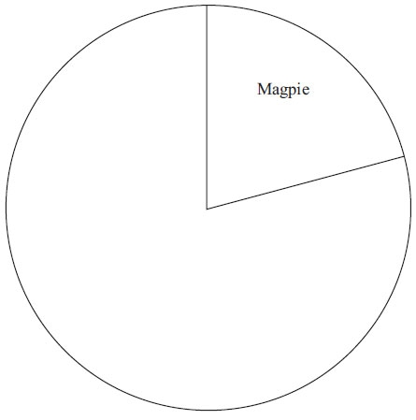

4. Carlos has a cafe in Clacton.
Each day, he records the maximum temperature in degrees Celsius (°C) in Clacton and the number of hot chocolate drinks sold.
The scatter graph shows this information.
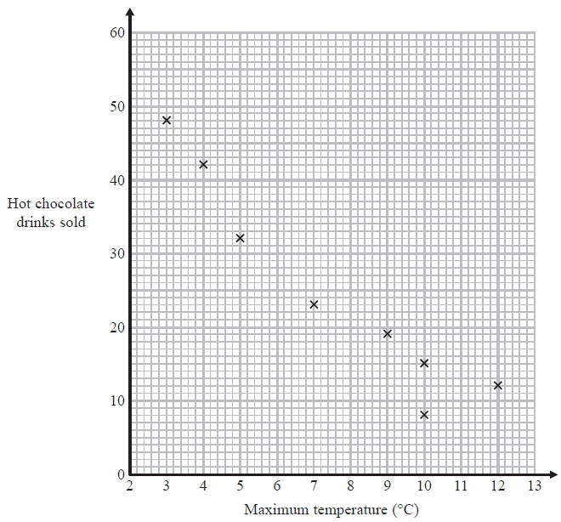
On another day the maximum temperature was 6 °C and 35 hot chocolate drinks were sold.
(a) Show this information on the scatter graph.
(1)
(b) Describe the relationship between the maximum temperature and the number of hot chocolate drinks sold.

.......................................................................................................................................

.......................................................................................................................................
(1)
(c) Draw a line of best fit on the scatter diagram.
(1)
One day the maximum temperature was 8 °C.
(d) Use your line of best fit to estimate how many hot chocolate drinks were sold.
..........................
5. 30 adults took part in a survey. They were each asked how much money they spent on lottery tickets last week. The table shows the results of the survey.
Money (£) | Frequency
0 | 5
2 | 16
4 | 6
20 | 2
30 | 1

Work out the mean amount of money the 30 adults spent on lottery tickets.

£ ...........................................................

[Glue here]

