Set Notation and Venn Diagrams

1. For each of the following, list the elements of (i) A ∩ B and (ii) A ∪ B.
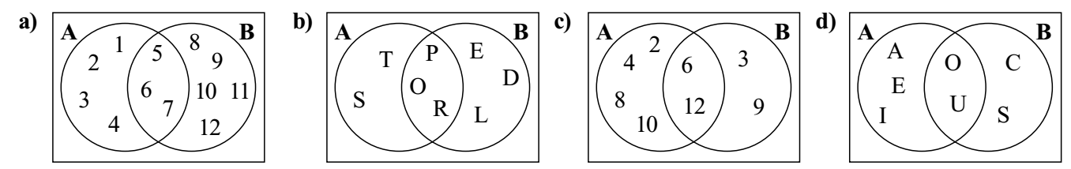
a) i) $A∩B=\{___________________________\}$ ii) $A∪B=\{___________________________\}$
b) i) $A∩B=\{___________________________\}$ ii) $A∪B=\{___________________________\}$
c) i) $A∩B=\{___________________________\}$ ii) $A∪B=\{___________________________\}$
d) i) $A∩B=\{___________________________\}$ ii) $A∪B=\{___________________________\}$

2. Find $A∩B$ for each of the following, where the universal set is the set of all real numbers.
a) $A=\{x:0<x<50\}$ $B=\{x:30<x<100\}$ $A∩B=\{___________________________\}$
b) $A=\{x:20<x≤30\}$ $B=\{x:30≤x<100\}$ $A∩B=\{___________________________\}$
c) $A=\{x:x≤100\}$ $B=\{x:x≤50\}$ $A∩B=\{___________________________\}$
d) $A=\{x:x<50\}$ $B=\{x:x>60\}$ $A∩B=\{___________________________\}$
e) $A=\{x:x>20\}$ $B=\{x:x≤150\}$ $A∩B=\{___________________________\}$

3. Shade each of the following regions on the diagrams below.
a) $A∩B∩C$ b) $A∪B∪C$ c) $(A∪B)∩C$ d) $A∪(B∩C)$
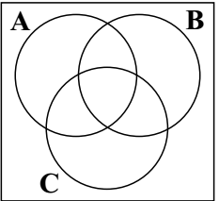

4. For each of the following, list the elements of $A'$, the complement of set $A$.
a) $ξ=\{1,2,3,4,5,6,7,8,9,10\}$ $A=\{even numbers\}$ $A^{'}=\{____________________________\}$
b) $ξ=\{prime numbers\}$ $A=\{odd numbers\}$ $A^{'}=\{____________________________\}$
c) $ξ=\{factors of 120\}$ $A=\{x:x<20\}$ $A^{'}=\{____________________________\}$

5. Given that $n(P ∩Q)=11$, $n(P∪Q)'=7$, $n(Q')=10$ and $n(ξ)=25$, draw a Venn diagram to help you find:
a) $n(Q)=_____$
b) $n(P')=_____$
c) $n(P∩Q)'=_____$
d) $n(P∪Q')=_____$

