You are on a very criminal mission to steal the world famous Loci Diamond.

You must enter the room at Door 1, collect the diamond, and exit at Door 2.
Sounds simple, but the Loci Diamond is very heavily protected with eight laser beams on the floor.
Your challenge is to make a map of the room including the laser beams using the information below – then you can figure out a route to take without setting off any alarms. GOOD LUCK!

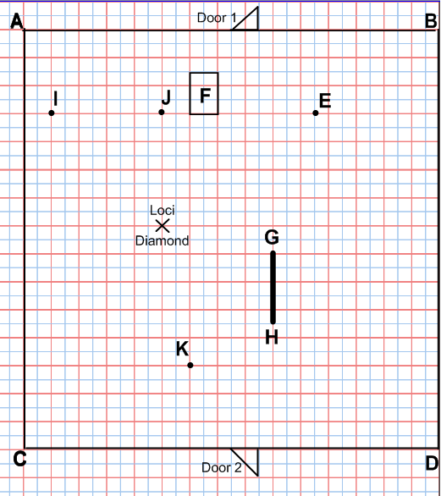
1cm = 1m
Laser 1 is always 2.5 metres from the line BD.
Laser 2 is equidistant from AB and AC. Laser 2 is beamed from point A.
Laser 3 is always 4.5 metres from D.
Laser 4 is always 2 metres from post E.
Laser 5 is always 1 metre away from the rectangular table F.
Laser 6 is 2.5 metres away from the solid wooden bar GH.
Laser 7 is equidistant from the statues I and J.
Laser 8 is always 2 metres from point K.

SOLUTION!

