**Measures (H)**

Pre-Intervention Assessment

Name: _______________________________

Class: _______________________________

Date: _______________________________

|  |  |  |
| --- | --- | --- |
| **Question** | **Objective** | **RAG** |
| 1 | Solve problems involving similar lengths, area and volume |  |
| 2 | Interpret velocity-time graphs |  |

**1.** Cylinder **A** and cylinder **B** are mathematically similar.

The length of cylinder **A** is 4 cm and the length of cylinder **B** is 6 cm.  
The volume of cylinder **A** is 80 cm³.



Calculate the volume of cylinder **B**.

........................................................... cm³

**2**. Here is a speed-time graph for a car.

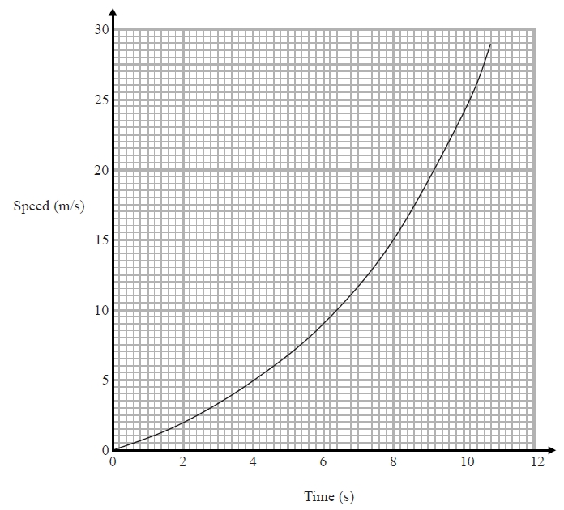

(a)   Work out an estimate for the distance the car travelled in the first 10 seconds.   
Use 5 strips of equal width.

........................................................... m

(b)   Is your answer to (a) an underestimate or an overestimate of the actual distance?

Give a reason for your answer.

....................................................................................................................

....................................................................................................................

....................................................................................................................

[Glue here]