End of Unit Test Name: ____________________________
Sequences, Functions and Graphs - HIGHER

1. Sketch the graphs of:
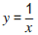
(a) y = x² (b) y = x³ (c)

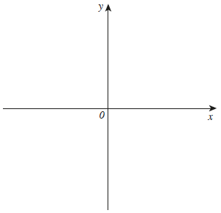
(Total 3 marks)
2. (a) Line M has the equation 3x + 2y = 7. Circle the gradient of line M.

(1)
(b) Line N has the equation $y=5- \frac{3}{4}x$
Circle the gradient of a line that is perpendicular to line N.

(1)
(Total 2 marks)
3. On each grid, the graph of y = x² is shown dashed to help you.
(a) Sketch the graph of y = x² + 5 on the grid.
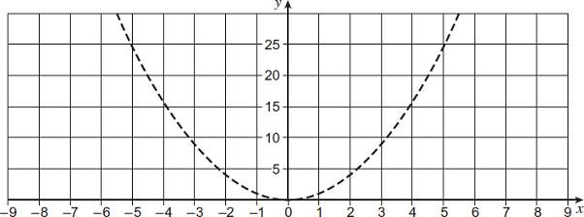
(1)
(b) Sketch the graph of y = (x − 3)² on the grid.
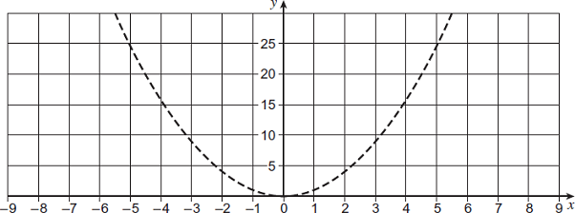
(1)
(Total 2 marks)

4. Work out an expression for the nth term of the quadratic sequence
11 15 21 29 39 .....

…………………………………………………………………………………………………………

…………………………………………………………………………………………………………

…………………………………………………………………………………………………………

…………………………………………………………………………………………………………

…………………………………………………………………………………………………………

…………………………………………………………………………………………………………

nth term = .......................................................................
(Total 4 marks)
5. f(x) = 3x. Circle the expression for f^{–1}(x)

(Total 1 mark)
6. f(x) = 2x + c g(x) = cx + 5 fg(x) = 6x + d
c and d are constants. Work out the value of d.

…………………………………………………………………………………………………………

…………………………………………………………………………………………………………

…………………………………………………………………………………………………………

…………………………………………………………………………………………………………

Answer ............................................
[Total 3 marks]
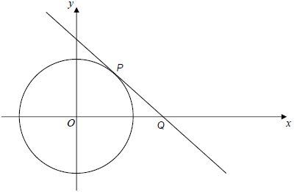
7. The diagram shows the circle x² + y² = 10. P lies on the circle and has x-coordinate 1. The tangent at P intersects the x-axis at Q. Work out the coordinates of Q.

………………………………………………………

………………………………………………………

………………………………………………………

…………………………………………………………………………………………………………

…………………………………………………………………………………………………………

…………………………………………………………………………………………………………

Answer (......................, ......................)
(Total 5 marks)
(Total for test = 20 marks)

