Problem Solving with Number

Name: _____________________________________
Class: _____________________________________

Time: 1 hour 20 mins
Total marks available: 70 | Total marks achieved: _____

Q1.
Paul organised an event for a charity.
Each ticket for the event cost £19.95
Paul sold 395 tickets.
Paul paid costs of £6000
He gave all money left to the charity.
(a) Work out an estimate for the amount of money Paul gave to the charity.

£...........................................................
(3)
(b) Is your answer to (a) an underestimate or an overestimate?
Give a reason for your answer.
.............................................................................................................................................
.............................................................................................................................................
(1)

(Total for question = 4 marks)

Q2.
A unit of gas costs 4.2 pence.
On average Ria uses 50.1 units of gas a week.
She pays for the gas she uses in 13 weeks.
(a) Work out an estimate for the amount Ria pays.
...........................................................
(3)
(b) Is your estimate to part (a) an underestimate or an overestimate?
Give a reason for your answer.
.............................................................................................................................................
.............................................................................................................................................
(1)

(Total for question is 4 marks)

Q3.
Tom and Amy set the alarms on their phones to sound at 6.45 am.
Both alarms sound together at 6.45 am.
Tom's alarm then sounds every 9 minutes.
Amy's alarm then sounds every 12 minutes.
At what time will both alarms next sound together?

...........................................................

(Total for question = 3 marks)

Q4.
Dan buys 24 packets of nuts.
Each packet of nuts weighs 225 g.
(a) Work out the total weight of all the packets of nuts that Dan buys.
(2)
Susan is going to have a party.
There will be 50 people at the party.
Susan wants to buy enough sausages so that each person at the party can have 2 sausages.
There are 8 sausages in each pack.
Susan buys 12 packs of sausages.
(b) Has she bought enough sausages?
(3)

(Total for question = 5 marks)

Q5.
The table gives information about the cost of cinema tickets.
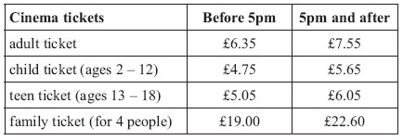
Mr and Mrs White have 2 children.
One child is aged 10
The other child is aged 14
Mr and Mrs White and their 2 children go to the cinema after 5pm.
It is cheaper for Mr and Mrs White to buy 1 family ticket than to buy 4 separate tickets.
How much cheaper?

£ . . . . . . . . . . . . . . . . . . . . . .
(Total for Question is 4 marks)

Q6.
* Sandeep and her 3 friends are going shopping in town.
Sandeep finds out these costs of getting to town.
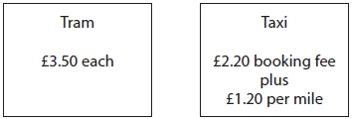
The journey to town is 10 miles.
Is it cheaper for all 4 people to go to town by tram or to go to town by taxi?
You must show your working.

(Total for question = 4 marks)

Q7.
Priya and Amit are going on holiday with their 3 children.
The table gives information about the cost of travel and the cost of the hotel.
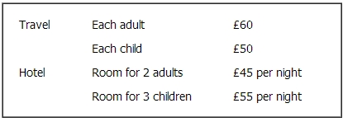
Priya and Amit have saved £1500 for their holiday.
They will be away for 7 nights.
Work out how much of the £1500 they will have left to spend on their holiday.

£ . . . . . . . . . . . . . . . . . . . . . .
(Total for Question is 4 marks)

Q8.
* Jerry is making some shelves.
He needs
5 pieces of wood of length 65 cm
2 pieces of wood of length 110 cm.
The wood is sold in three different lengths.
Information about these lengths is shown in the table.
Length | Cost
100 cm | £21
150 cm | £25
180 cm | £28
Jerry wants to pay as little money as possible.
How much will Jerry have to pay?
You must show your working.

(Total for Question is 4 marks)

Q9.
* Nilmini is going to buy some grass seed.
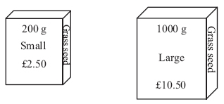
Grass seed is sold
in 200 g boxes costing £2.50 each,
in 1000 g boxes costing £10.50 each.
Which box of grass seed gives the better value for money?
You must show all your working.

(Total for Question is 3 marks)

Q10.
∗Milk is sold in two sizes of bottle.
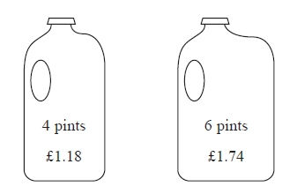
A 4 pint bottle of milk costs £1.18
A 6 pint bottle of milk costs £1.74
Which bottle of milk is the best value for money?
You must show all your working.

(Total for Question is 3 marks)

Q11.
Miss Martins is organising a school play.
The total cost of putting on the play is £960
The school pays £300 of this cost.
Miss Martins sells tickets to pay the rest of the cost.
Miss Martins sells 500 tickets.
Each ticket costs £4
Miss Martins has enough money to pay the rest of the costs and to give all the money left over to charity.
Work out how much money Miss Martins gives to charity.

£ ...........................................................
(Total for Question is 4 marks)

Q12.
Here are the ticket prices for entry to a museum.
Ticket pricesAdult ticket £12
Child ticket £7
Senior ticket £8 Family ticket (2 adult tickets and 2 child tickets) £30
Shamus takes his family to the museum.
He gets tickets for
2 adults,
3 children,
1 senior.
Shamus pays the least possible amount of money for the tickets.
He pays with three £20 notes.
How much change should he get?

£...........................................................
(Total for Question is 4 marks)

Q13.
* Aleena is planning a trip for people at her Youth Club.
Here are the costs for the trip.
Transport | £230
Insurance | £50
Other costs | £30
Entry fee | £14 per person
Aleena charges £18 per ticket for the trip.
She sells 100 tickets.
Is there enough money from the ticket sales for Aleena to pay all the costs for the trip?
You must show your working.

(Total for Question is 4 marks)

Q14.
John buys some boxes of pencils and some packets of pens for people to use at a conference.
There are 40 pencils in a box.
There are 15 pens in a packet.
John gives one pencil and one pen to each person at the conference.
He has no pencils left.
He has no pens left.
How many boxes of pencils and how many packets of pens did John buy?

........................................................... boxes of pencils
........................................................... packets of pens

(Total for question = 3 marks)

Q15.
Sarah has saved 254 pound coins.
She puts the pound coins into bags.
There are 20 pound coins in each full bag of coins.
Sarah is going to take all her full bags of coins to the bank.
She can only take up to 5 full bags of coins to the bank each day.
Sarah wants to go to the bank on as few days as possible.
On how many days will Sarah need to go to the bank?

...........................................................
(Total for Question is 3 marks)

Q16.
A ticket for a seat at a school play costs £2.95
There are 21 rows of seats.
There are 39 seats in each row.
The school will sell all the tickets.
Work out an estimate for the total money the school will get.

£ . . . . . . . . . . . . . . . . . . . . . .
(Total for Question is 3 marks)

Q17.
Sally uses her van to deliver boxes to shops.
She can put a maximum weight of 450 kg in the van.
Sally has to deliver 50 boxes to a shop.
Each box has a weight of 30 kg.
Work out the least number of times Sally has to drive to the shop to deliver all 50 boxes.
You must show all your working.
...........................................................
(Total for Question is 3 marks)

Q18.
Mr Morris is going to take his family to the zoo.
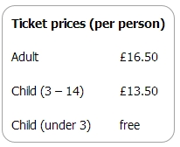
Mr Morris wants to buy tickets for two adults and two children aged 2 and 4
(a) How much in total will the tickets cost?

£. . . . . . . . . . . . . . . . . . . . . .
(2)

Mr Morris pays with three £20 notes.
(b) How much change should he get?

£. . . . . . . . . . . . . . . . . . . . . .
(2)
(Total for Question is 4 marks)

Q19.
Helen has 80 books to sell.
Each book is Fiction or Non–fiction.
The ratio of the number of Fiction books to the number of Non–fiction books is 3:1
Each book has a normal price of £10
Helen reduces the price of all the Non–fiction books.
Helen sells all 80 books.
Work out the total amount of money Helen will receive.
£ ...........................................................

(Total for question = 4 marks)

