End of Unit Test Name: ____________________________
Construction and Loci - FOUNDATION

Q1. Using a ruler and a protractor, draw this triangle accurately.
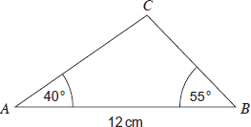
Not drawn accurately.

(Total 3 marks)
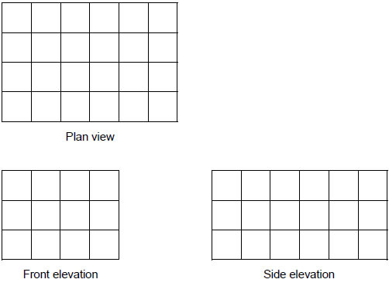
Q2. A solid cuboid is made from centimetre cubes.

How many centimetre cubes were used to make the cuboid?

Answer ...................................................................................
(Total 2 marks)

Q3. The diagram shows the position of ships A and B.

(a) Circle the size of angle x

55° 65° 75° 85° 95°
(1)
(b) What is the 3-figure bearing of B from A?

Answer ........................................ °
(1)
(Total 2 marks)

Q4. The airport is on a bearing of 040° from the Hospital and 270° from the Stadium.
Mark the position of the Airport on the map.
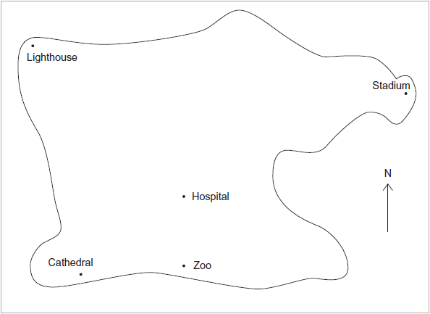
(Total 3 marks)
Q5. The map shows the positions of two ships, A and B.

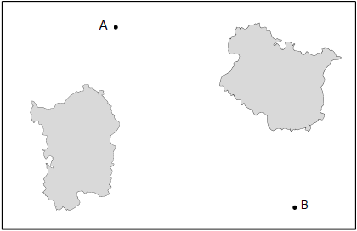

Scale: 1 cm represents 2.5 km
Work out the actual distance between the ships.

.........................................................................................................................

.........................................................................................................................

.........................................................................................................................

Answer ............................................ km
(Total 2 marks)
Q6. The scale on a map is 1 : 20 000. What is the actual distance represented by 1 centimetre?
Give your answer in metres.

.........................................................................................................................

.........................................................................................................................

.........................................................................................................................

Answer .................................................................. m
(Total 2 marks)

Q7. You will need a ruler and compasses to answer this question. Construct the angle bisector of angle A.
(Total 3 marks)

Q8. You will need a ruler and compasses to answer this question. Construct the perpendicular bisector of angle XY.

(Total 3 marks)
(Total for test = 20 marks)

