Reading Scales GREEN

Write down the value of each scale. Make sure you include units.

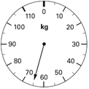 | 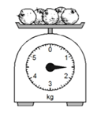 | 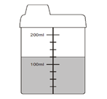
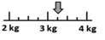 | 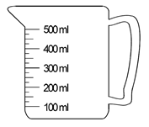 | 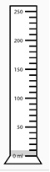
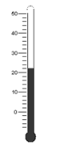 | 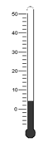 | 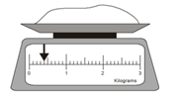

Reading Scales AMBER

Write down the value of each scale.

_________ kg | _________ kg | _________ ml
_________ kg | _________ ml | _________ ml
_________ °C | _________ °C | _________ kg

Reading Scales RED

Write down the value of each scale.

_________ kg | _________ kg | 150 ml  _________ ml
3.5  _________ kg | 350 ml  _________ ml | 10 ml  _________ ml
8  6  4  2  _________ °C | 8  6  4  2  _________ °C | 0.5  _________ kg

