Venn and Carroll Diagrams

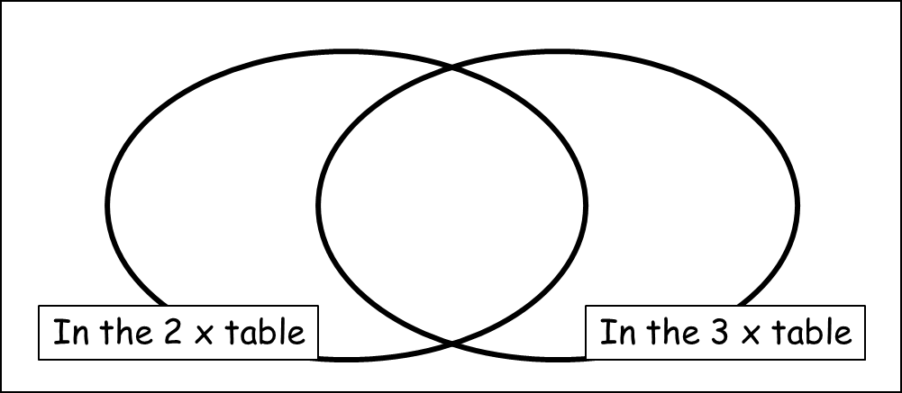
1. Complete this Venn diagram for numbers 1 – 20. Cross them off as you go to make sure you’ve included all of them.

1 2 3 4 5 6 7 8 9 10
11 12 13 14 15 16 17 18 19 20

 | Even | Odd
3 x table
Not in 3 x table
2. Put the numbers in the list below in the correct box of the Carroll diagram.

15 11 10 16 18 21
22 24 12 23 17 20

3. Complete the Venn diagram with names of students in this class. You will have to talk to everyone to make sure you have them in the right place!

