Interior and Exterior angles of regular polygons GREEN

1. Calculate the sum (total) of all the interior angles in a polygon
with:
a. 10 sides b. 12 sides c. 13 sides

2. How many sides do these regular polygons have if their exterior angles are?
a. 30° b. 18° c. 40°

3. What is each interior angle of a regular polygon with 14 sides?

4. Each interior angle of a regular polygon is 168°. How many sides
does the polygon have?

5. Calculate the sum of the interior angles of a polygon with 22 sides.

6. John says that he has drawn a regular polygon with interior
angles of 25°. James says that is not possible. Is James right or wrong and why?

7. I walk around the perimeter of a regular hexagonal ornamental
pond. Through how many degrees do I turn at each corner? And
altogether?

8. What are the sizes of angles (a) and (b)?

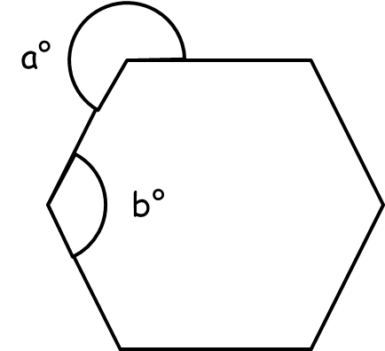

Interior and Exterior angles of regular polygons AMBER

1. Calculate the sum (total) of all the interior angles in a polygon
with:
a. 10 sides b. 12 sides c. 13 sides

(10 – 2) x 180

2. How many sides do these regular polygons have if their exterior angles are?
a. 30° b. 18° c. 40°

360 ÷ 30

3. What is each interior angle of a regular polygon with 14 sides?
Either start by calculating the sum of interior angles OR the size of an exterior angle.

4. Each interior angle of a regular polygon is 168°. How many sides
does the polygon have?
Start by calculating the size of an exterior angle.

5. Calculate the sum of the interior angles of a polygon with 22 sides.
Use (n – 2) x 180

6. John says that he has drawn a regular polygon with interior
angles of 25°. James says that is not possible. Is James right or wrong and why?
Calculate the exterior angle and divide 360° by your answer.

7. I walk around the perimeter of a regular hexagonal ornamental
pond. Through how many degrees do I turn at each corner? And
altogether?
Sketching this problem may help!

8. What are the sizes of angles (a) and (b)?
(a) is not an exterior angle…

Interior and Exterior angles of regular polygons RED

1. Calculate the sum (total) of all the interior angles in a polygon
with:
a. 10 sides b. 12 sides c. 13 sides

(10 – 2) x 180 (12 – 2) x 180
= 8 x 180 =
= 1440° =

2. How many sides do these regular polygons have if their exterior angles are?
a. 30° b. 18° c. 40°

360 ÷ 30
= 12 sides

3. What is each interior angle of a regular polygon with 14 sides?
Start by calculating the size of an exterior angle.
Exterior angle = 360 ÷ 14 = ____

Interior angle = 180 - ____ =

4. Each interior angle of a regular polygon is 168°. How many sides
does the polygon have?
Start by calculating the size of an exterior angle.

Exterior angle =180 – 168 = ____

Sides = 360 ÷ ____ = ____

5. Calculate the sum of the interior angles of a polygon with 22 sides.
Use (n – 2) x 180

(22 – 2) x 180
=

6. John says that he has drawn a regular polygon with interior
angles of 25°. James says that is not possible. Is James right or wrong and why?
Calculate the exterior angle and divide 360° by your answer.

Exterior angle = 180 – 25 = ____

Sides = 360 ÷ ____ = ____

7. I walk around the perimeter of a regular hexagonal ornamental
pond. Through how many degrees do I turn at each corner? And
altogether?
Sketching this problem may help!
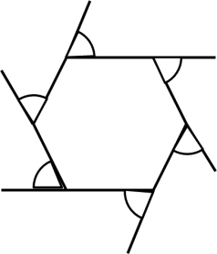

8. What are the sizes of angles (a) and (b)?
(a) is not an exterior angle…

(b) is an interior angle

(a) + (b) = 360°

