Cosine Rule GREEN

Use the cosine rule to find side $x$ in each of the following triangles

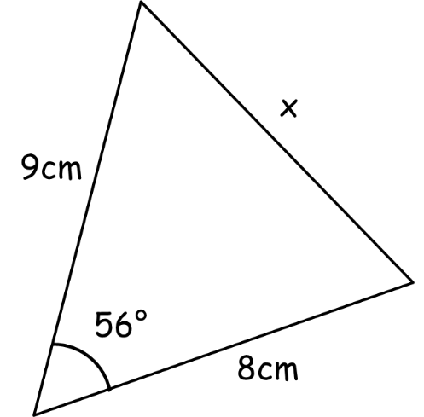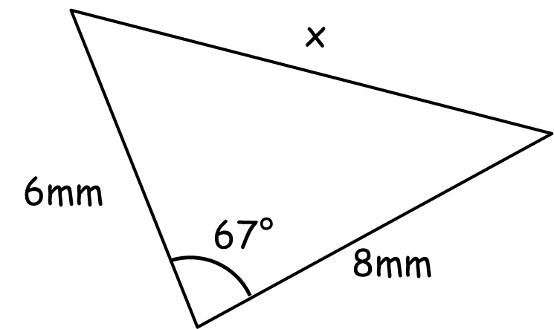

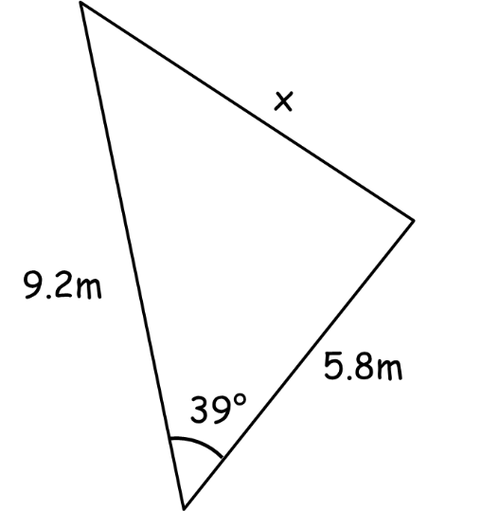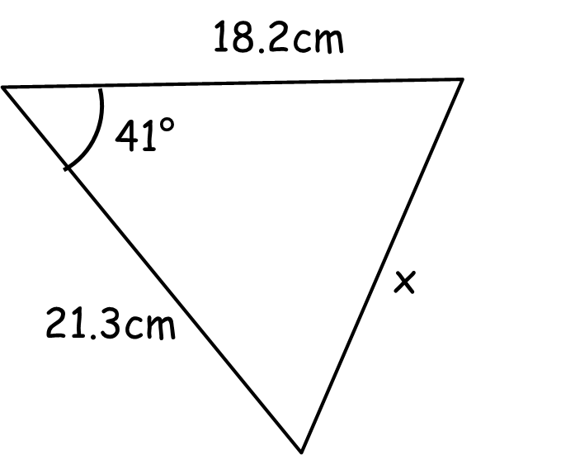

Use the cosine rule to find angle $X$ in each of the following triangles

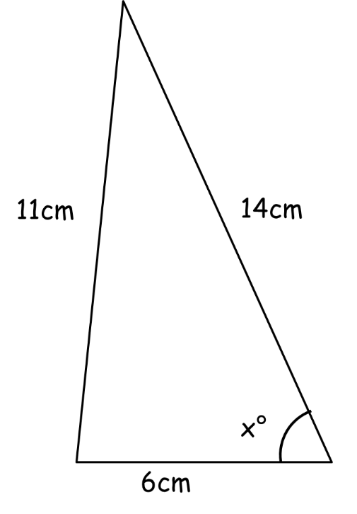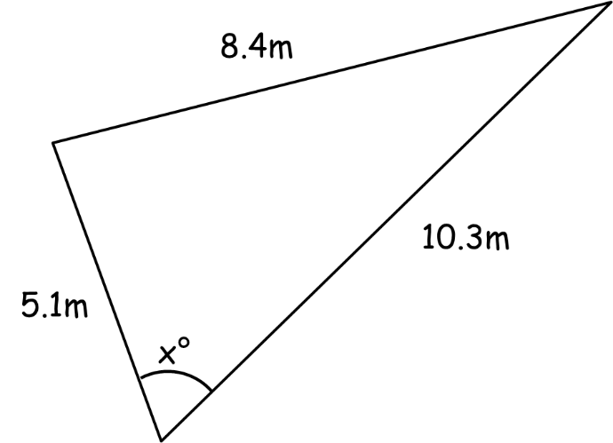

Cosine Rule AMBER

Use the cosine rule to find side $x$ in each of the following triangles

$$a^{2}=b^{2}+c^{2}-2bc\cos{A}$$

Use the cosine rule to find angle $X$ in each of the following triangles

$$\cos{A=\frac{b^{2}+c^{2}-a^{2}}{2bc}}$$

Cosine Rule RED

Use the cosine rule to find side $x$ in each of the following triangles

$$a^{2}=b^{2}+c^{2}-2bc\cos{A}$$

$x^{2}=9^{2}+8^{2}-2×9×8\cos{56}$

$x=$

Use the cosine rule to find angle $X$ in each of the following triangles

$$\cos{A=\frac{b^{2}+c^{2}-a^{2}}{2bc}}$$

$\cos{X=\frac{6^{2}+{14}^{2}-{11}^{2}}{2×6×14}}$

$X=\cos^{-1}($

