Best Buys Investigation

If you were making a new chocolate bar weighing around 45g what price should it be?
Which chocolate bar is best value for money?

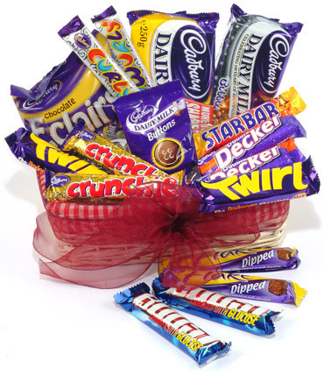

Type | Cost (p) | Weight (g)
Finger of Fudge | 15 | 19
Dairy Milk | 60 | 49
Buttons | 19 | 23
Galaxy Bar | 58 | 46
Fairtrade Co-op | 37 | 40
Boost | 55 | 60.5
Twix | 58 | 58
Snickers | 46 | 58
Kit Kat | 49 | 44
Curly Wurly | 20 | 26
Milky Bar | 17 | 12
Smarties | 45 | 21

Hint: Could you show this information on a graph?

