Angles around a point, on a line and in triangle GREEN

Complete the sheet!

Question | Answer | Reason
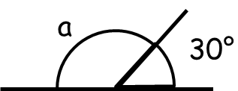
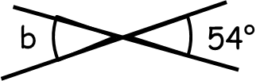
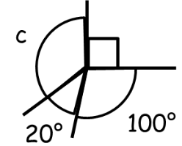
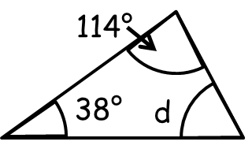
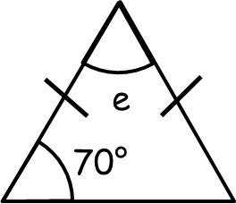
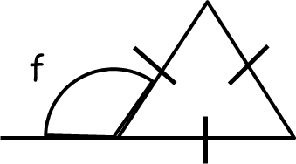
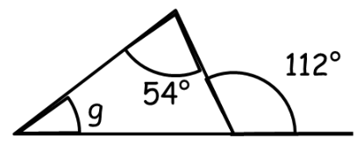
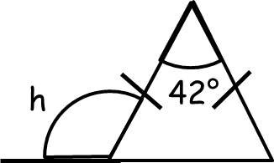
Angles around a point, on a line and in triangle AMBER

Complete the reasons and use them to fill in the answers

Question | Answer | Reason
 |  | Angles on a straight line…
 |  | Vertically opposite angles…
 |  | Angles around a point…
 |  | Angles in a triangle…
 |  | Angles in a triangle…
Equilateral triangles…

Angles in a triangle…

Angles on a straight line…

Angles on a straight line…

Angles in a triangle…
Isosceles triangles…

Angles in a triangle…

Angles on a straight line…

Angles around a point, on a line and in triangle RED

Cut out and match the question, answer and reason.

Question | Answer | Reason
 | 28° | Angles in a triangle add up to 180°
 | 58° | Angles on a straight line add up to 180° and angles in a triangle add up to 180°
 | 54° | Angles around a point add up to 360°
 | 40° | Isosceles triangles have two equal angles and angles in a triangle add up to 180° and angles on a straight line add up to 180°
 | 111° | Vertically opposite angles are equal
 | 150° | Angles in a triangle add up to 180°
 | 120° | Angles on a straight line add up to 180°
 | 150° | Equilateral triangles have all equal angles and angles in a triangle add up to 180° and angles on a straight line add up to 180°
ANSWERS!!

Question | Answer | Reason
 | 150° | Angles on a straight line add up to 180°
 | 54° | Vertically opposite angles are equal
 | 150° | Angles around a point add up to 360°
 | 28° | Angles in a triangle add up to 180°
 | 40° | Angles in a triangle add up to 180°
 | 120° | Equilateral triangles have all equal angles and angles in a triangle add up to 180° and angles on a straight line add up to 180°
 | 58° | Angles on a straight line add up to 180° and angles in a triangle add up to 180°
 | 111° | Isosceles triangles have two equal angles and angles in a triangle add up to 180° and angles on a straight line add up to 180°

