Solving Non-Monic Quadratics by Factorising GREEN

Question | Working | Factorised | Solutions
$$4x^{2}-19x+12=0$$

$$2x²+x-6=0$$

$$4x²-15x+9=0$$

$$4x²+7x+3=0$$

$$6x²+19x+10=0$$

$$2x²-x-21=0$$

$$10x²-11x+3=0$$

$$2x²-10x-28=0$$

Solving Non-Monic Quadratics by Factorising AMBER

Question | Working | Factorised | Solutions
$$4x²-19x+12=0$$  $48$ | 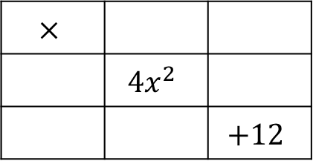
$$2x²+x-6=0$$
$-12$
$$4x²-15x+9=0$$
$36$
$$4x²+7x+3=0$$

$$6x²+19x+10=0$$

$$2x²-x-21=0$$

$$10x²-11x+3=0$$

$$2x²-10x-28=0$$

Solving Non-Monic Quadratics by Factorising RED

Question | Working | Factorised | Solutions
$$4x²-19x+12=0$$  $48$ | Factor pairs of 48:  1&48, 2&24, 3&___,  4&___,
$$2x²+x-6=0$$  $-12$ | 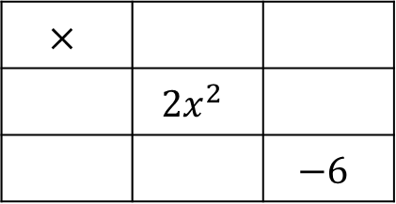  Factor pairs of 12:  1&___, 2&___,
$$4x²-15x+9=0$$  $36$ | 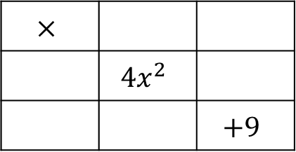  Factor pairs of 9:
$$4x²+7x+3=0$$

$$6x²+19x+10=0$$

$$2x²-x-21=0$$

$$10x²-11x+3=0$$

$$2x²-10x-28=0$$

