Measuring Bearing GREEN

a) What is the bearing each plane must take in order to return to the airport?
b) If 1cm is equal to 100km, estimate the distance each plane must travel in order to reach the airport.

Plane A . Plane G.

Plane B. Plane F.
.AIRPORT

Plane C.

Plane D.
Plane E.

Measuring Bearings AMBER

Use a PROTRACTOR to find the size of the marked bearings.
Remember to measure CLOCKWISE from NORTH and give your answers 3 DIGITS.
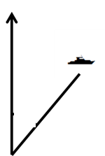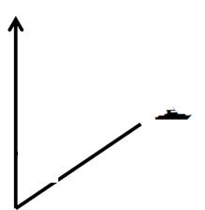

Bearing: _____ Bearing: _____ Bearing: _____

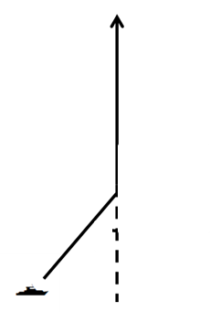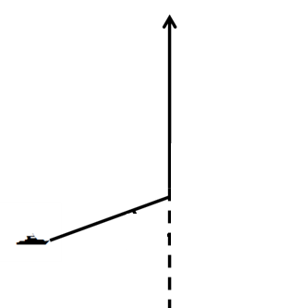

Bearing: _____ Bearing: _____ Bearing: _____

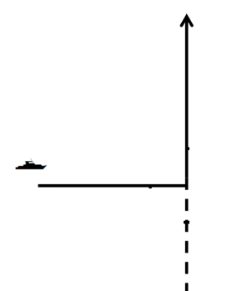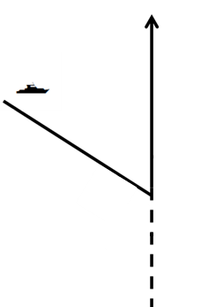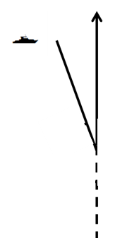

Bearing: _____ Bearing: _____ Bearing: _____

Measuring Bearings RED

Use a PROTRACTOR to find the size of the marked bearings.
Remember to measure CLOCKWISE from NORTH and give your answers 3 DIGITS.
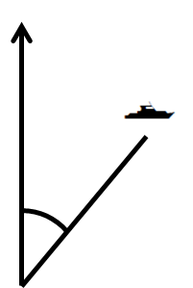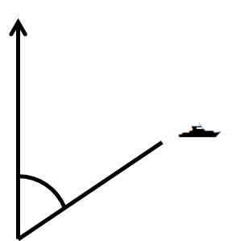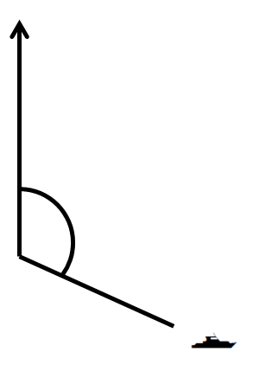

Angle: _____ Angle: _____ Angle: _____
Bearing: _____ Bearing: _____ Bearing: _____

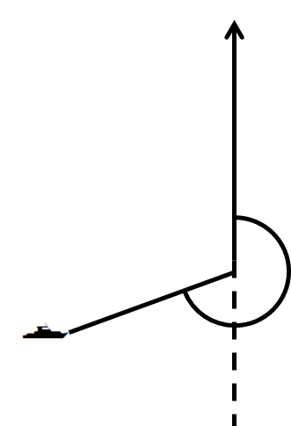

Angle: _____ Angle: _____ Angle: _____
Bearing: _____ Bearing: _____ Bearing: _____

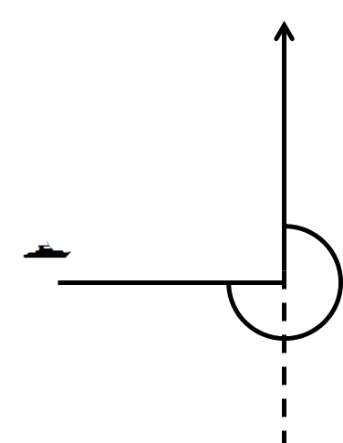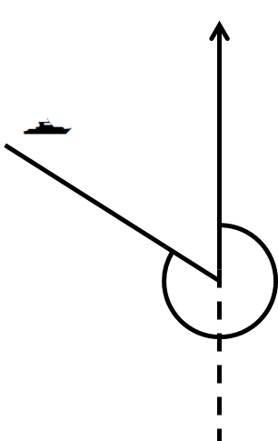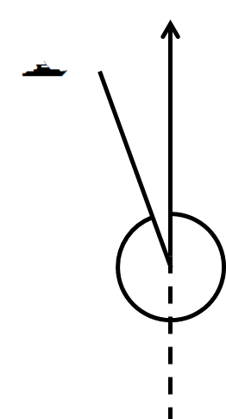

Angle: _____ Angle: _____ Angle: _____
Bearing: _____ Bearing: _____ Bearing: _____

