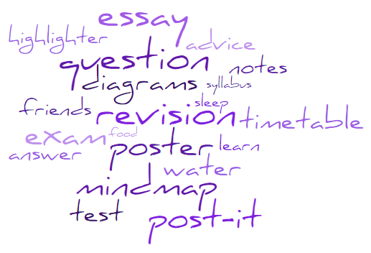
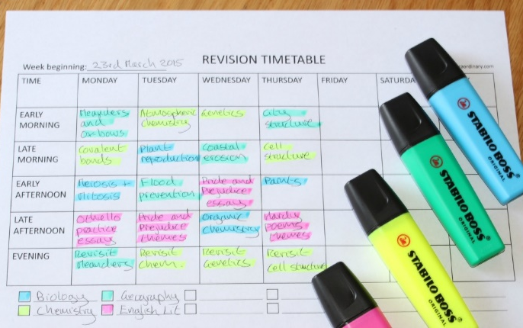
General Advice for Revising

What
Revision is not a passive activity, it is an active process to help you revisit work. It is composed of three main parts:
- Note-taking: breaking down your classwork into concise key points;
- Learning: learning and memorising the notes;
- Testing: test yourself to see what you’ve learnt, then start the process again.

Start now
Cramming has been proven to be ineffective. Start revising as soon as you can so you’re not as stressed towards the end. Compare revision to song lyrics – the more time you hear the song, the better you are at singing along. The more you cover a topic, the more confident you’ll be with it.

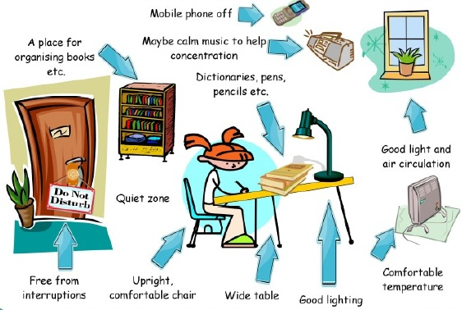
How
Use the methods which work the best for you. There’s more on this later on in this booklet

Where
Your revision zone should be uncluttered and free from distractions. It needs to help you focus.

When
Design a revision timetable and STICK TO IT. Allocate time for each subject depending on what you need to work on more. You may need several versions of your timetable throughout the year.

Plan breaks
Include breaks, rewards, exercise and snacks in your revision timetable. You have to be realistic with the time that you have available; include other activities that usually fit into your week.

Drink, eat and sleep
A good diet and lots of water will help you stay healthy during what could be a stressful time.
Make time for sleep when you have to get up at a certain time, count back the number of hours you want to sleep and then add half an hour. This time becomes the scheduled time to switch the lights out. The extra half an hour is important - we often forget about the time it takes to brush teeth, set the alarm clock and so on.
Watch what you eat and when eating late meals because you have been studying all day will alter your internal clock and impair sleep. Although you should try not to go to bed hungry, try to have a big dinner before 7pm and then a smaller snack in the evening if you are still hungry. It’s thought that certain foods help sleep; turkey, milk, bananas, and walnuts all contain tryptophan, which the body uses to make melatonin.
Limit caffeinated drinks remember caffeine isn’t just in coffee – it’s also in things like tea, chocolate, and fizzy drinks.
Clear your head before bed sitting and worrying about the day will keep the brain active, so try keeping a notebook by your bed to write thoughts down before sleep instead. Meditation and breathing exercises can also help.

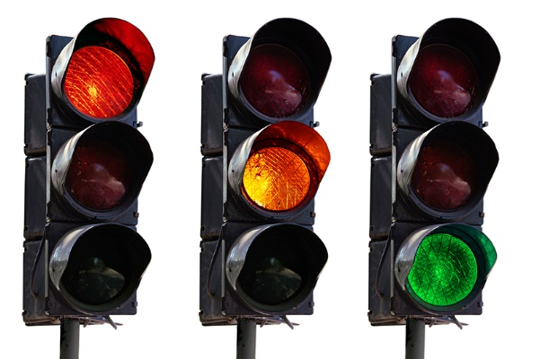
RAG rate your subject content
Use the colours red, amber and green to evaluate your current understanding of each assessment objective or topic. Focus on the red topics first (the things you find hard). Your teacher will be able to give you a list of everything you need to know.

Revision Methods

Remember we said revision is split into three parts? Test yourself now: can you remember what those three parts were?
Note-Taking
Taking notes of other notes ensures that you are processing what you’ve previously written, rather than just passively reading. However you take notes, try to make them more memorable. Have a look at some ideas below:
- Flash or index cards
- Add colour, headings, bullet points
- Posters
- Post-it notes
- Mind maps
- Diagrams
- Pictures or infographics
- Definitions of keywords
- Mnemonics
- Website links
Testing
Obviously exam questions are an easy way to tick this category, but there are other alternatives too. Try “look, cover, write, check” as a quick test for what you’ve learnt. Or you could time yourself to write a list of key facts or answer an essay question.
Learning
Think back to that song lyrics analogy earlier. Repetition really is the best way to learn as it strengthens pathways between neurons in your brain over time. Other ideas include annotate pictures to see what you can remember, creating rhymes or songs or teaching a friend. Group revision (as long as it’s focussed) is great for applying what you’ve learnt.

Remember that you have a huge support network around you made up of friends, family and your teachers. Use them. It’s what they’re there for

