Fractions, Decimals and Percentages (H)

Intervention Booklet

Name: _______________________________

Class: _______________________________

Useful websites:

www.mathswatchvle.com
(Video explanations and questions)
Username: STH…@twgash
Password: stmaths

www.methodmaths.com
(Past papers online that get instantly marked)
Centre ID: wga
Username: firstname
Password: lastname

www.hegartymaths.com
(Online tutorials and quizzes)
Login: first name and last name are case sensitive

www.bbc.co.uk/schools/gcsebitesize/maths

Percentages of Amounts, Increasing and Decreasing

Things to remember:
- “Per cent” means “out of 100”.
- Increase means the value will go up, decrease means the value will go down.

Questions:
1. David is going to buy a cooker.
The cooker has a price of £320
David pays a deposit of 15% of the price of the cooker.
How much money does David pay as a deposit?
£ ...........................................................
(Total for Question is 2 marks)

2. Work out 65% of 300
...........................................................
(Total for question = 2 marks)

*3. Barak is going to buy 550 nails from one of these companies.
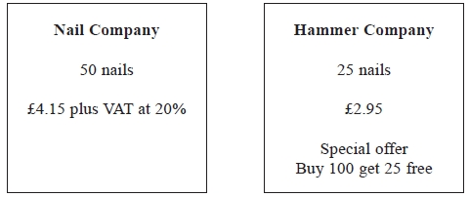
He wants to buy the nails at the cheaper cost.
Where should he buy the nails, from the Nail Company or the Hammer Company?

(Total for question = 5 marks)

4. Greg sells car insurance and home insurance.
The table shows the cost of these insurances.
Insurance | car insurance | home insurance
Cost | £200 | £350
Each month Greg earns
£530 basic pay
5% of the cost of all the car insurance he sells
and 10% of the cost of all the home insurance he sells
In May Greg sold
6 car insurances
and 4 home insurances
Work out the total amount of money Greg earned in May.

£ ...........................................................
(Total for Question is 5 marks)

5. Mr Watkins needs to buy some oil for his central heating.
Mr Watkins can put up to 1500 litres of oil in his oil tank.
There are already 850 litres of oil in the tank.
Mr Watkins is going to fill the tank with oil.
The price of oil is 67.2p per litre.
Mr Watkins gets 5% off the price of the oil.
How much does Mr Watkins pay for the oil he needs to buy?

£ ...........................................................
(Total for Question is 5 marks)

*6. Jim's pay is £180 each week.
Jim asks his boss for an increase of £20 a week.
Jim's boss offers him a 10% increase.
Is the offer from Jim's boss more than Jim asked for?
You must show your working.

(Total for Question is 3 marks)

*7. Gordon owns a shop.
Here are the prices of three items in Gordon's shop and in a Supermarket.
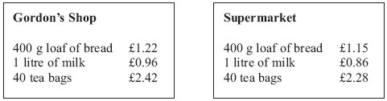
Gordon reduces his prices by 5%.
Will the total cost of these three items be cheaper in Gordon's shop than in the Supermarket?

(Total for Question is 3 marks)

8. Mr Brown and his 2 children are going to London by train.
An adult ticket costs £24
A child ticket costs £12
Mr Brown has a Family Railcard.
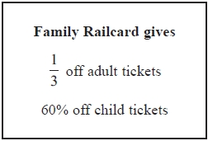
Work out the total cost of the tickets when Mr Brown uses his Family Railcard.
£...........................................................
(Total for Question is 4 marks)

Percentages – compound interest

Things to remember:
Number of years
- ${New amount=original amount x multiplier}^{n}$

Questions:
1. Henry invests £4500 at a compound interest rate of 5% per annum.
At the end of n complete years the investment has grown to £5469.78.
Find the value of n.

...........................................................
(Total 2 marks)

2. Bill buys a new machine.
The value of the machine depreciates by 20% each year.
(a) Bill says ‘after 5 years the machine will have no value’.
Bill is wrong. Explain why.

.......................................................................................................................................

.......................................................................................................................................

.......................................................................................................................................
(1)
Bill wants to work out the value of the machine after 2 years.
(b) By what single decimal number should Bill multiply the value of the machine when new?

...........................................................
(2)
(Total 3 marks)

3. Gwen bought a new car. Each year, the value of her car depreciated by 9%.
Calculate the number of years after which the value of her car was 47% of its value when new.

...........................................................
(Total 3 marks)
4. The value of a car depreciates by 35% each year.
At the end of 2007 the value of the car was £5460
Work out the value of the car at the end of 2006

£ ...........................................................
(Total 3 marks)

5. Toby invested £4500 for 2 years in a savings account.
He was paid 4% per annum compound interest.
(a) How much did Toby have in his savings account after 2 years?

£ ...........................................................
(3)
Jaspir invested £2400 for n years in a savings account.
He was paid 7.5% per annum compound interest.
At the end of the n years he had £3445.51 in the savings account.
- Work out the value of n.

...........................................................
(2)
(Total 5 marks)

6. Mario invests £2000 for 3 years at 5% per annum compound interest.
Calculate the value of the investment at the end of 3 years.

£ ...........................................................
(Total 3 marks)

7. Toby invested £4500 for 2 years in a savings account.
He was paid 4% per annum compound interest.
How much did Toby have in his savings account after 2 years?

£ ...........................................................
(Total 3 marks)

Percentages – reverse

Things to remember:
- Work out what the multiplier would have been;
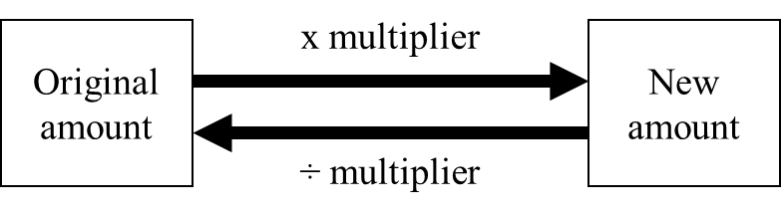

Questions:
1. Loft insulation reduces annual heating costs by 20%.
After he insulated his loft, Curtley’s annual heating cost was £520.
Work out Curtley’s annual heating cost would have been, if he had not insulated his loft.

£ ...........................................................
(Total 3 marks)

2. In a sale, normal prices are reduced by 20%.
SALE
20% OFF
Andrew bought a saddle for his horse in the sale.
The sale price of the saddle was £220.
Calculate the normal price of the saddle.

£ ...........................................................
(Total 3 marks)

3. Hajra’s weekly pay this year is £240
This is 20% more than her weekly pay last year.
Bill says ‘This means Hajra’s weekly pay last year was £192’.
Bill is wrong,
(a) Explain why.

.......................................................................................................................................

.......................................................................................................................................
(1)
(b) Work out Hajra’s weekly pay last year.

£ ...........................................................
(2)
(Total 3 marks)

4. The price of all rail season tickets to London increased by 4%.
(a) The price of a rail season ticket from Cambridge to London increased by £121.60
Work out the price before this increase.

£ ...........................................................
(2)
(b) After the increase, the price of a rail season ticket from Brighton to London was £2828.80
Work out the price before this increase.

£ ...........................................................
(3)
(Total 5 marks)

5. In a sale, normal prices are reduced by 25%.
The sale price of a saw is £12.75
Calculate the normal price of the saw.

£ ...........................................................
(Total 3 marks)

6. In a sale, normal prices are reduced by 12%.
The sale price of a DVD player is £242.
Work out the normal price of the DVD player.

£ ...........................................................
(Total 3 marks)

Converting Recurring Decimals to Fractions

Things to remember:
- Call the recurring decimal “x”;
- Multiply x by 10^{n} where n is the number of recurring decimal digits;
- Subtract x from 10^{n}x;
- Divide by the coefficient of x;
- Simplify the fraction if possible.

Questions:
1. (a) Change $\frac{3}{11}$ to a decimal

…………………….
(1)
(b) Prove that the recurring decimal $0.\dot{3}\dot{9}$ = $\frac{13}{33}$

(3)
(Total 4 marks)

2. Prove that the recurring decimal $0.\dot{4}\dot{5}$ = $\frac{15}{33}$

(Total 3 marks)
3. Express the recurring decimal $0.2\dot{1}\dot{3}$ as a fraction

...........................................................
(Total 3 marks)

4. Prove that $0.4\dot{7}\dot{3}$ can be written as the fraction $\frac{469}{990}$

(Total 3 marks)

5. Prove that the recurring decimal $0.\dot{1}\dot{7}$ = $\frac{17}{99}$

(Total 3 marks)
6. Express $0.\dot{2}\dot{7}$ as a fraction in its simplest form.

...........................................................
(Total 3 marks)

7. Change the recurring decimal $0.\dot{2}\dot{3}$ to a fraction.

...........................................................
(Total 3 marks)

8. (i) Convert the recurring decimal $0.\dot{3}\dot{6}$ to a fraction.

...........................................................
(ii) Convert the recurring decimal $2.1\dot{3}\dot{6}$ to a mixed number.
Give your answer in its simplest form.

...........................................................
(Total 5 marks)

9. Convert the recurring decimal $2.1\dot{4}\dot{5}$ to a fraction.

...........................................................
(Total 3 marks)

10. Express the recurring decimal $0.1\dot{2}\dot{6}$ as a fraction.

...........................................................
(Total 3 marks)
11. Express $0.3\dot{2}\dot{8}$ as a fraction in its simplest form.

...........................................................
(Total 3 marks)
12. The recurring decimal $0.\dot{7}\dot{2}$ can be written as the fraction $\frac{8}{11}$
Write the recurring decimal $0.5\dot{7}\dot{2}$ as a fraction.

...........................................................
(Total 2 marks)

13. Express the recurring decimal $2.0\dot{6}$ as a fraction.
Write your answer in its simplest form.

...........................................................
(Total 3 marks)

