3D Pythagoras’ Theorem GREEN

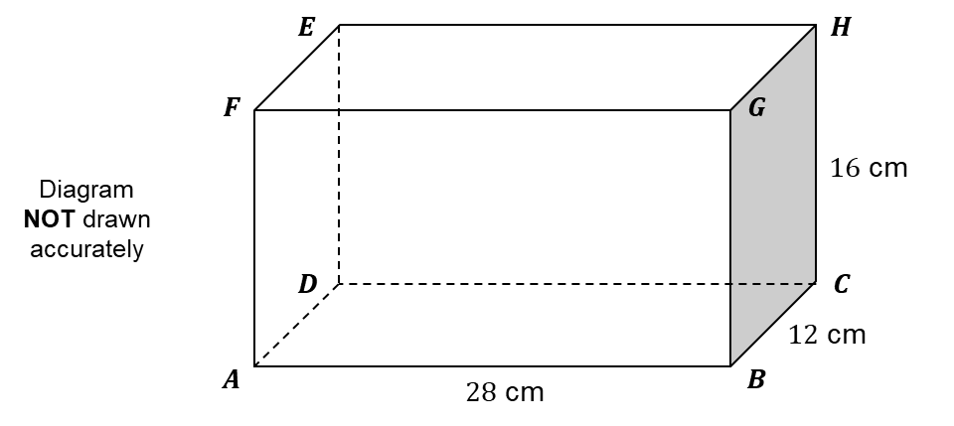

The diagram represents a cuboid $ABCDEFGH$.
$AB=28$ cm. $BC=12$ cm. $CH=16$ cm.
Calculate the length of $AH$.

…………………cm
(4 marks)

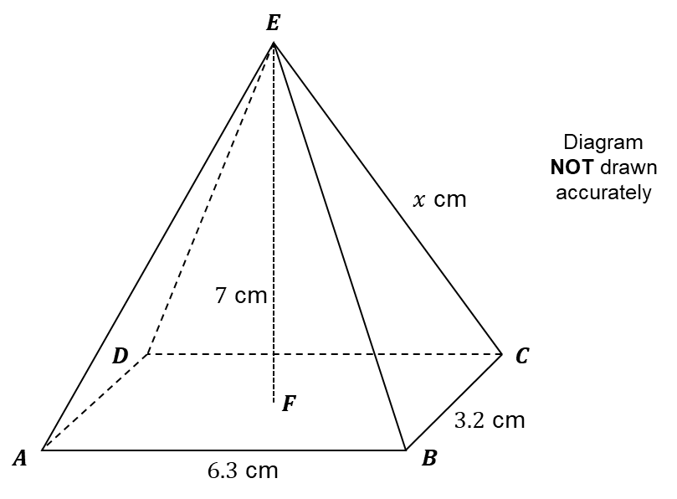
The diagram represents a pyramid $ABCDE$ with height $EF$.
$AB=6.3$ cm. $BC=3.2$ cm. $EF=7$ cm. $CE=x$ cm.
Calculate $x$.

…………………cm
(4 marks)

3D Pythagoras’ Theorem AMBER

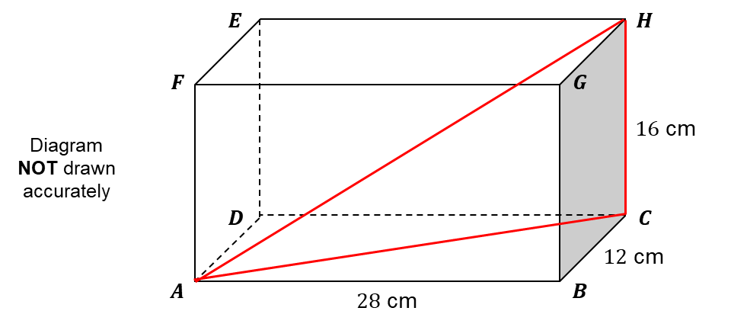

The diagram represents a cuboid $ABCDEFGH$.
$AB=28$ cm. $BC=12$ cm. $CH=16$ cm.
Calculate the length of $AH$.

…………………cm
(4 marks)

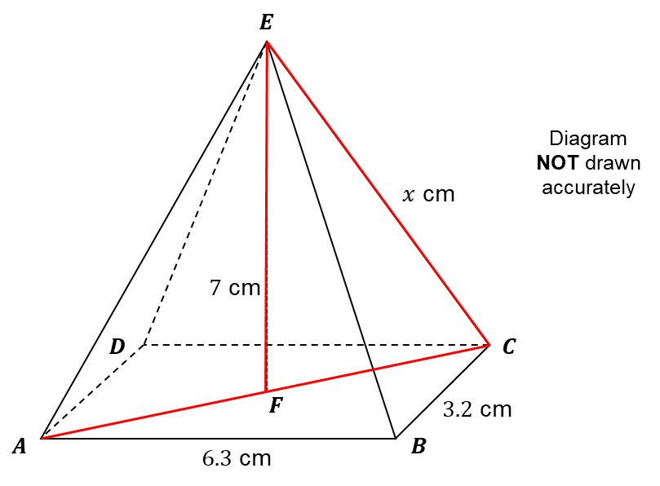
The diagram represents a pyramid $ABCDE$ with height $EF$.
$AB=6.3$ cm. $BC=3.2$ cm. $EF=7$ cm. $CE=x$ cm.
Calculate $x$.

…………………cm
(4 marks)

3D Pythagoras’ Theorem RED

The diagram represents a cuboid $ABCDEFGH$.
$AB=28$ cm. $BC=12$ cm. $CH=16$ cm.
Calculate the length of $AH$.
Start by using Pythagoras’ Theorem with triangle ABC to calculate length AC.
Then use Pythagoras’ Theorem with triangle ACH to calculate length AH.

…………………cm
(4 marks)
The diagram represents a pyramid $ABCDE$ with height $EF$.
$AB=6.3$ cm. $BC=3.2$ cm. $EF=7$ cm. $CE=x$ cm.
Calculate $x$.
Start by using Pythagoras’ Theorem with triangle ABC to calculate length AC.
Divide AC by 2 to calculate length FC.
Then use Pythagoras’ Theorem with triangle CEF to calculate x.

…………………cm
(4 marks)

