**Measures (F)**

Pre-Intervention Assessment

Name: _______________________________

Class: _______________________________

Date: _______________________________

|  |  |  |
| --- | --- | --- |
| **Question** | **Objective** | **RAG** |
| 1 | Convert between metric units |  |
| 2 | Calculate with speed, distance and time |  |
| 3 | Draw and interpret real life graphs |  |
| 4 | Solve problems involving similar lengths, area and volume |  |

**1.** Jack is 1.78 m tall. Amy is 5 cm taller than Jack. How tall is Amy?

. . . . . . . . . . . . . . . . . . . . . .

**2**. The world speed record for a train is 360 mph.

It takes Malcolm 6 seconds to drive a train 1 kilometre.

Has the train broken the world speed record?

Use 5 miles = 8 km.

**3**. Anna drives 45 miles from her home to a meeting. Here is the travel graph for Anna's journey to the meeting. Anna's meeting lasts for 1 hour. She then drives home at a steady speed of 30 miles per hour with no stops.

Complete the travel graph to show this information. 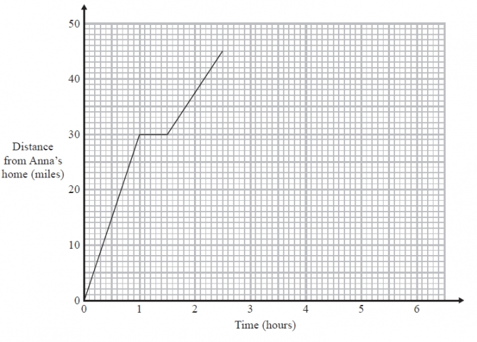

**4**. Cylinder **A** and cylinder **B** are mathematically similar.  
The length of cylinder **A** is 4 cm and the length of cylinder **B** is 6 cm.  
The volume of cylinder **A** is 80 cm³.



Calculate the volume of cylinder **B**.

........................................................... cm³

[Glue here]