Angles in Parallel Lines RED
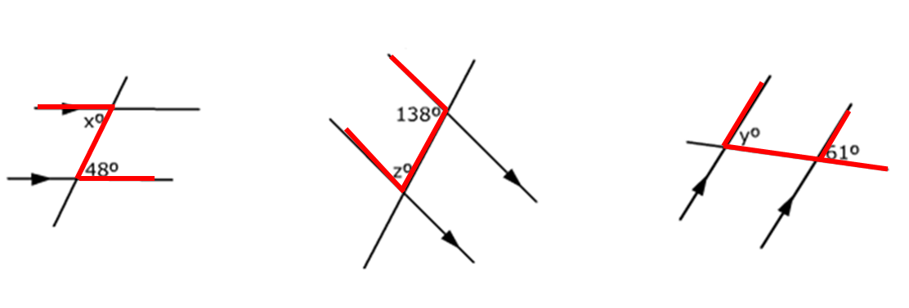
____º because alternate ____º because supplementary ____º because corresponding

angles ______________ angles ______________ angles ______________
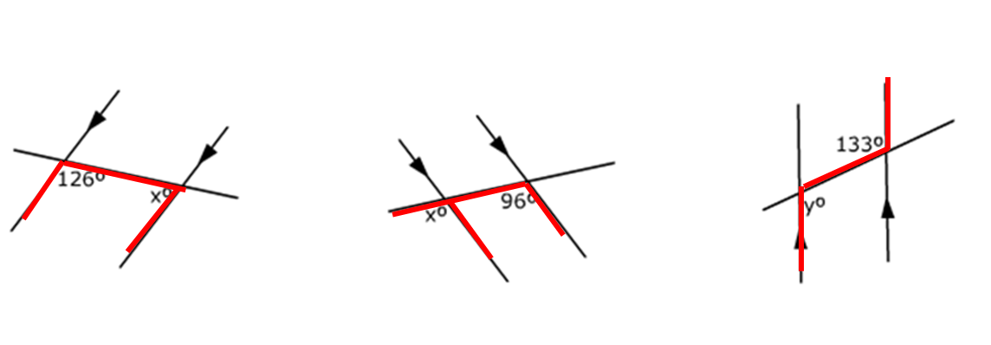
____º _____________ ____º _____________ ____º _____________

___________________ ___________________ ___________________
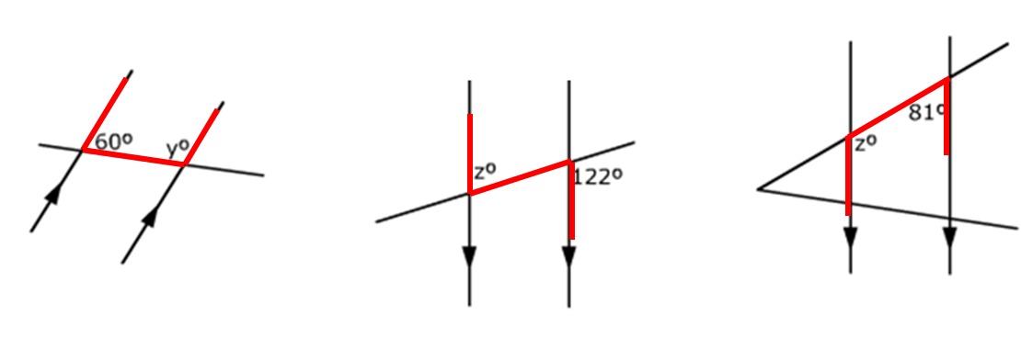
____º _____________ ____º _____________ ____º _____________

___________________ ___________________ ___________________

Angles in Parallel Lines AMBER
____º _____________ ____º _____________ ____º _____________

___________________ ___________________ ___________________

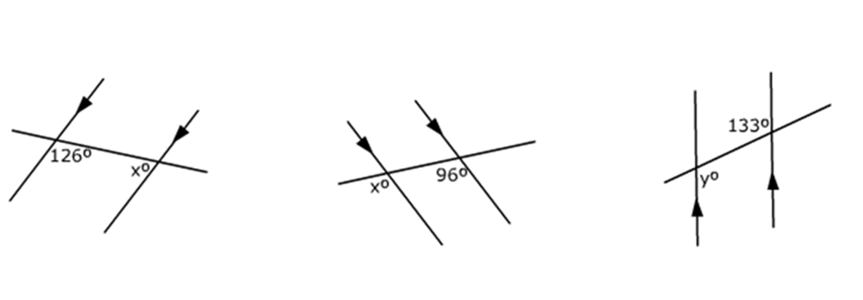____º _____________ ____º _____________ ____º _____________

___________________ ___________________ ___________________

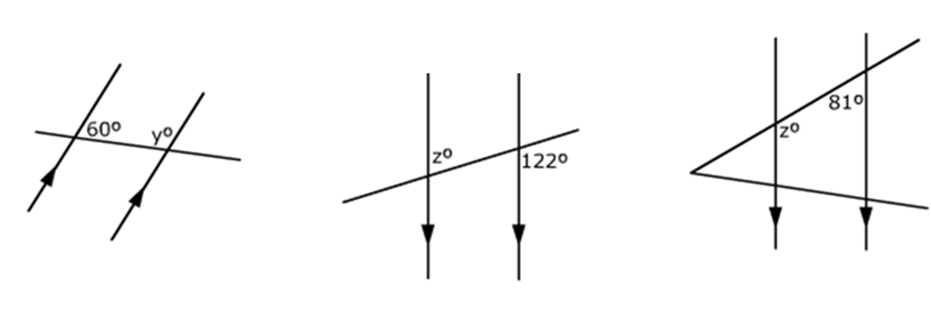____º _____________ ____º _____________ ____º _____________

___________________ ___________________ ___________________

Angles in Parallel Lines GREEN
____º _____________ ____º _____________ ____º _____________

___________________ ___________________ ___________________

____º _____________ ____º _____________ ____º _____________

___________________ ___________________ ___________________

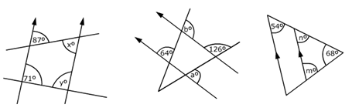
x = ____º ___________ a = ____º ___________ m = ____º ___________

___________________ ___________________ ___________________

y = ____º ___________ b = ____º ___________ n = ____º ___________

___________________ ___________________ ___________________

